**Sachin Sirohi  
API TOOL POSTMAN E-BOOK**

**HTTP Status Codes**

httpstatuses.com is an easy to reference database of HTTP Status Codes with their definitions and helpful code references all in one place. Visit an individual status code via httpstatuses.com/code or browse the list below.

[@ Share on Twitter](https://twitter.com/intent/tweet?hashtags=httpstatuses&text=Helpful%20HTTP%20Status%20Code%20reference%20site&url=https%3A%2F%2Fhttpstatuses.com&via=webpagefx)[⊕ Add to Pinboard](https://pinboard.in/add?showtags=yes&url=https%3A%2F%2Fhttpstatuses.com&description=HTTP%20Status%20Code%20Reference%20Site&title=httpstatuses.com&tags=reference,development)

* **1×× Informational**
* [**100** Continue](https://httpstatuses.com/100)
* [**101** Switching Protocols](https://httpstatuses.com/101)
* [**102** Processing](https://httpstatuses.com/102)
* **2×× Success**
* [**200** OK](https://httpstatuses.com/200)
* [**201** Created](https://httpstatuses.com/201)
* [**202** Accepted](https://httpstatuses.com/202)
* [**203** Non-authoritative Information](https://httpstatuses.com/203)
* [**204** No Content](https://httpstatuses.com/204)
* [**205** Reset Content](https://httpstatuses.com/205)
* [**206** Partial Content](https://httpstatuses.com/206)
* [**207** Multi-Status](https://httpstatuses.com/207)
* [**208** Already Reported](https://httpstatuses.com/208)
* [**226** IM Used](https://httpstatuses.com/226)
* **3×× Redirection**
* [**300** Multiple Choices](https://httpstatuses.com/300)
* [**301** Moved Permanently](https://httpstatuses.com/301)
* [**302** Found](https://httpstatuses.com/302)
* [**303** See Other](https://httpstatuses.com/303)
* [**304** Not Modified](https://httpstatuses.com/304)
* [**305** Use Proxy](https://httpstatuses.com/305)
* [**307** Temporary Redirect](https://httpstatuses.com/307)
* [**308** Permanent Redirect](https://httpstatuses.com/308)
* **4×× Client Error**
* [**400** Bad Request](https://httpstatuses.com/400)
* [**401** Unauthorized](https://httpstatuses.com/401)
* [**402** Payment Required](https://httpstatuses.com/402)
* [**403** Forbidden](https://httpstatuses.com/403)
* [**404** Not Found](https://httpstatuses.com/404)
* [**405** Method Not Allowed](https://httpstatuses.com/405)
* [**406** Not Acceptable](https://httpstatuses.com/406)
* [**407** Proxy Authentication Required](https://httpstatuses.com/407)
* [**408** Request Timeout](https://httpstatuses.com/408)
* [**409** Conflict](https://httpstatuses.com/409)
* [**410** Gone](https://httpstatuses.com/410)
* [**411** Length Required](https://httpstatuses.com/411)
* [**412** Precondition Failed](https://httpstatuses.com/412)
* [**413** Payload Too Large](https://httpstatuses.com/413)
* [**414** Request-URI Too Long](https://httpstatuses.com/414)
* [**415** Unsupported Media Type](https://httpstatuses.com/415)
* [**416** Requested Range Not Satisfiable](https://httpstatuses.com/416)
* [**417** Expectation Failed](https://httpstatuses.com/417)
* [**418** I'm a teapot](https://httpstatuses.com/418)
* [**421** Misdirected Request](https://httpstatuses.com/421)
* [**422** Unprocessable Entity](https://httpstatuses.com/422)
* [**423** Locked](https://httpstatuses.com/423)
* [**424** Failed Dependency](https://httpstatuses.com/424)
* [**426** Upgrade Required](https://httpstatuses.com/426)
* [**428** Precondition Required](https://httpstatuses.com/428)
* [**429** Too Many Requests](https://httpstatuses.com/429)
* [**431** Request Header Fields Too Large](https://httpstatuses.com/431)
* [**444** Connection Closed Without Response](https://httpstatuses.com/444)
* [**451** Unavailable For Legal Reasons](https://httpstatuses.com/451)
* [**499** Client Closed Request](https://httpstatuses.com/499)
* **5×× Server Error**
* [**500** Internal Server Error](https://httpstatuses.com/500)
* [**501** Not Implemented](https://httpstatuses.com/501)
* [**502** Bad Gateway](https://httpstatuses.com/502)
* [**503** Service Unavailable](https://httpstatuses.com/503)
* [**504** Gateway Timeout](https://httpstatuses.com/504)
* [**505** HTTP Version Not Supported](https://httpstatuses.com/505)
* [**506** Variant Also Negotiates](https://httpstatuses.com/506)
* [**507** Insufficient Storage](https://httpstatuses.com/507)
* [**508** Loop Detected](https://httpstatuses.com/508)
* [**510** Not Extended](https://httpstatuses.com/510)
* [**511** Network Authentication Required](https://httpstatuses.com/511)
* [**599** Network Connect Timeout Error](https://httpstatuses.com/599)

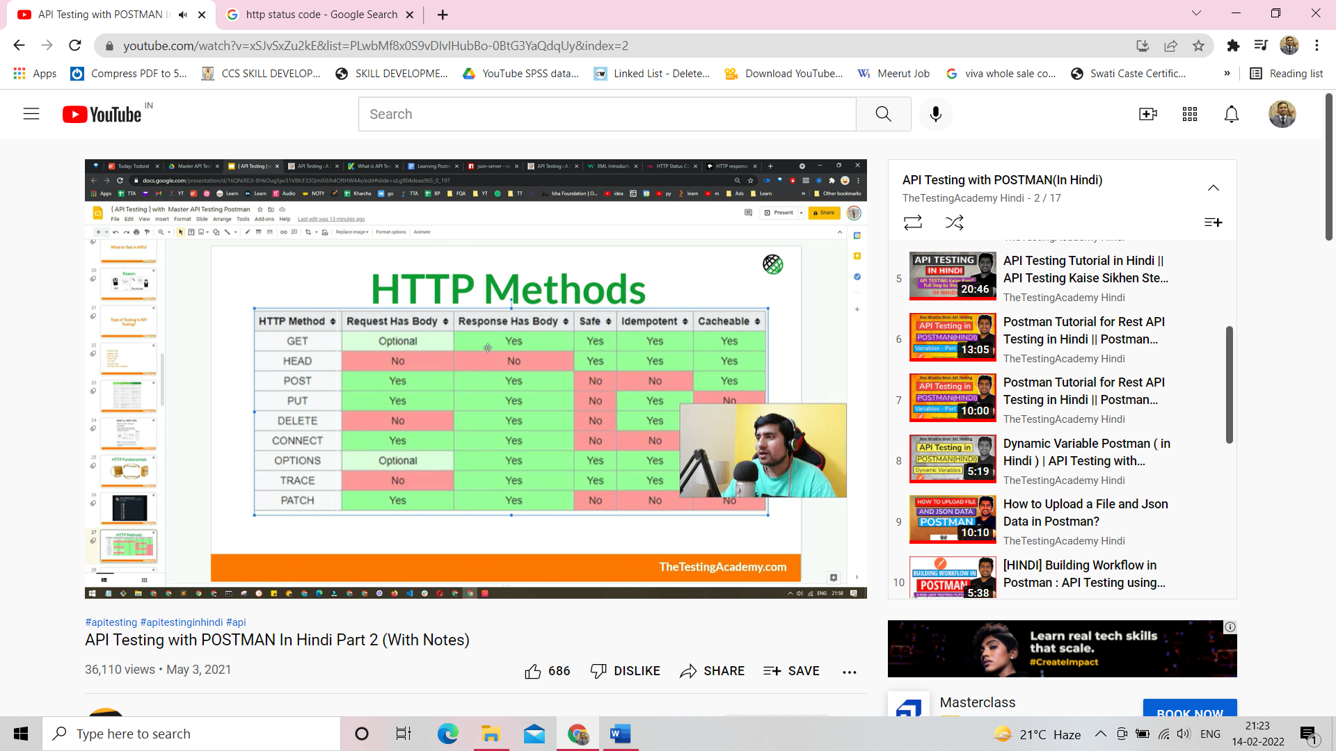

**CRUD – What is CRUD?**

The acronym **CRUD (Create, Read, Update, Delete)** may be familiar to experienced programmers and UX designers, but most people who come across it may not fully understand what it means and how it relates to everyday websites and apps.

What is CRUD?

CRUD – again is:

* Create
* Read
* Update
* Delete

is shorthand for the basic functions that an application must conventionally be able to fulfill in order to be considered “complete.”

For example, let’s consider a basic phone book app. In order to feel like a “finished” application, the user should be able to do at least four things: create new entries, access the information available for each entry, modify and save the existing information, and remove old and unnecessary entries from the book. In this example, the phone book is essentially functioning as a database, and it’s no coincidence that the term CRUD is generally used to describe what an application with a database should conventionally do.

Because these four functions are so universal to programming, each of the elements of CRUD is represented in virtually every single [programming language](https://rapidapi.com/blog/programming-languages/) out there that deals with databases. A query language like SQL may call their Create function an INSERT, and a web application using HTTP may make a POST request, but both of these things are simply telling a database somewhere to produce a new entry. Same goes with reading, updating, and deleting items in a database – these are universal necessities, and although different languages may handle them differently, you can always be assured that any application dealing with a table of information will need to have these four key capabilities.

REST vs CRUD

If you’ve ever dabbled in developing a website or an app, it’s possible that you’ve come across another acronym that sounds awfully similar to what we’re describing with CRUD. REST (Representational State Transfer), or RESTful programming, is another term that deals with how a developer might deal with the manipulation of information coming into and out of a program. However, these two concepts deal with very different levels of programming and actually don’t compete against each other so much as complement one another.

CRUD, at its roots, is a basic and primitive way of manipulating information. It’s what an application pretty much HAS to be able to do, rather than a way of going about doing it. REST, on the other hand, is a high-level way of creating, changing and removing information for the user. Specifically, REST refers to manipulating data through HTTP commands, and an ideology for how to streamline the relationship between the data that a user is manipulating on screen and the information that is saved on the server. A programmer can create a REST API that handles basic CRUD functions, but building a CRUD application in no way insinuates the use of RESTful programming.

Hopefully, this has been an insightful look at what CRUD means to programmers, how applications might handle those functions, and what exactly the difference is between CRUD and REST when it comes to creating an application.

Go for Dummy API Link

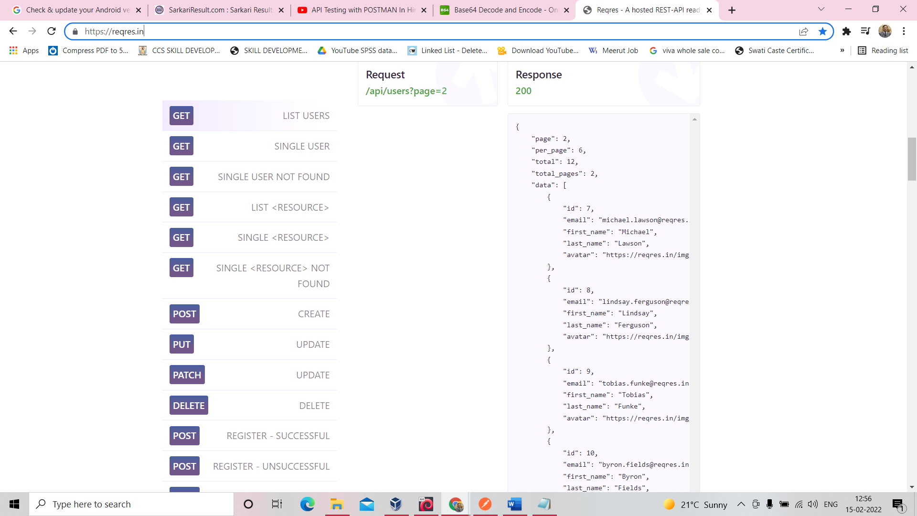

URL Link for API after open in web browser with inspect

**GET REQUEST**

<https://reqres.in/api/users/>?

Open postman->goto collections->in collection click on add request-> get-> send

<https://reqres.in/api/users/2>

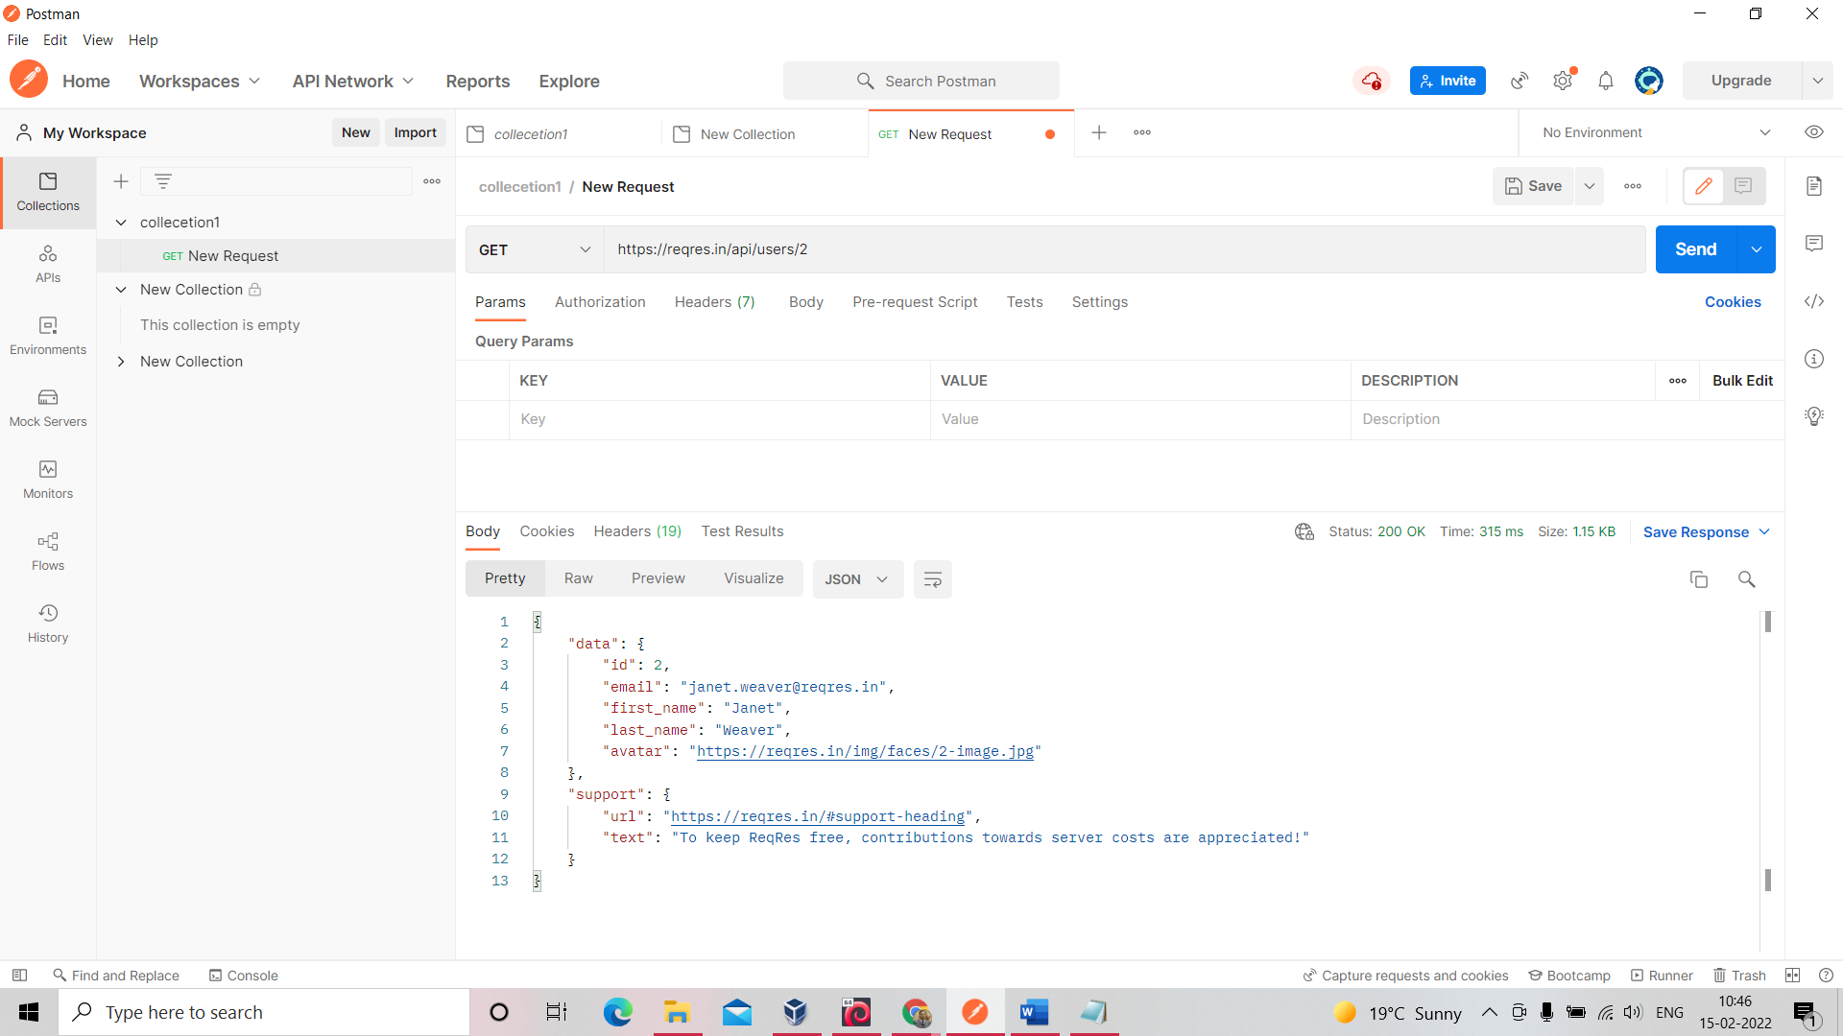

https://reqres.in/api/users/3

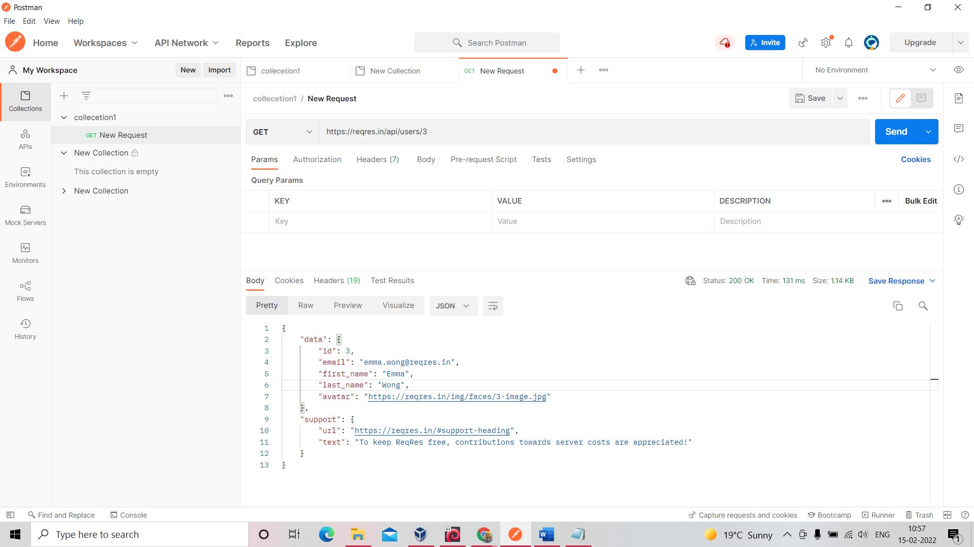

Authorization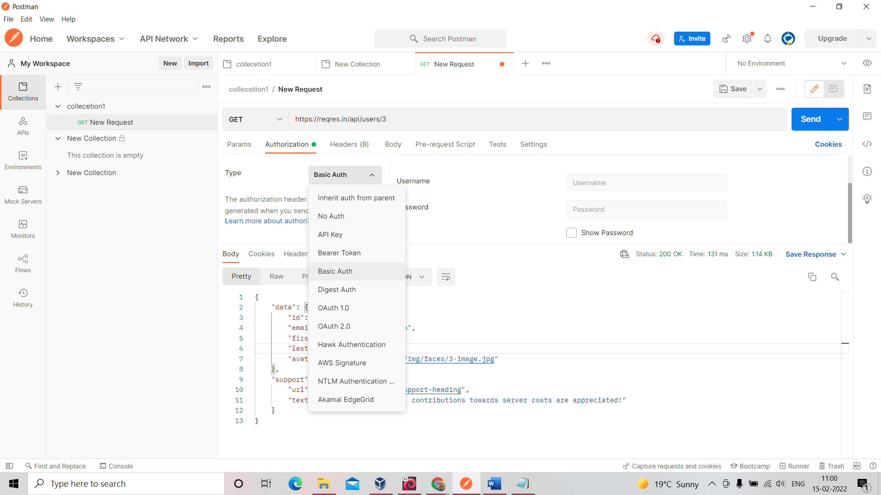

User name- admin

Password- admin (****)

Goto header->Authorization

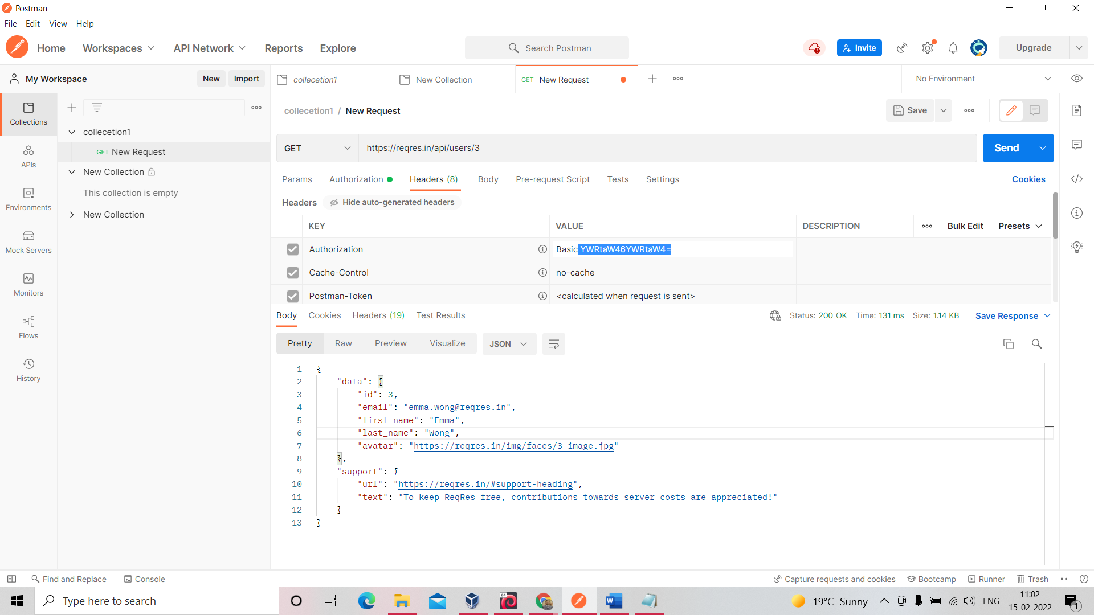

Got google= https://www.base64decode.org/

Convert authorization value - YWRtaW46YWRtaW4=  
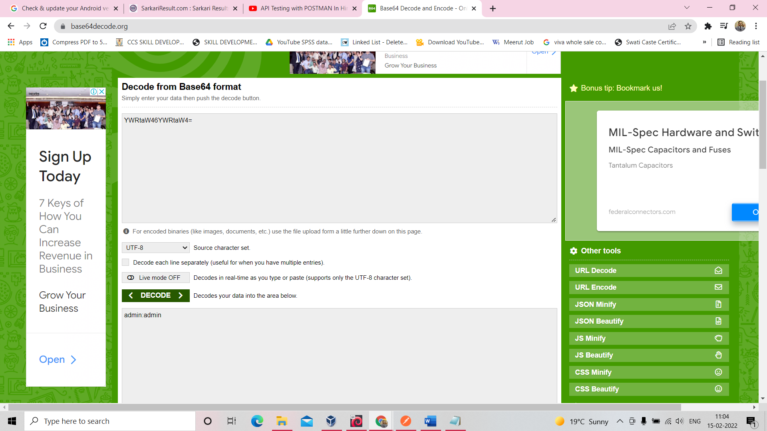

Copy key copy as Curl(cmd)

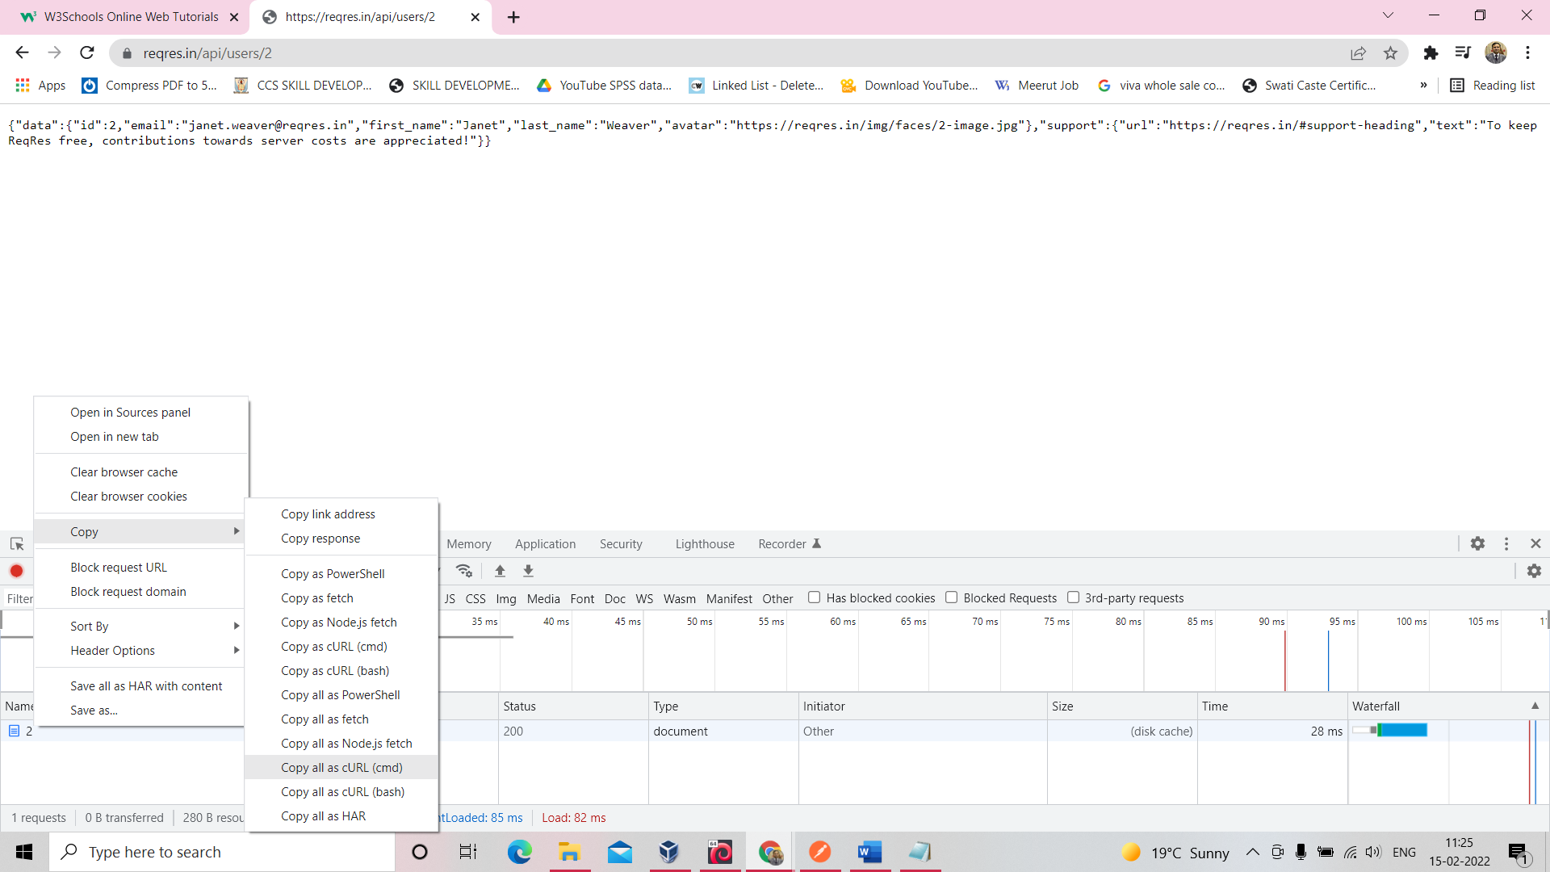

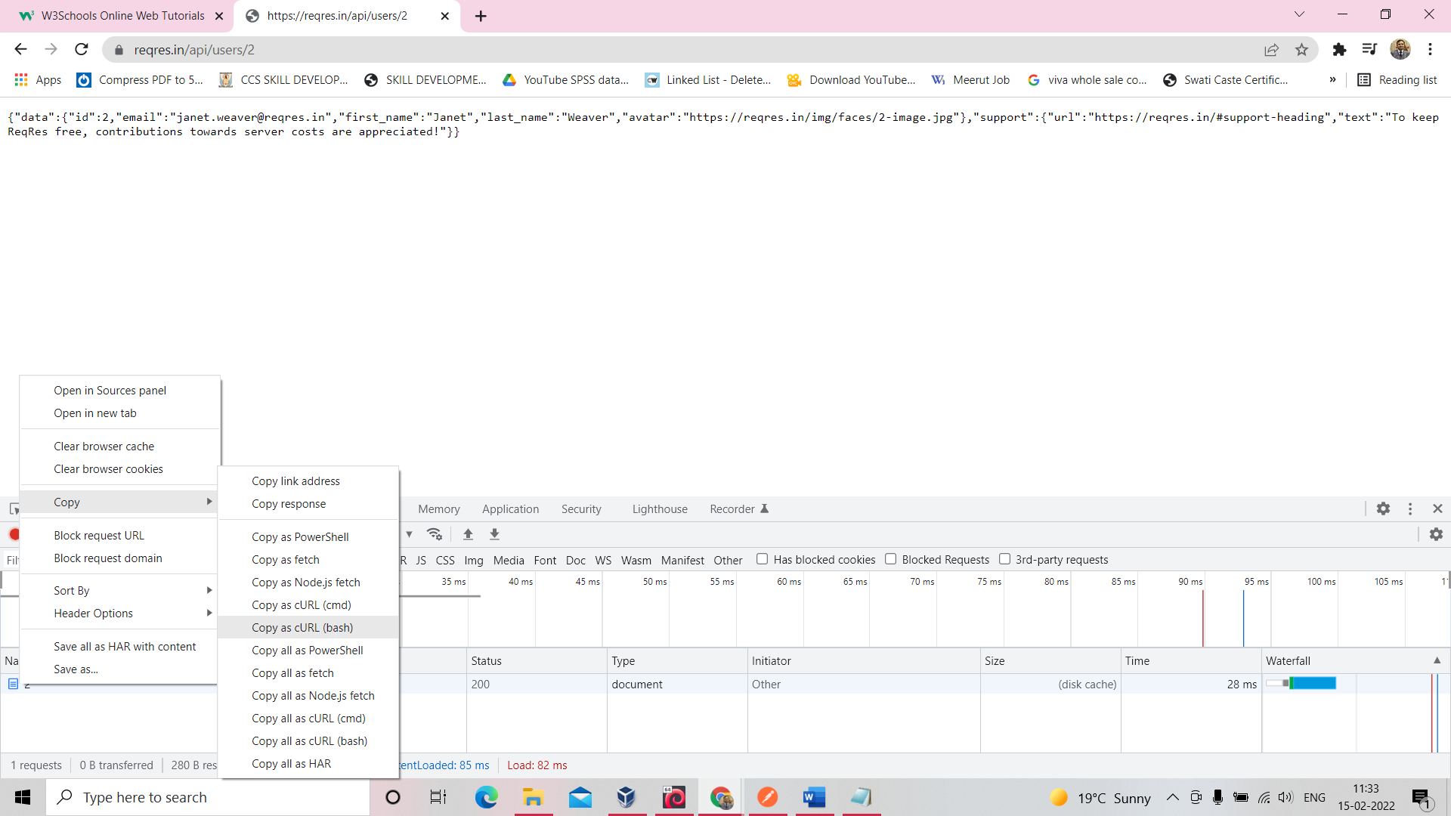

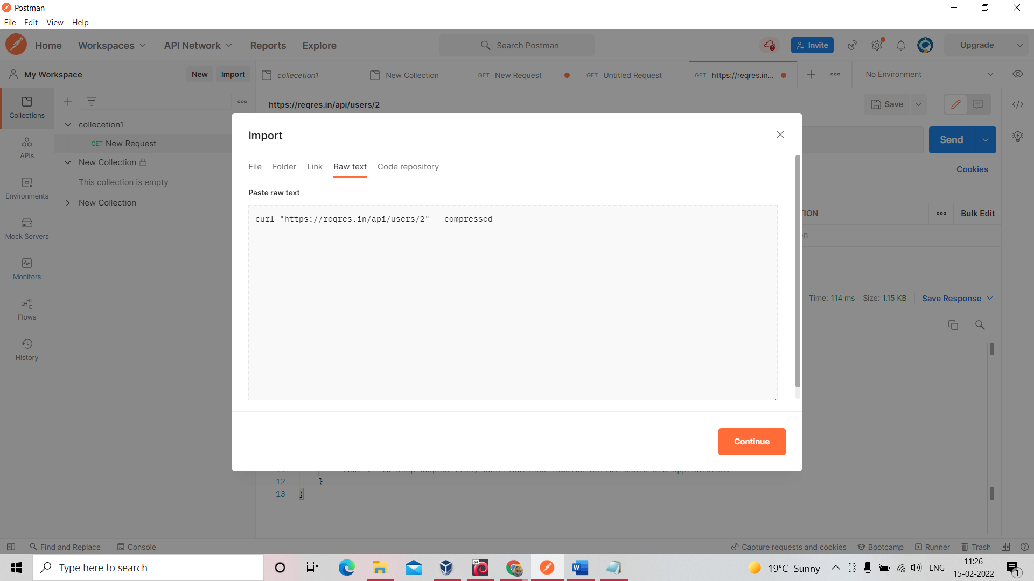

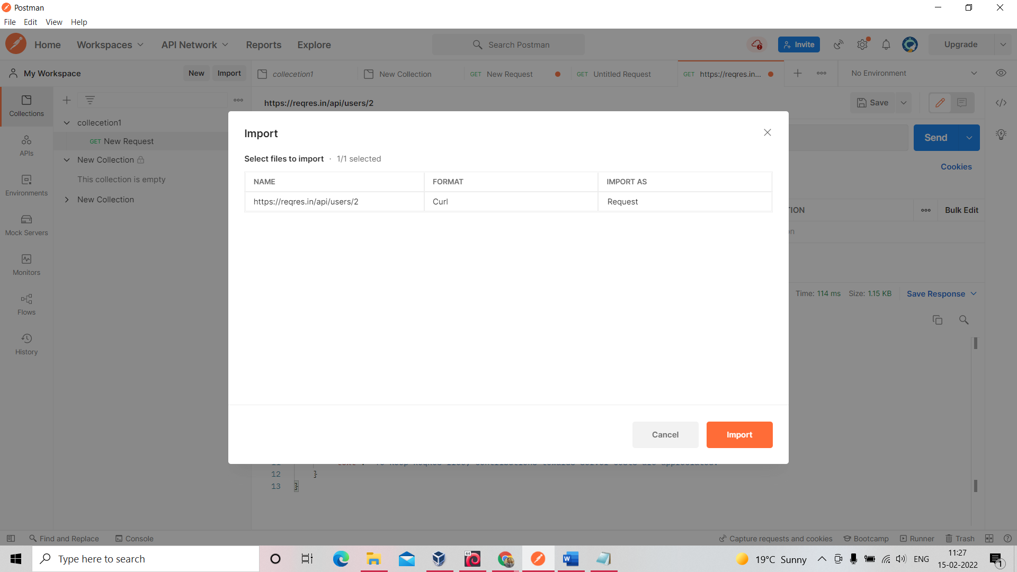

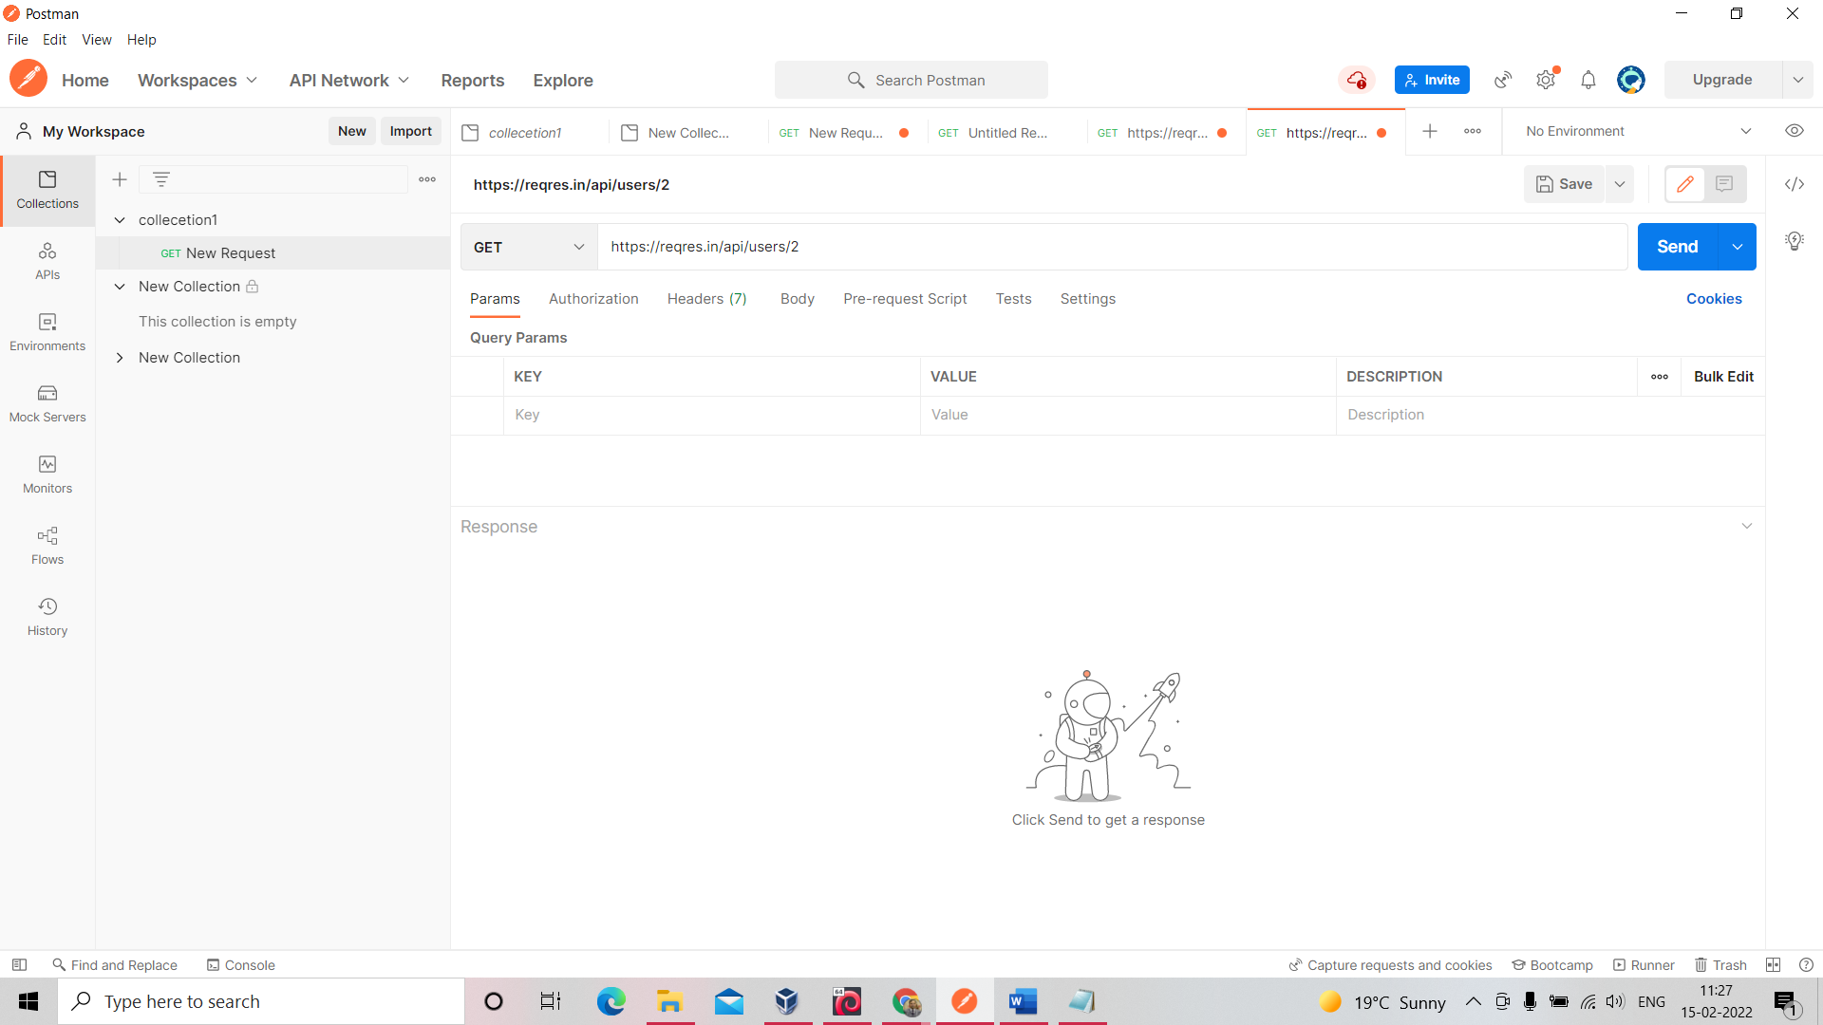

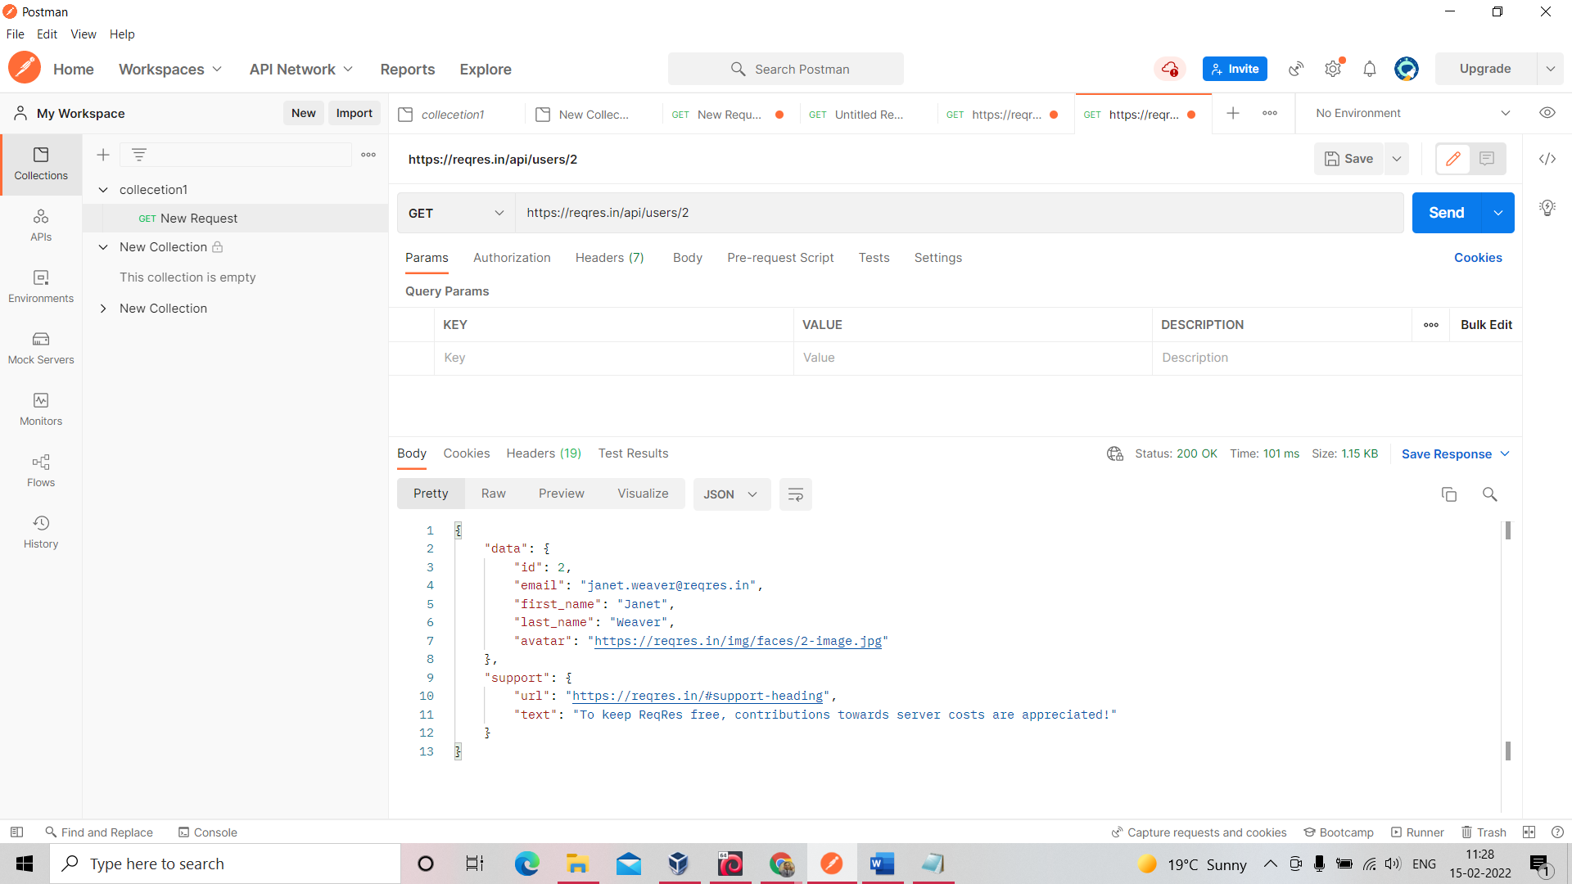

How to set content type header in json   
Add Manually Content-Type= application/json  
Send request into json and receive response into json

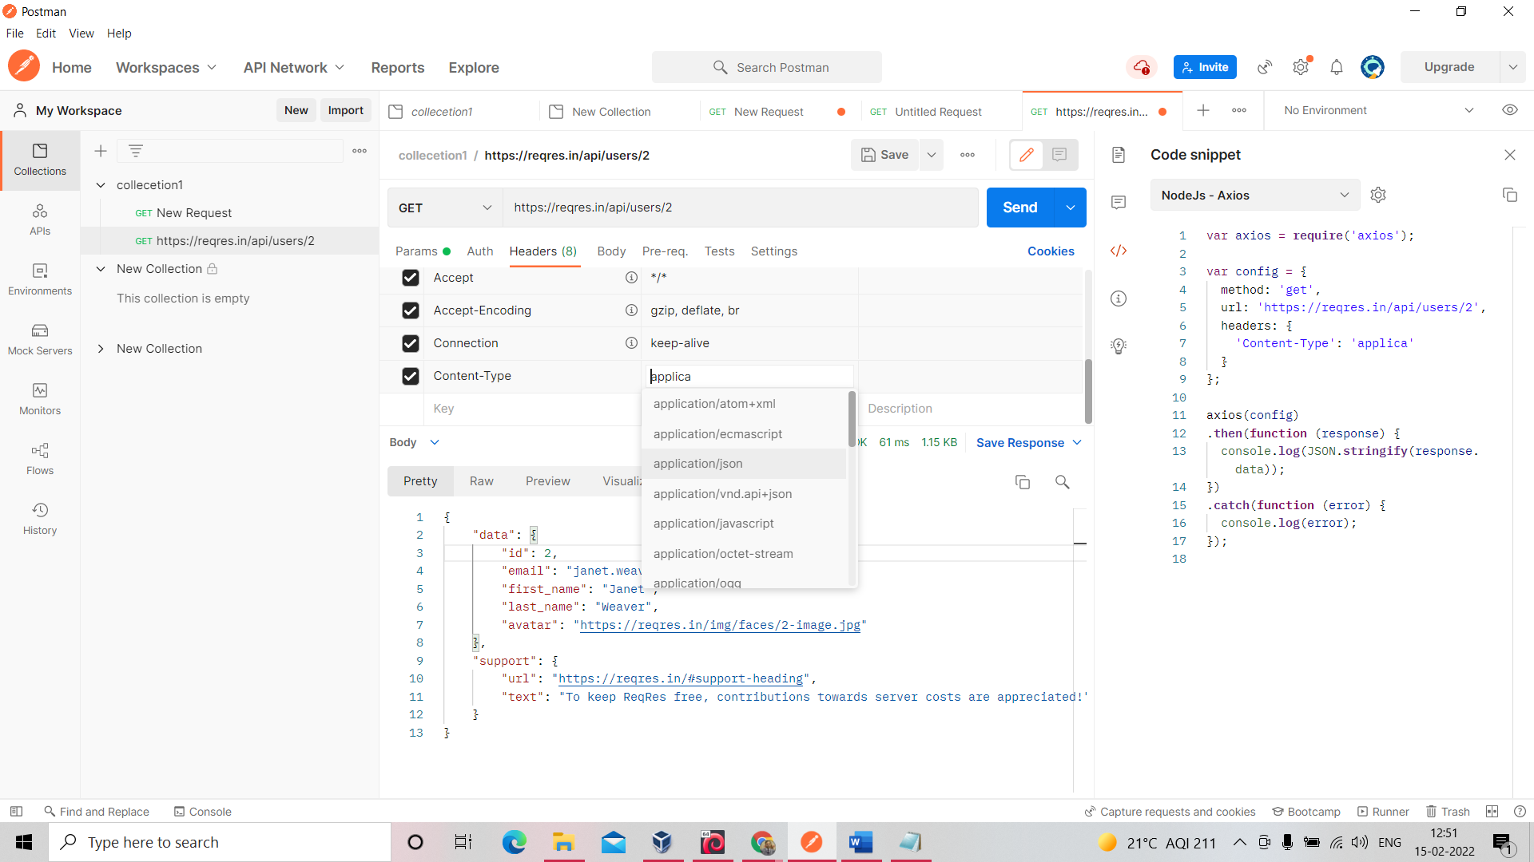

**POST REQUEST**

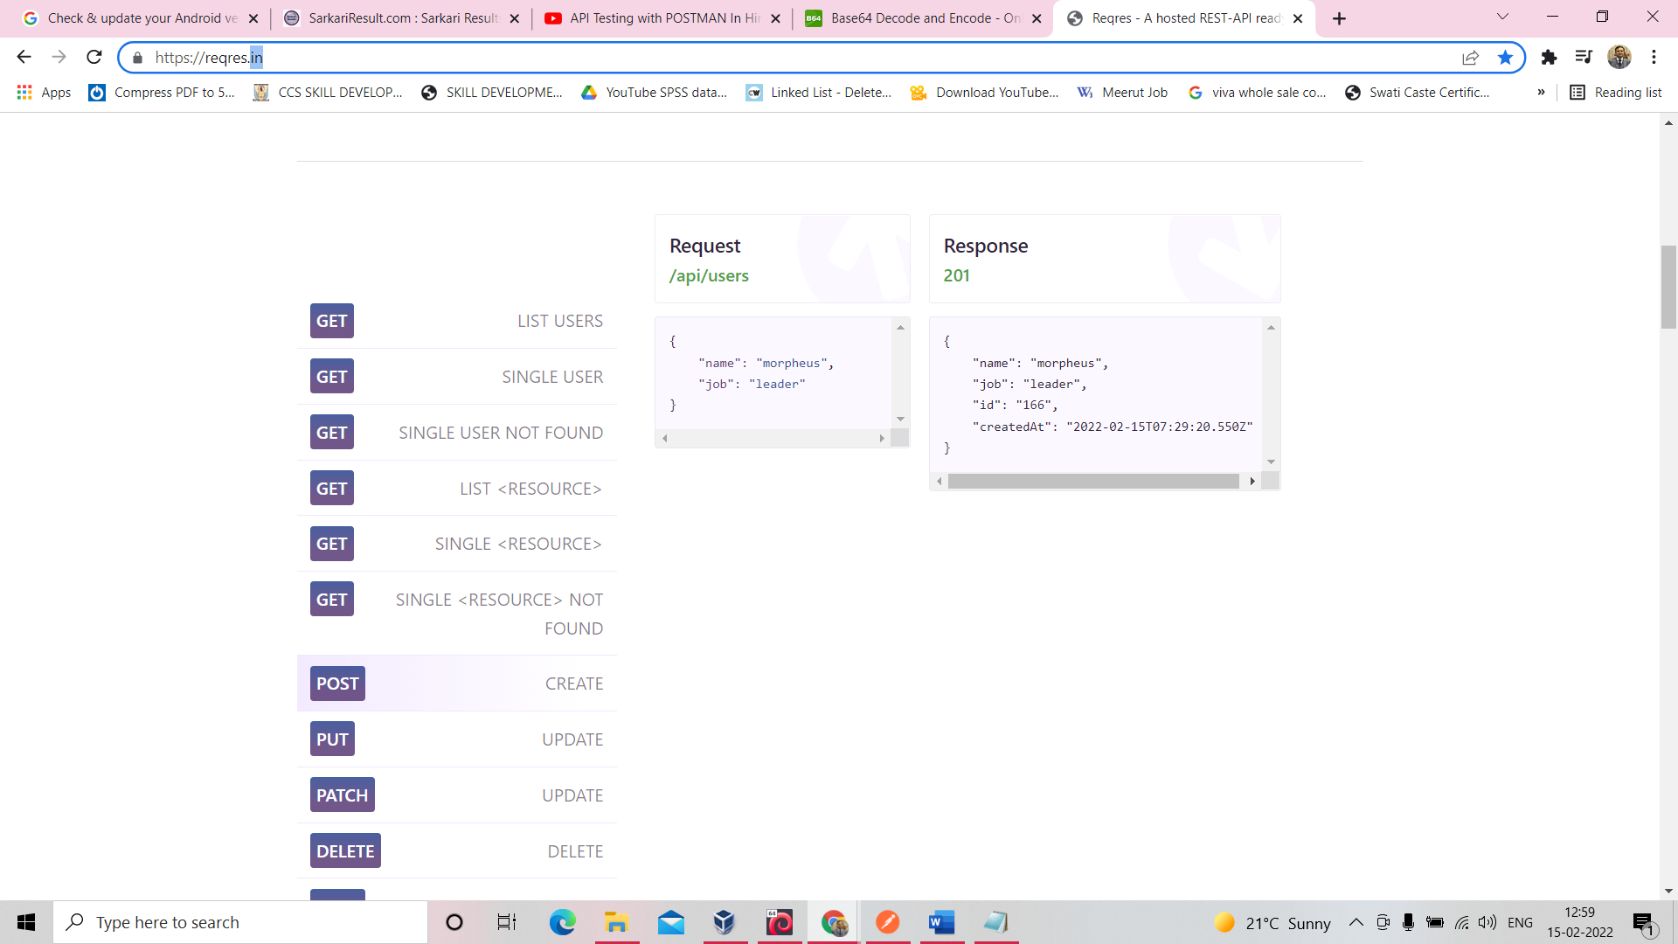

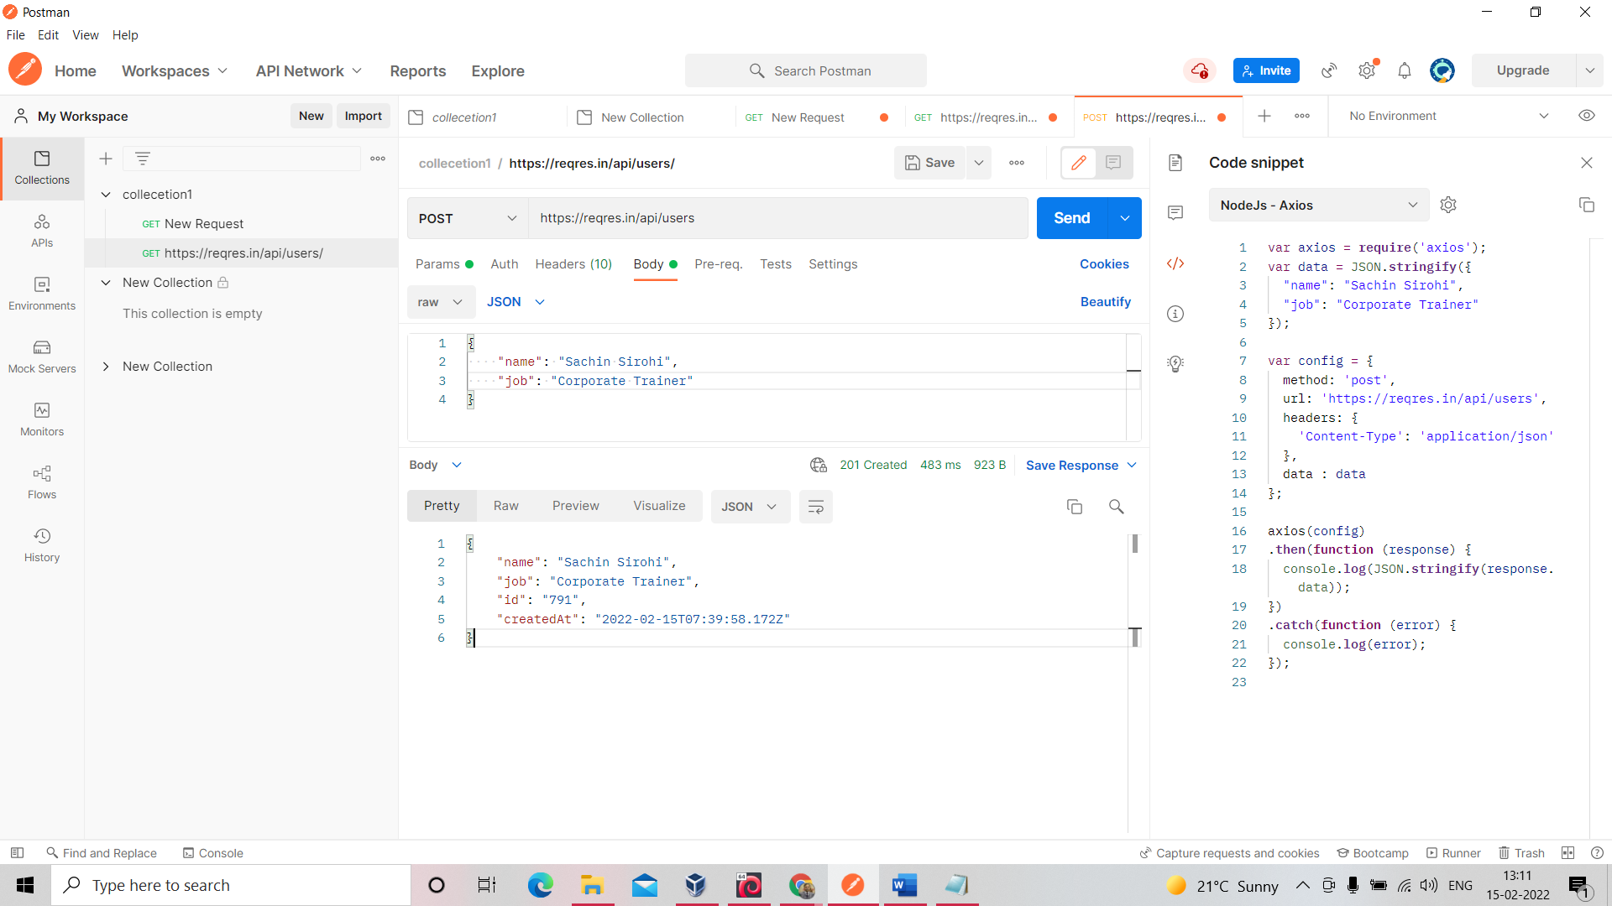

For Check this user id is created or not

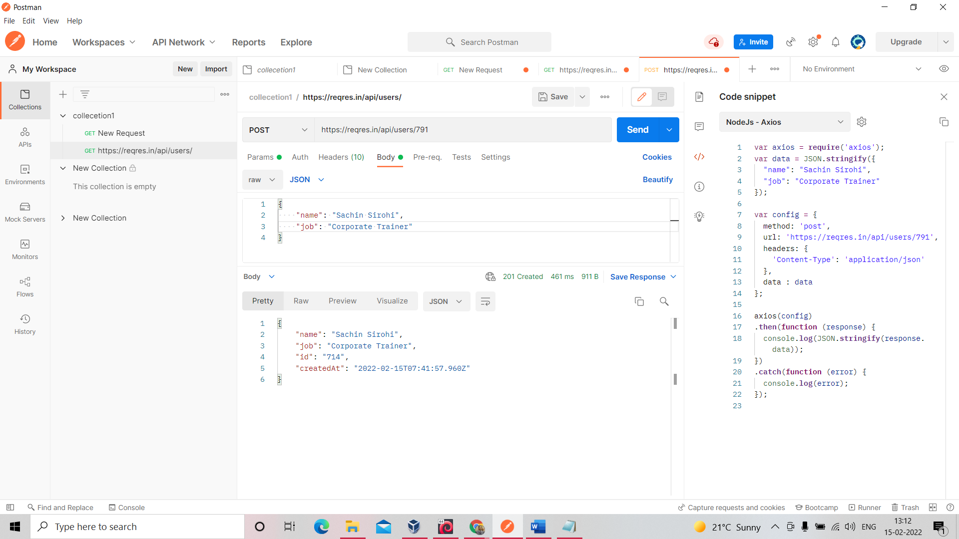

Put into Form Data use only if you want to send data into HTML Form

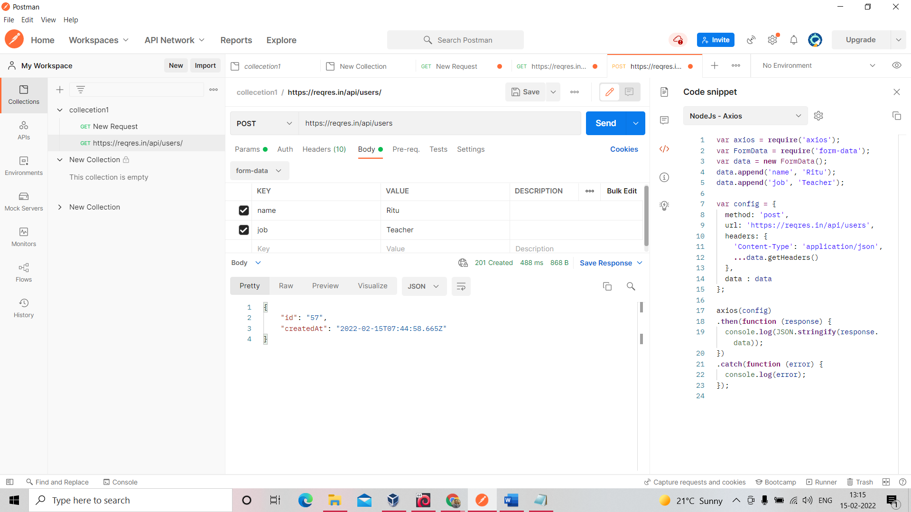

You can use pre-request like this

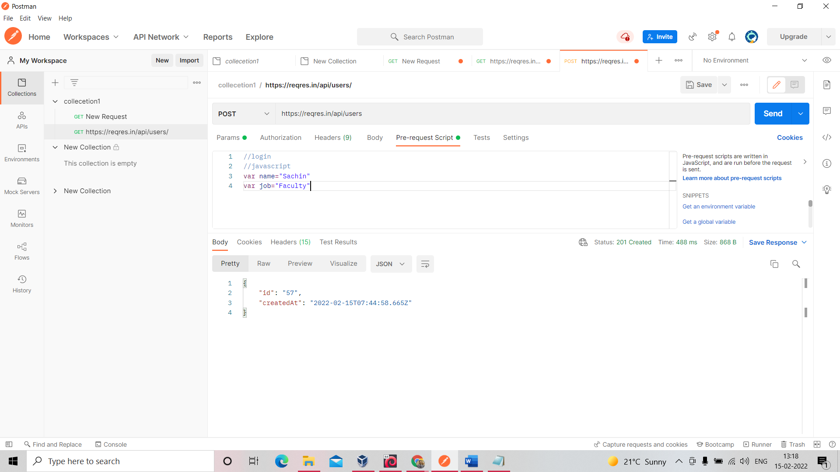

Postman Console- printing data whatever you type

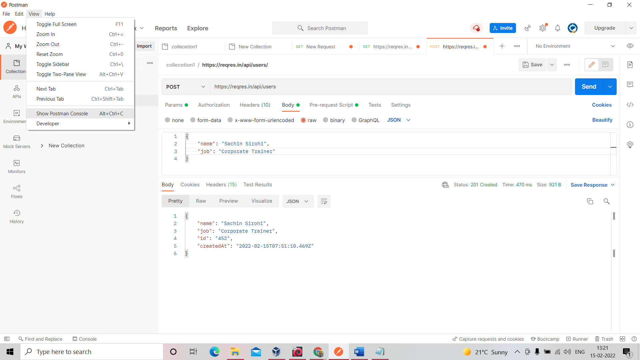

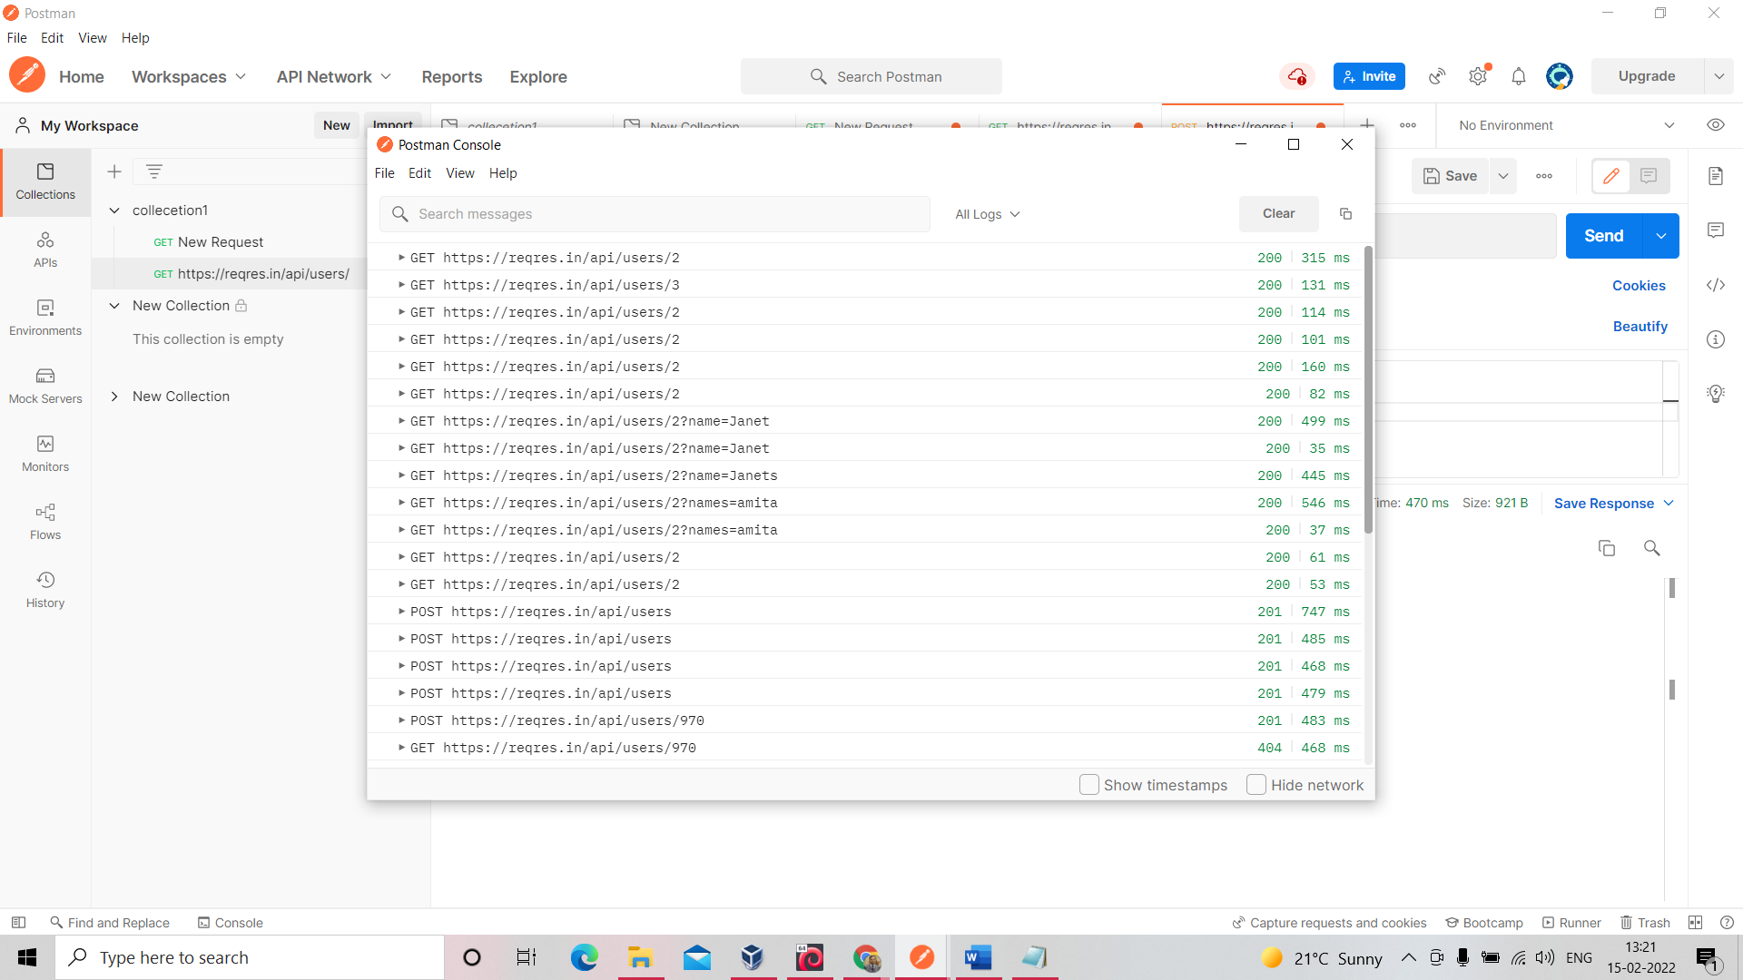

Session 3

How to add cookie   
show expiry also

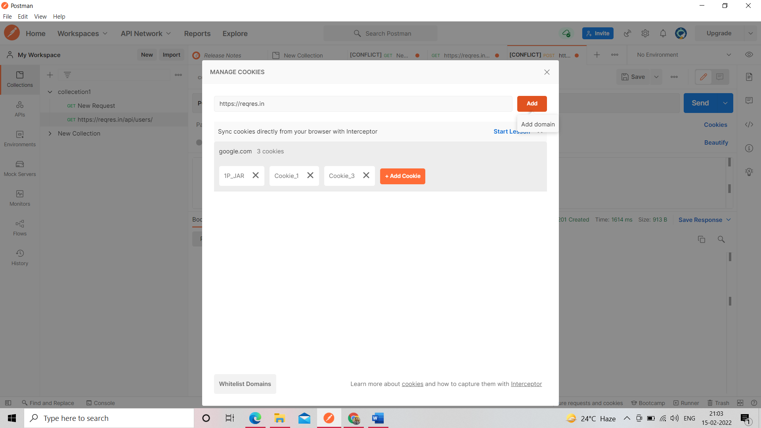

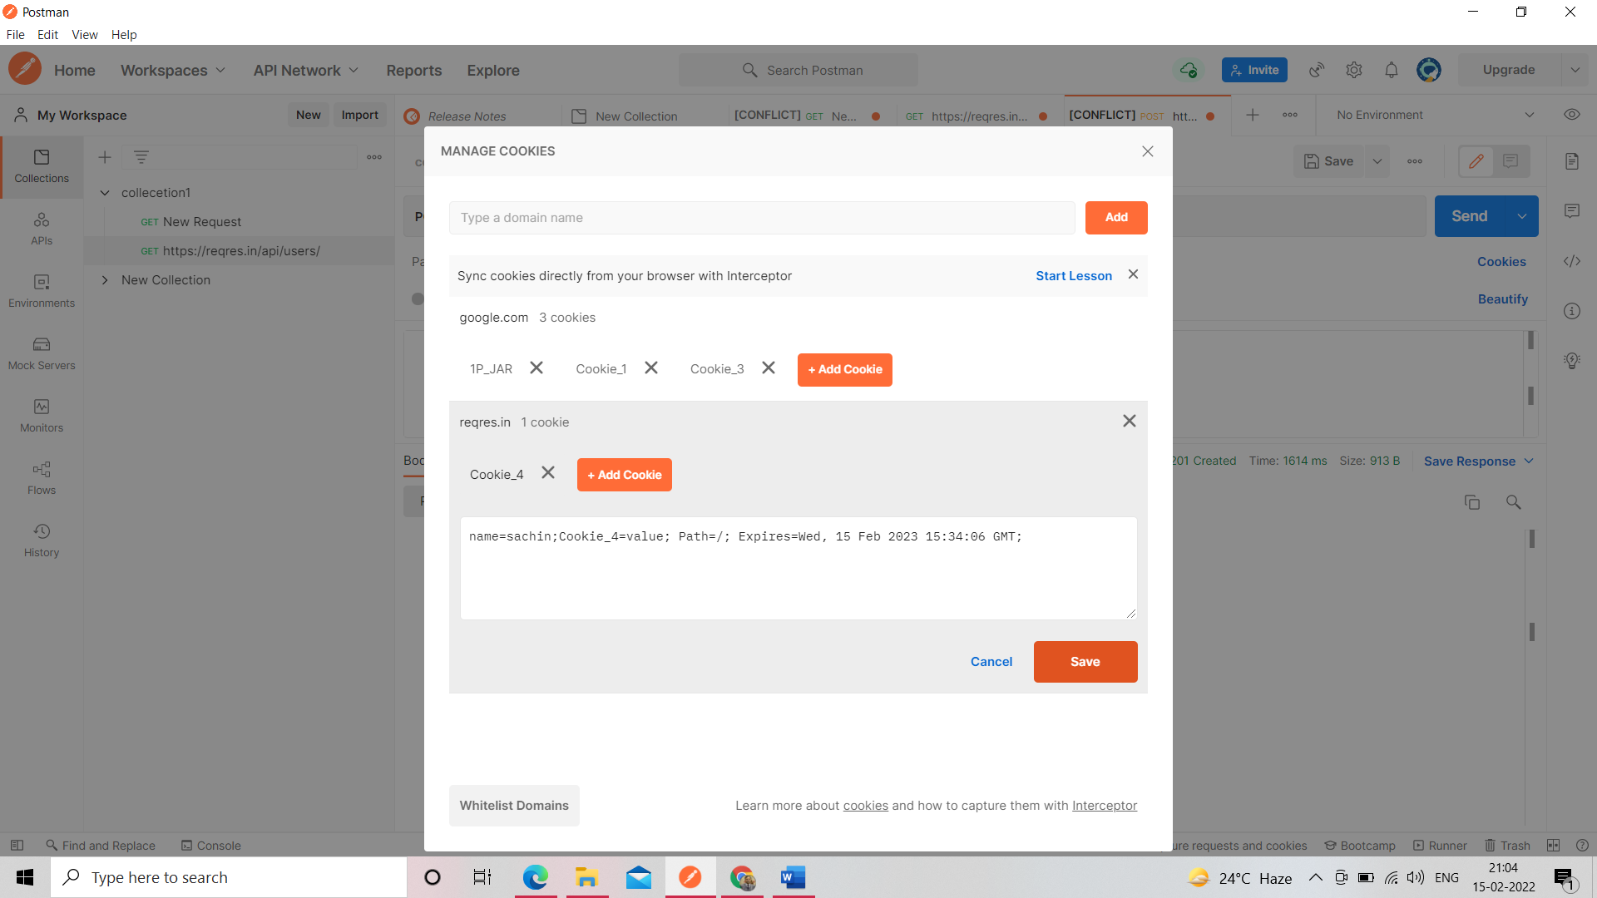

Share Collection

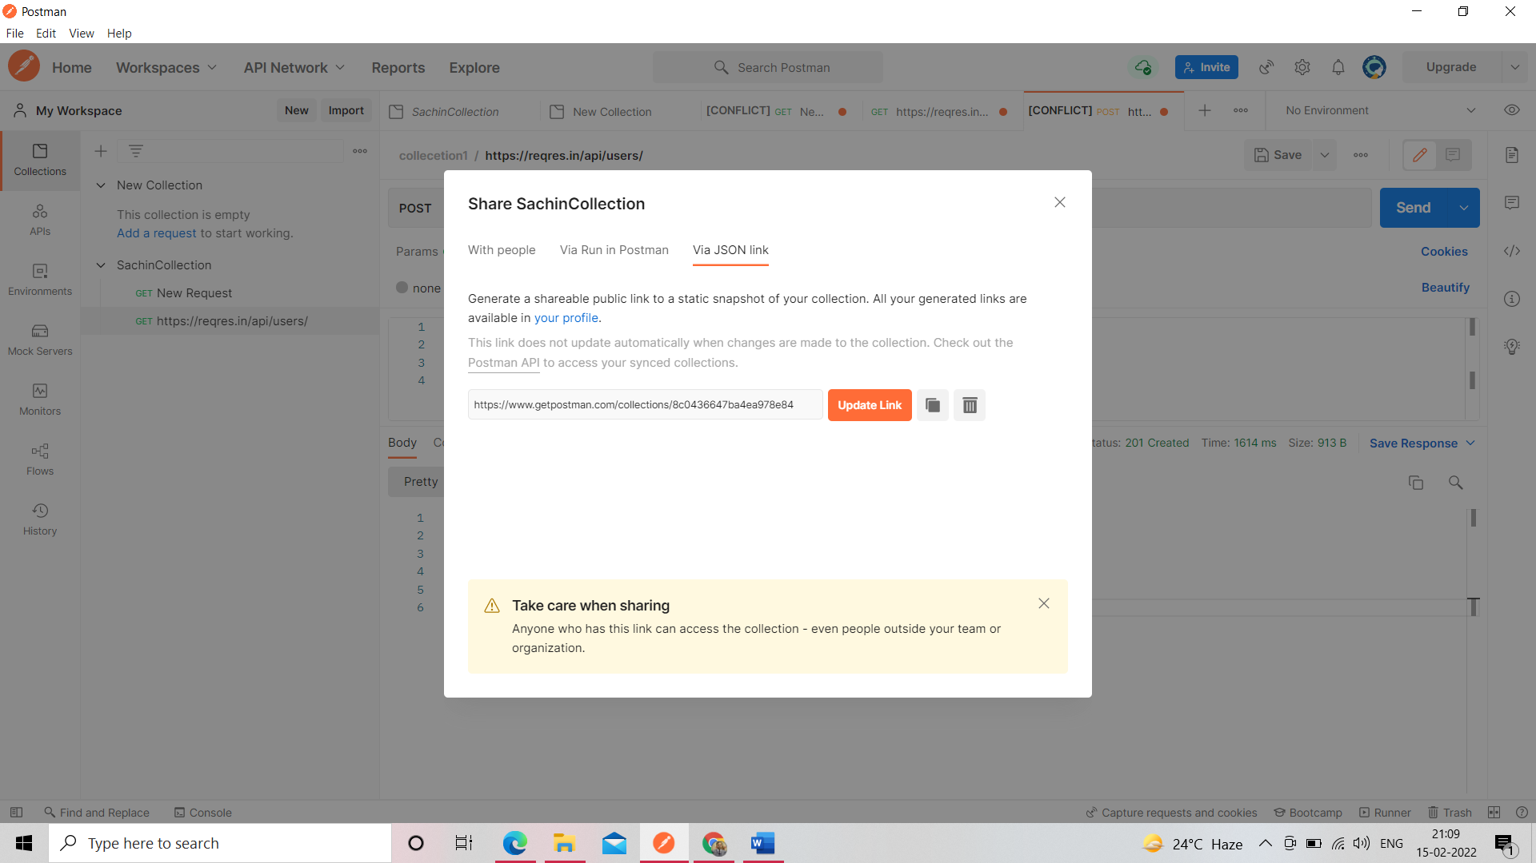

Export Collection

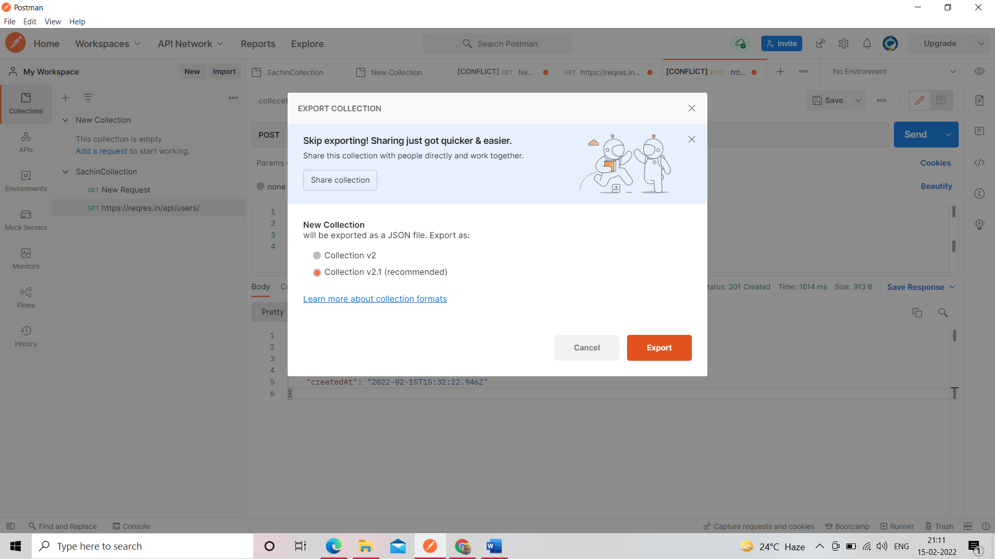

Import Collection by file

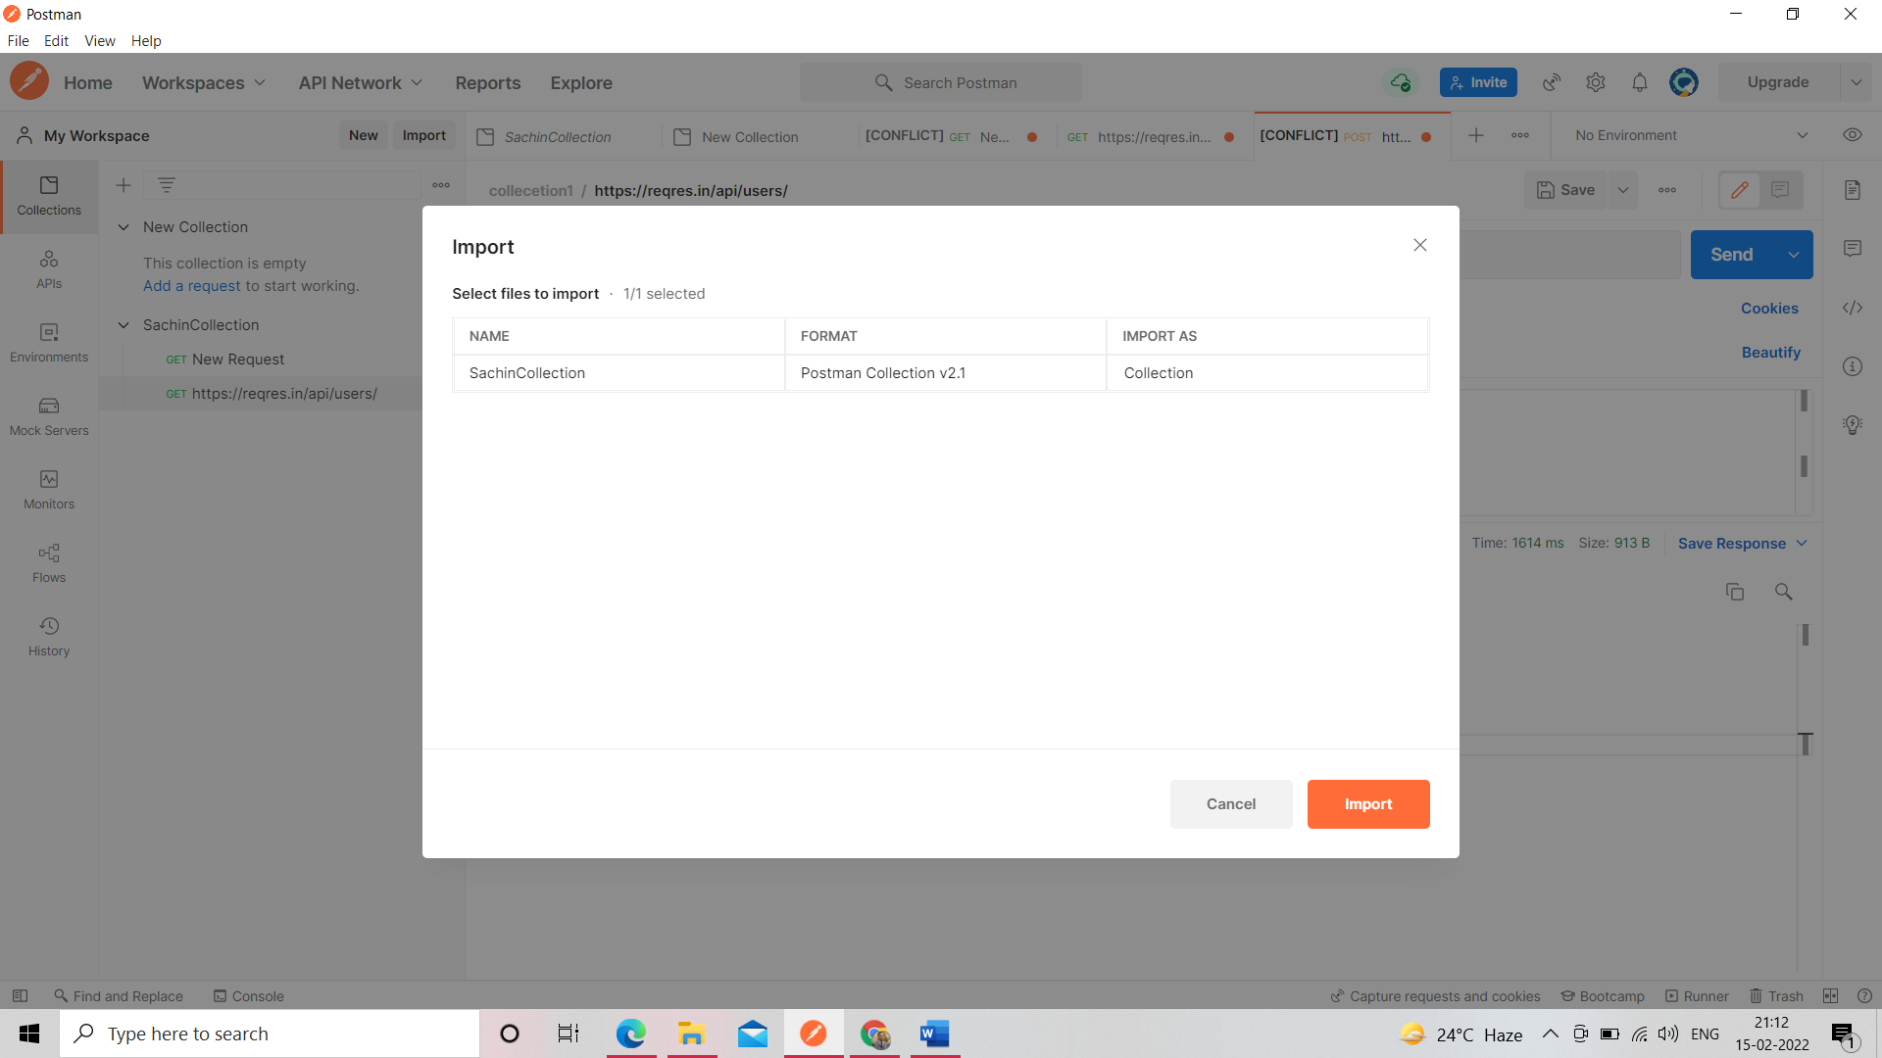

Monitor Collection

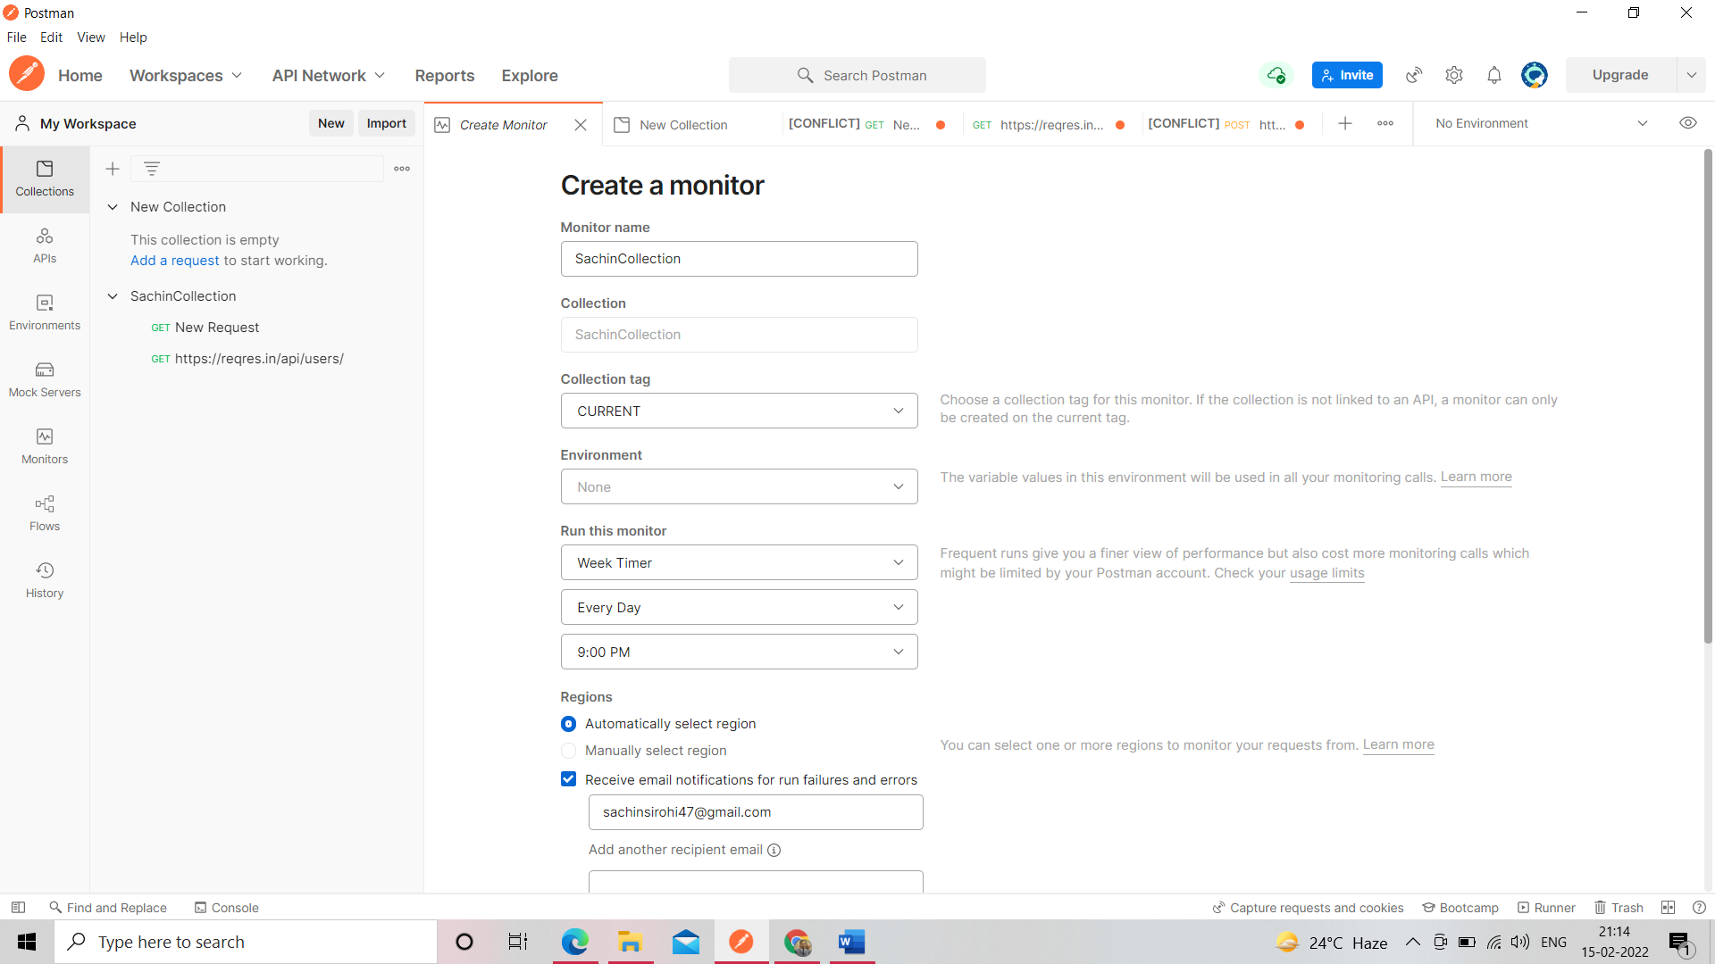

Run Monitor Collection after show this

We can also check geolocation and along with [www.runscope.com](http://www.runscope.com) by geolocation also

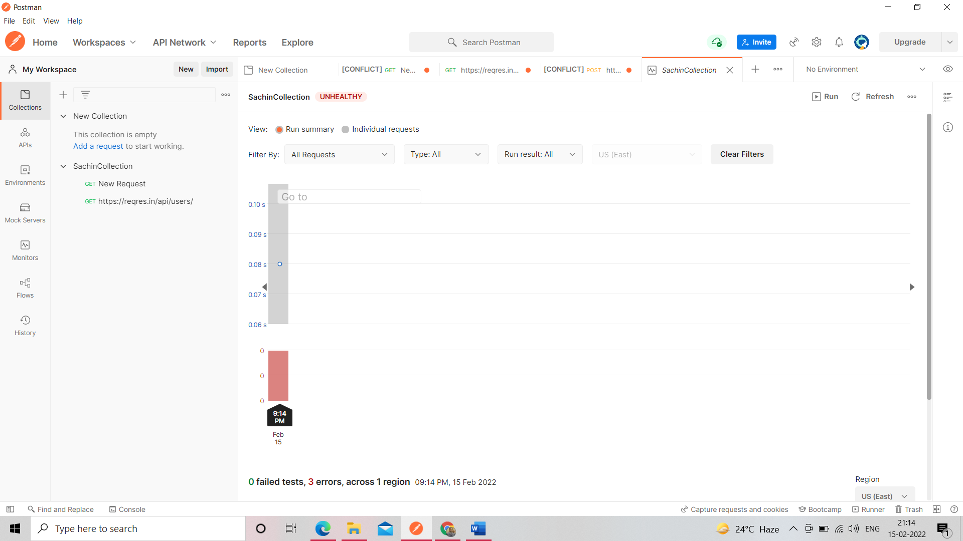

View Documentation and publish

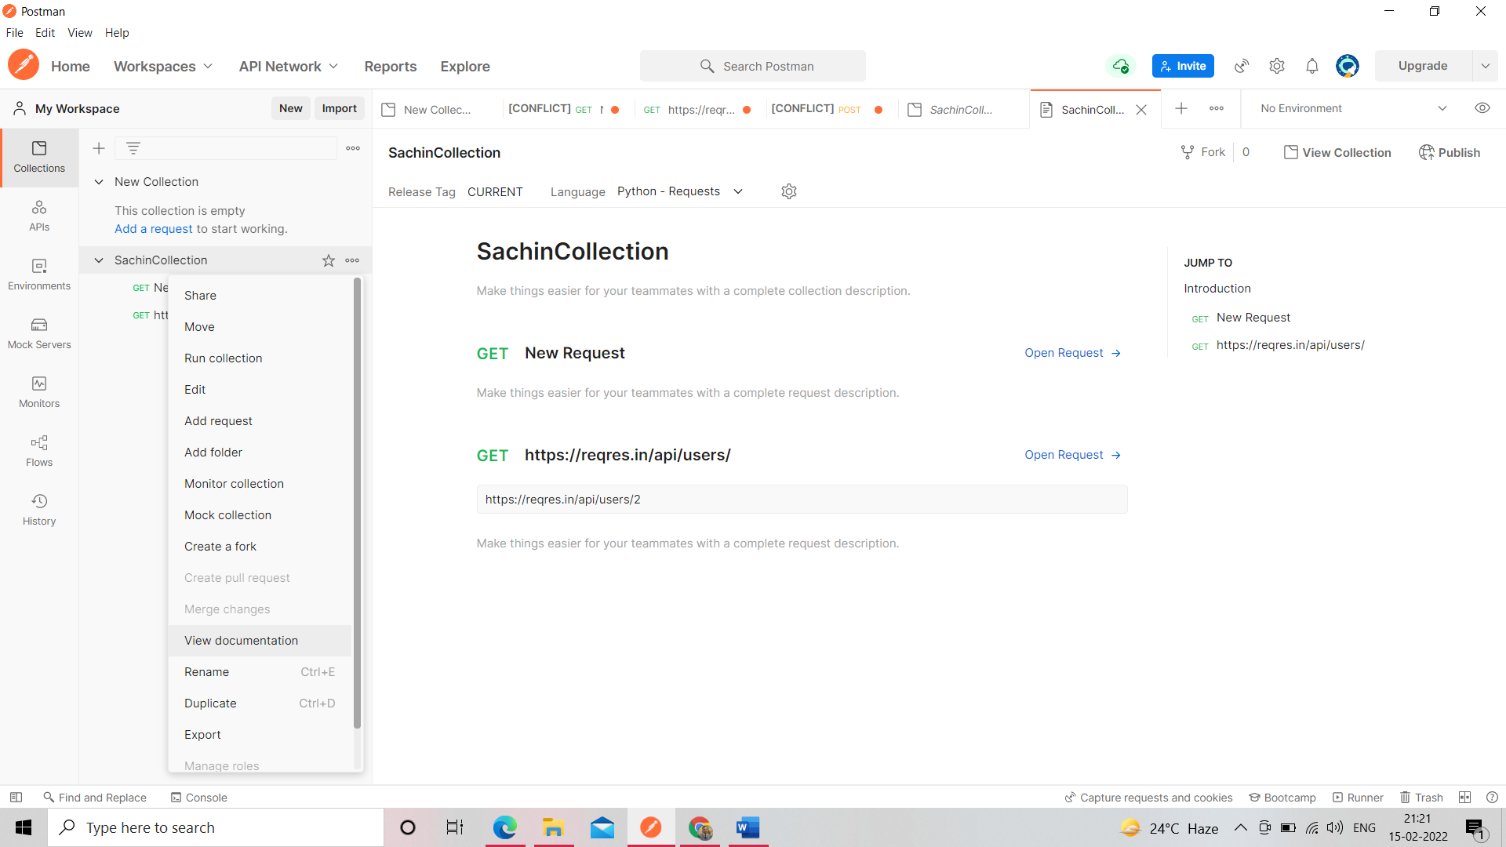

Collection Runner->click on run

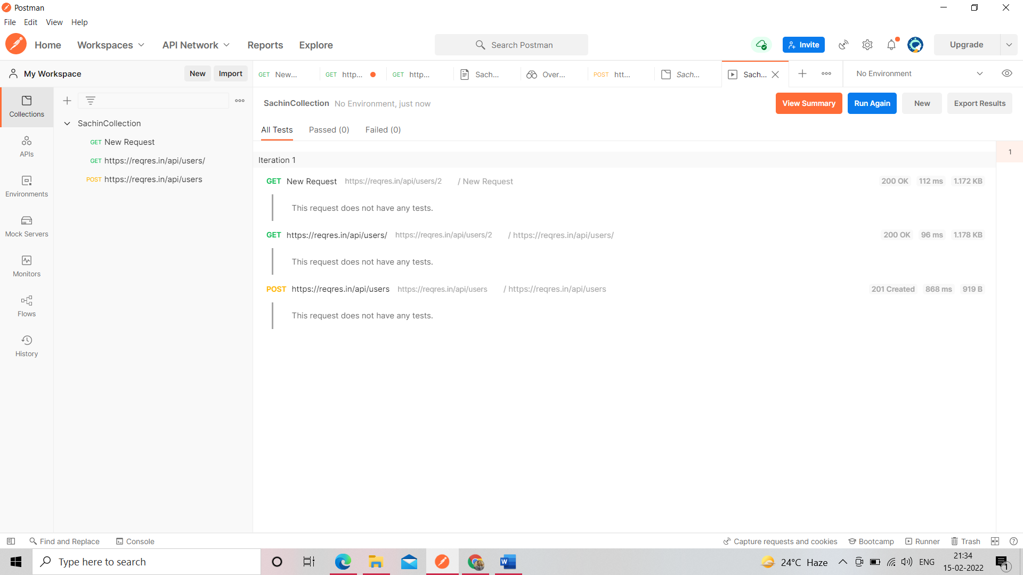

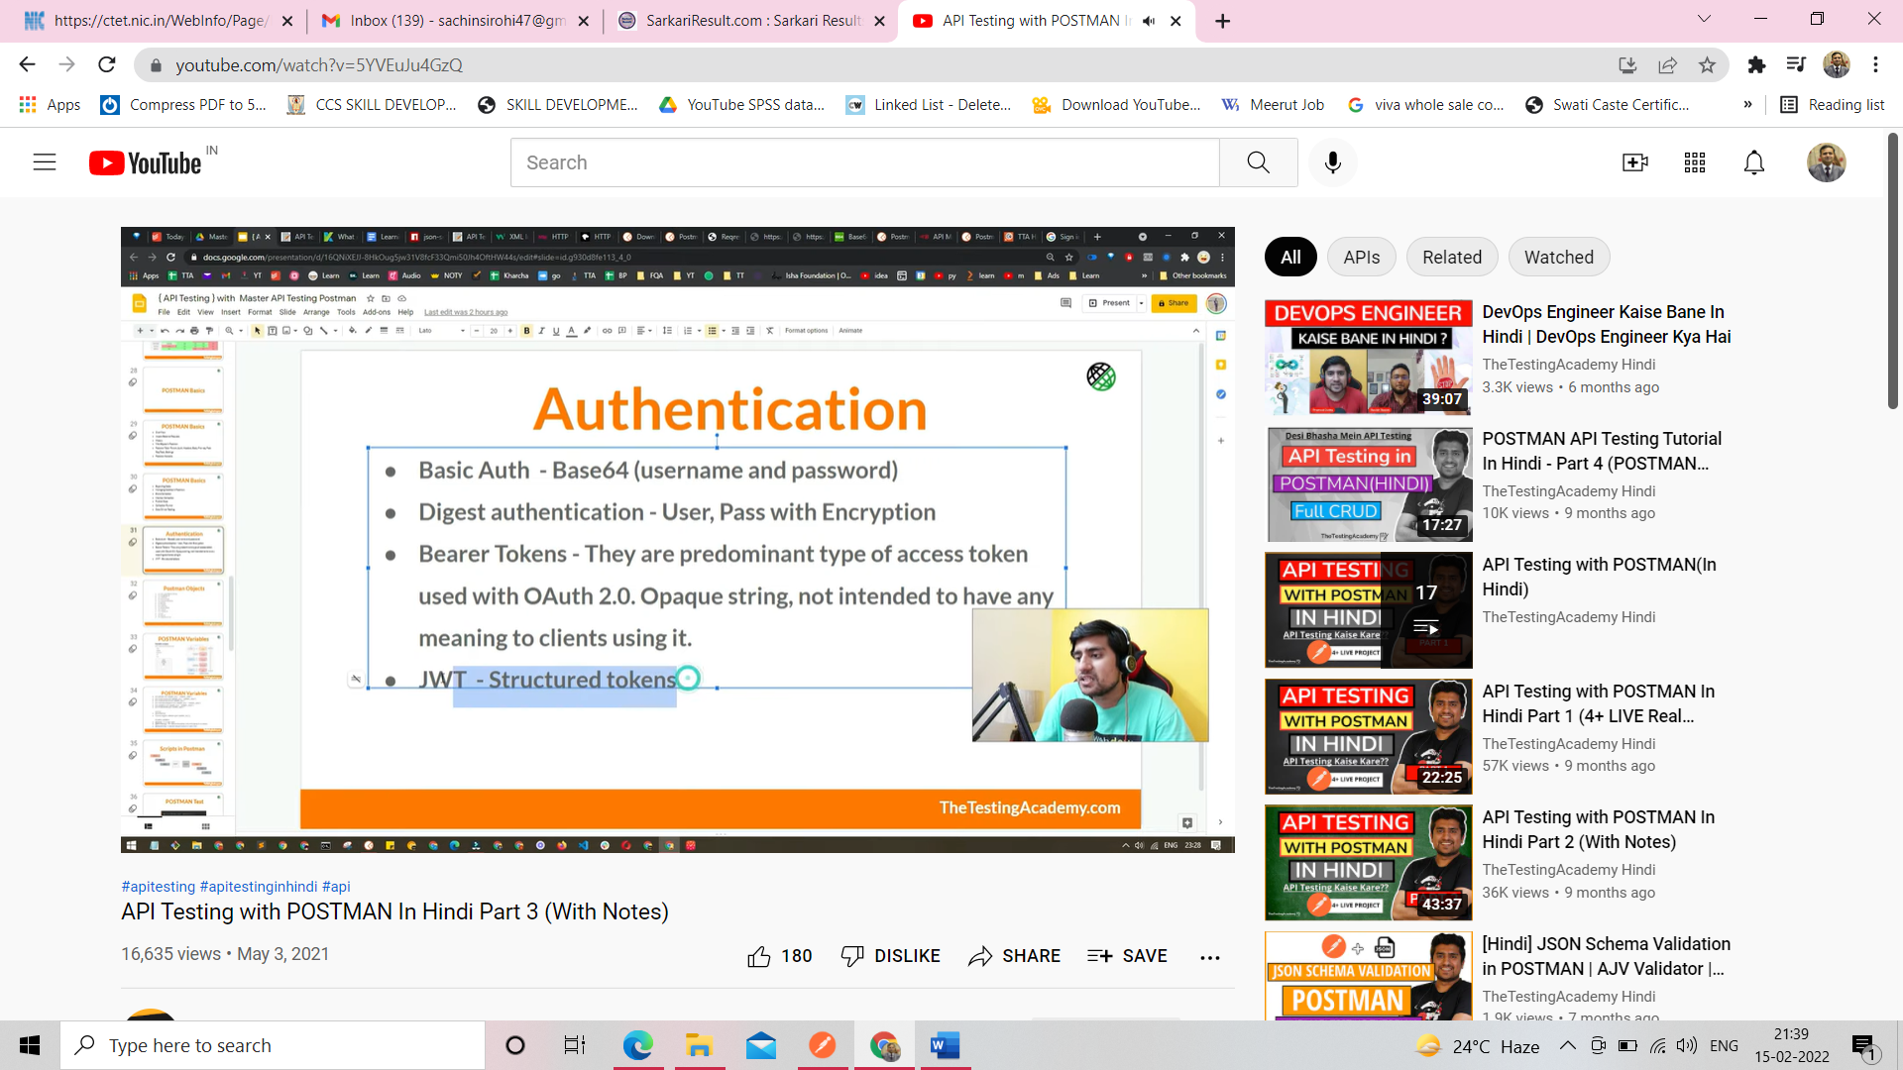

Jwt- json web token

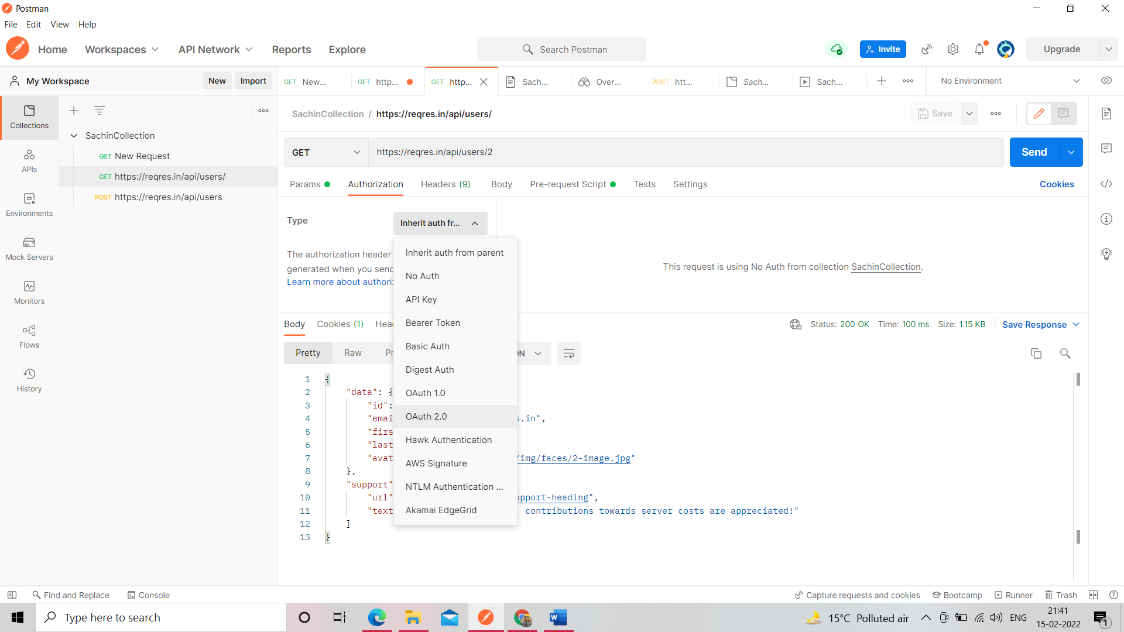

Go to fake api also see this command

Install Node Js Software

When Node js is install npm is automatically install no need to install

Install Json Server PowerShell= npm install -g json-server@v0.12.2

Open cmd check ->node -v

Check npm on cmd type->npm

Go to fake api

<https://www.npmjs.com/package/json-server>

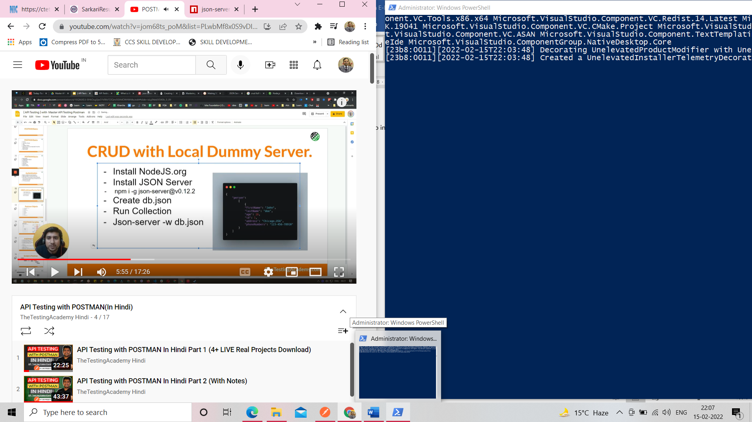

npm install -g json-server@v0.12.2

json-server --watch db.json

Create db.json on vs code and save any location

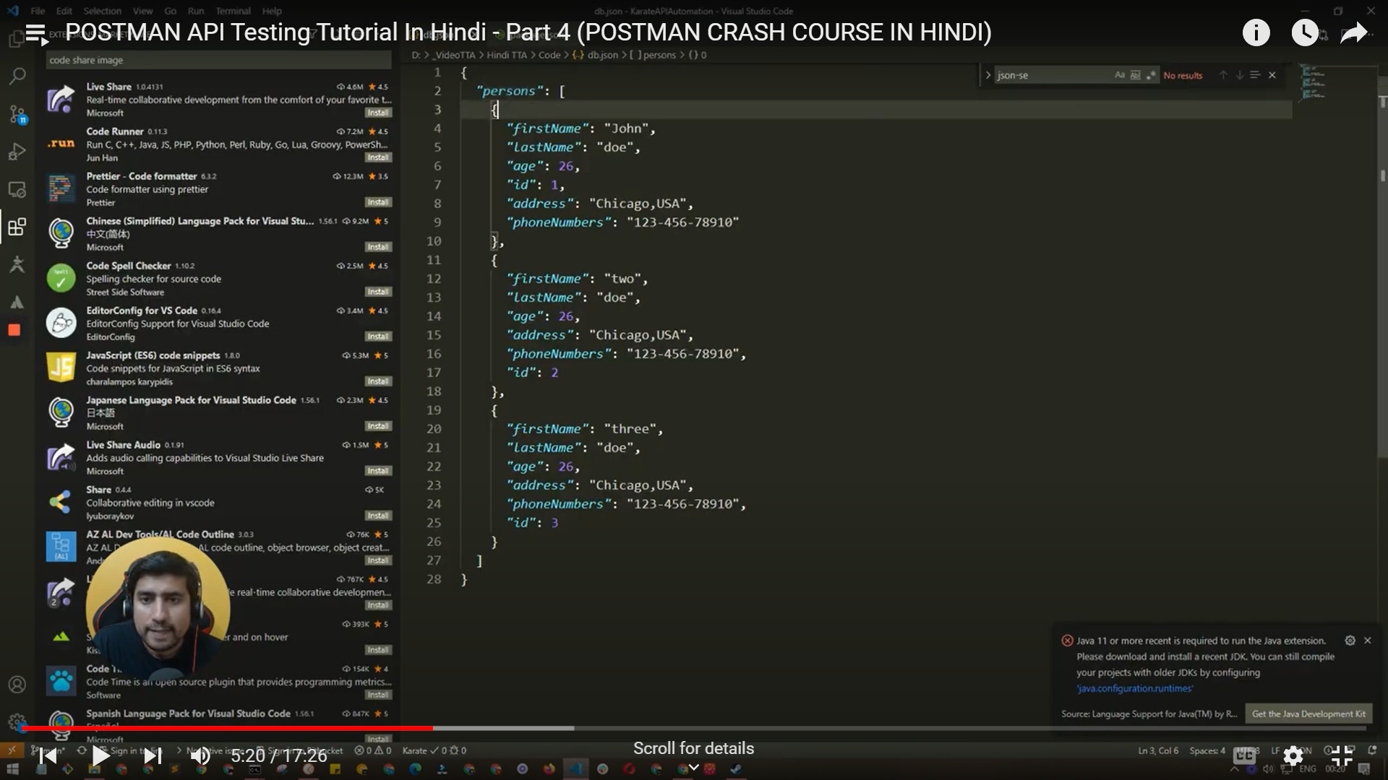

Change cmd path where db.json file is store and after run the - json-server --watch db.json

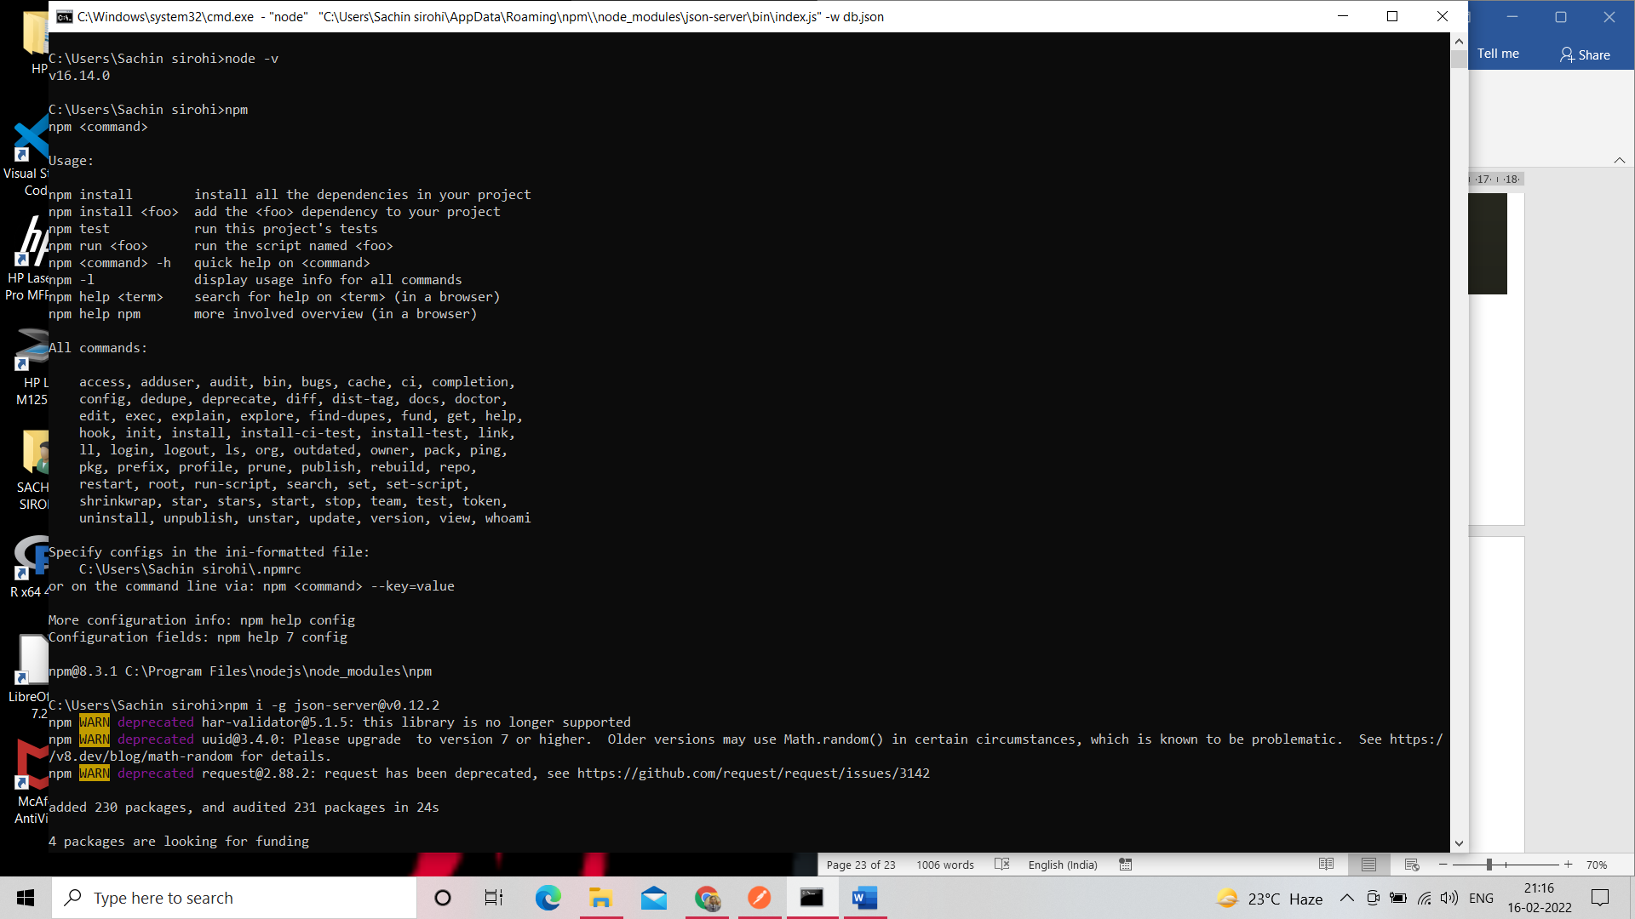

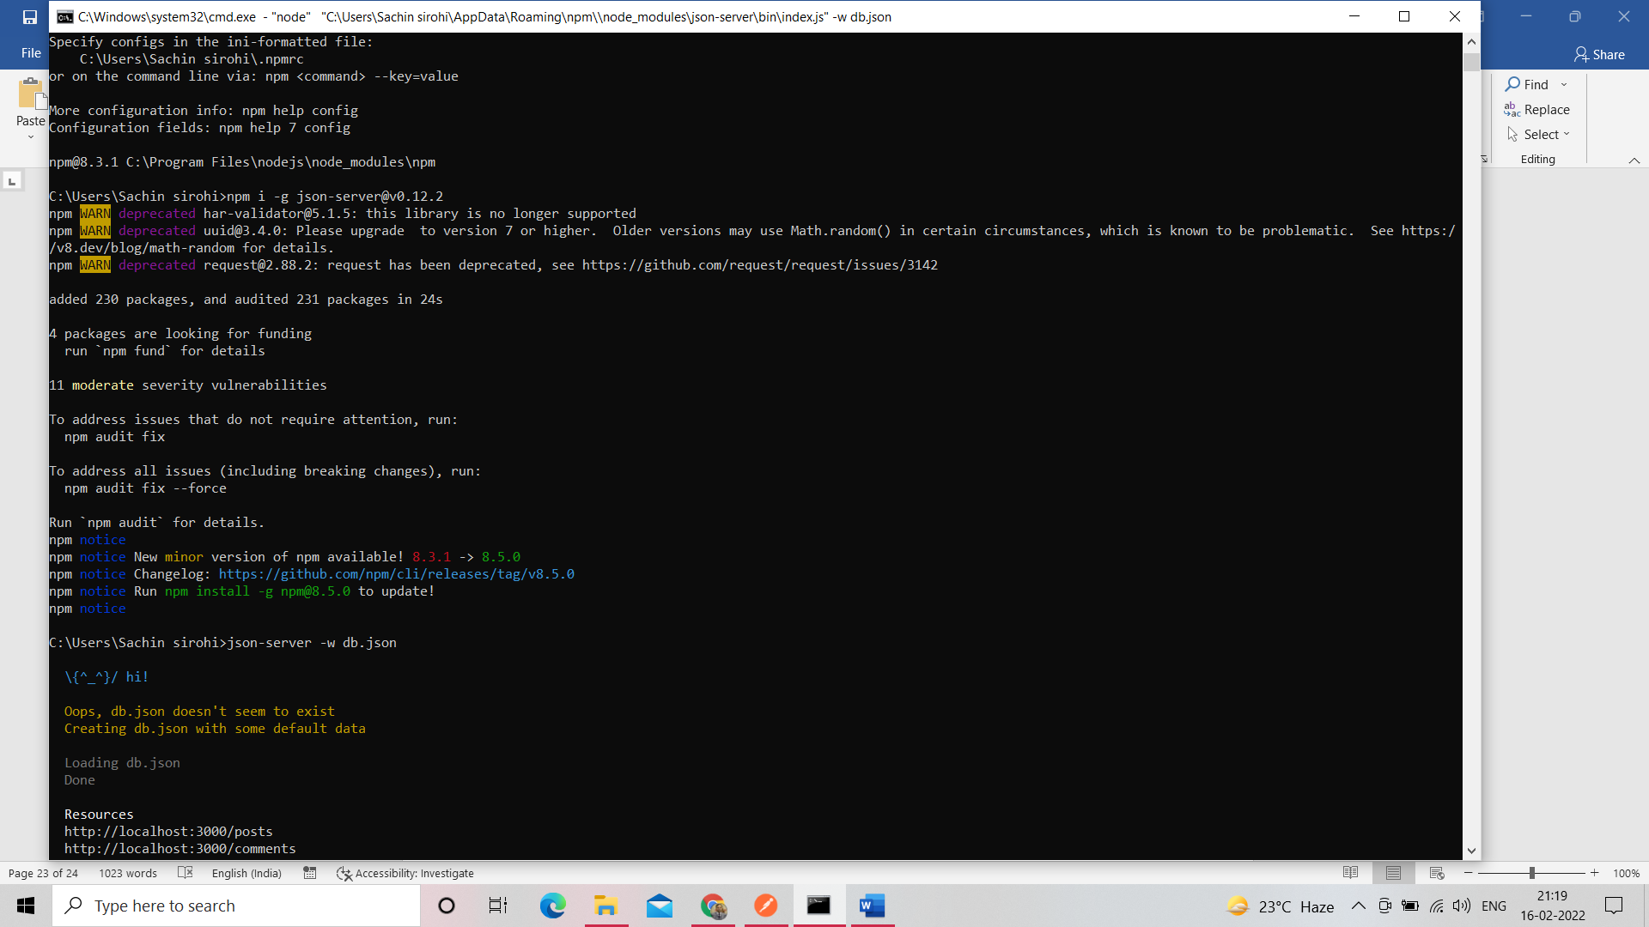

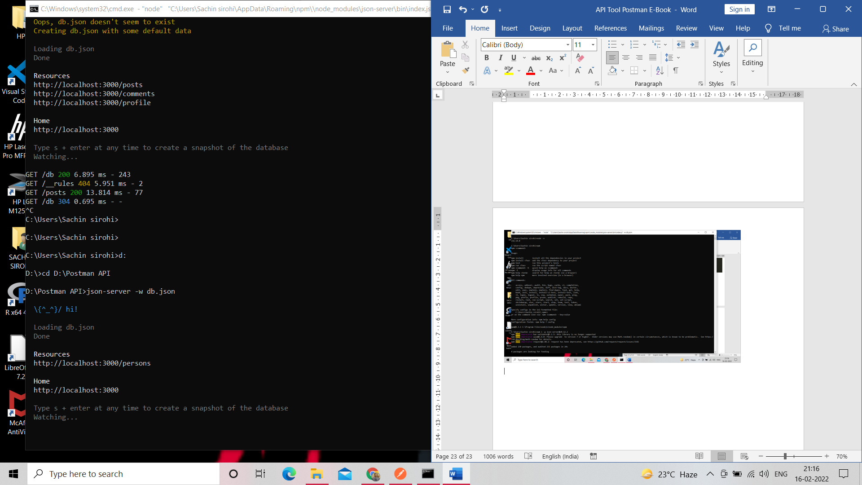

Open the web browser and type <http://localhost:3000/> after click person

<http://localhost:3000/persons>

Go to postman and create a request type above link

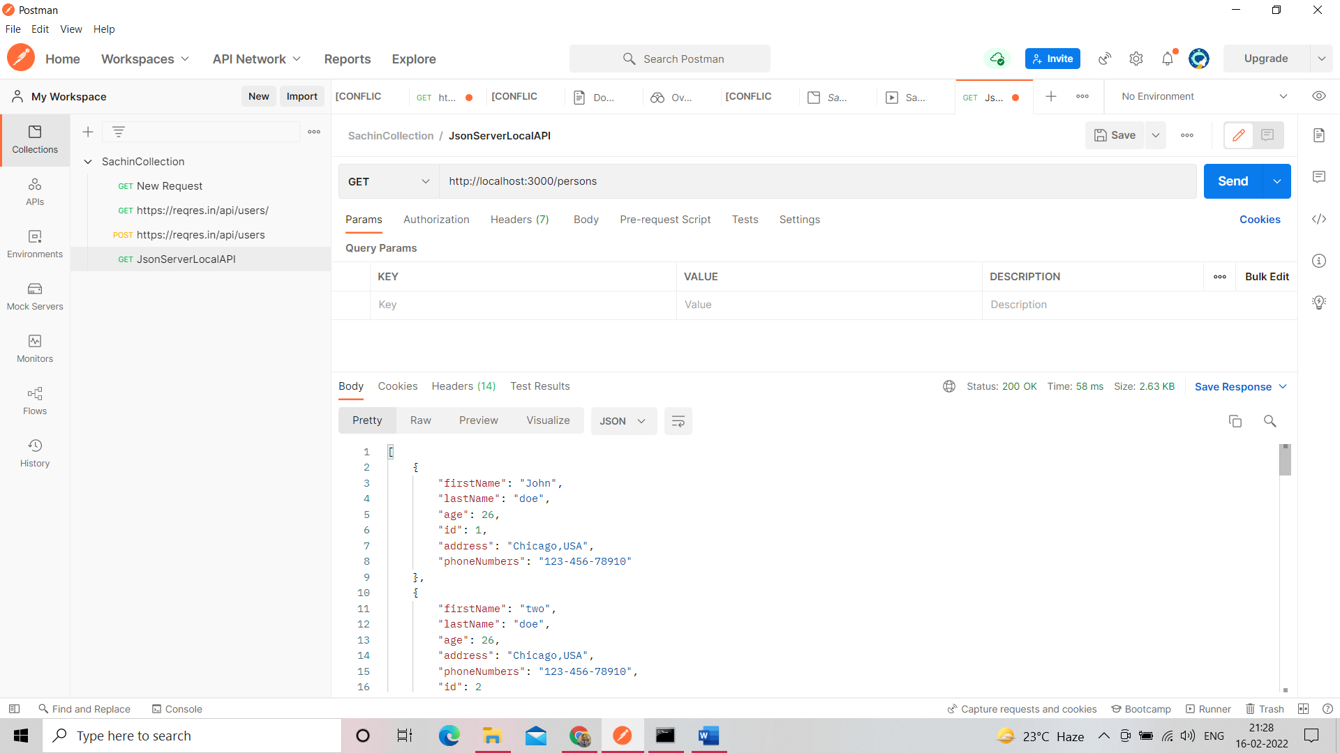

Create new person record by post request

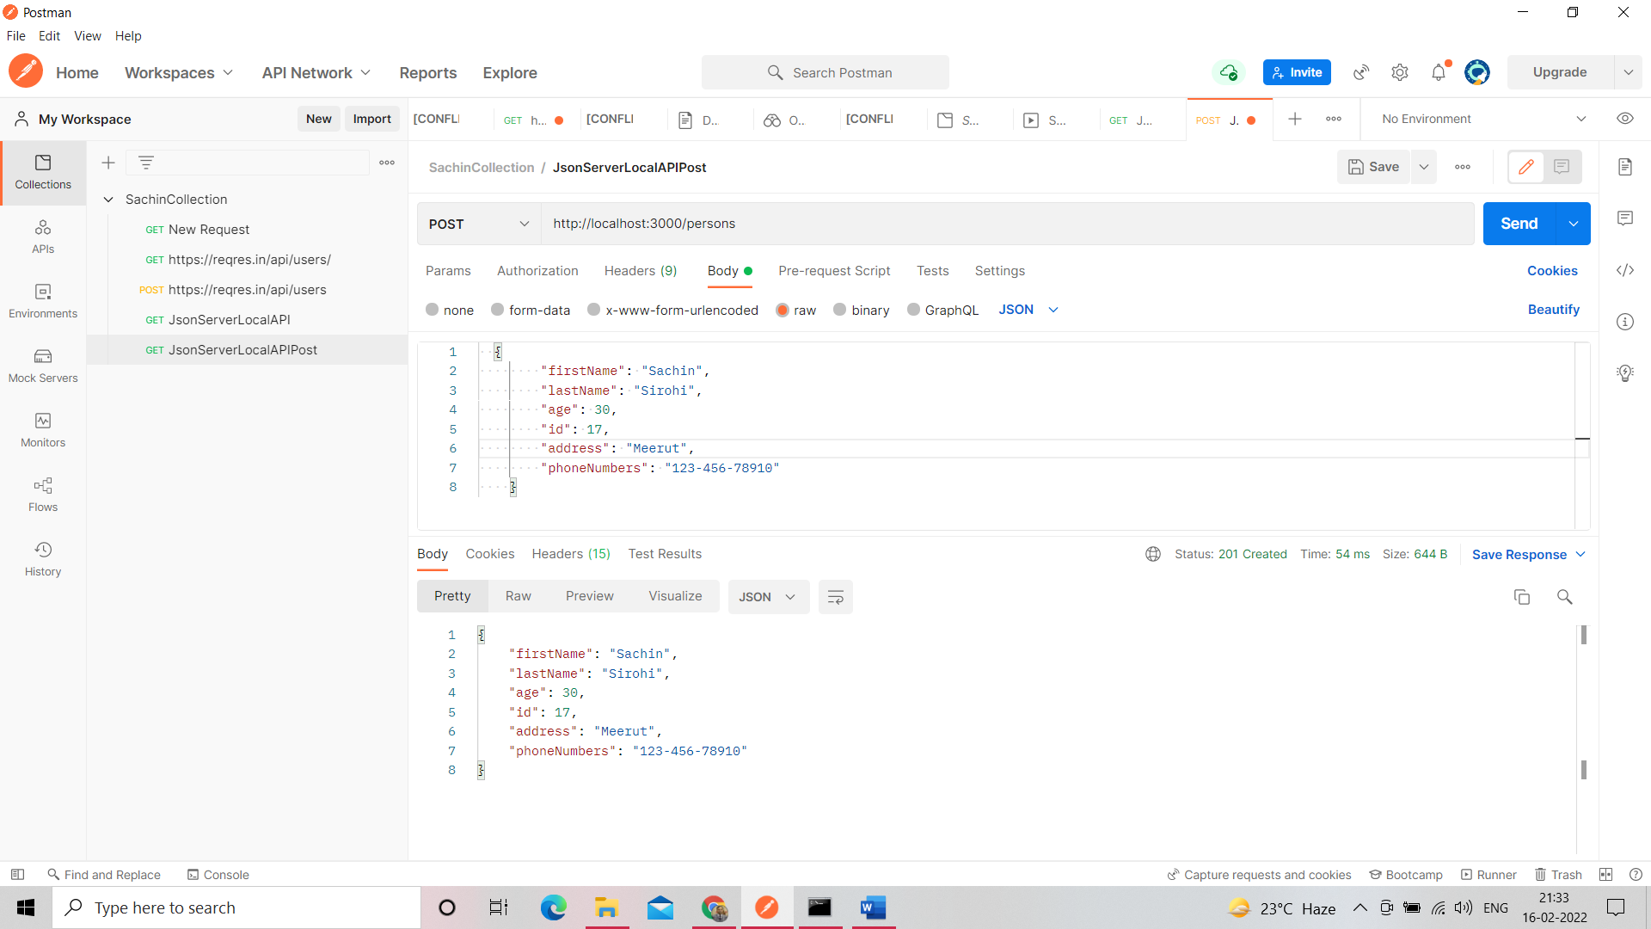

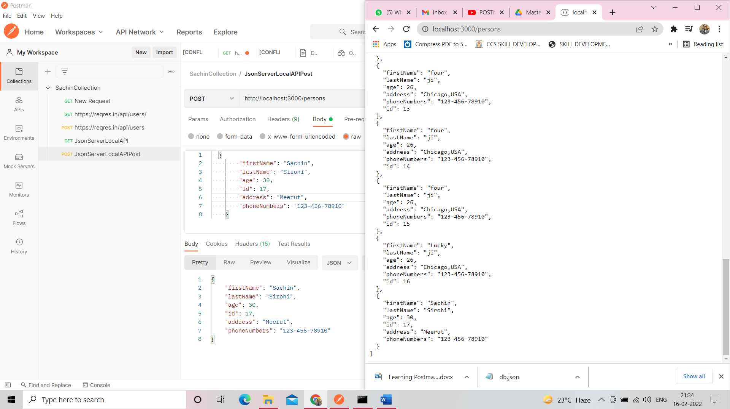

Patch Request change partial update into json file behalf of id

You can update only one record also

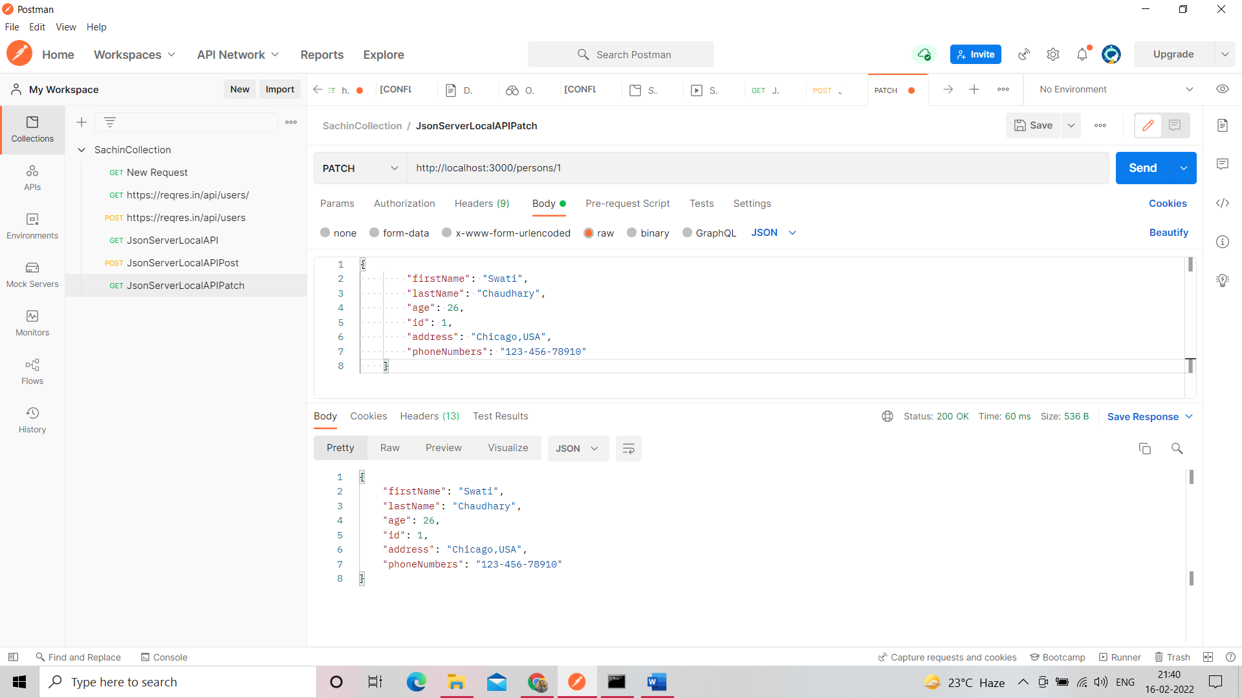

Partial Update

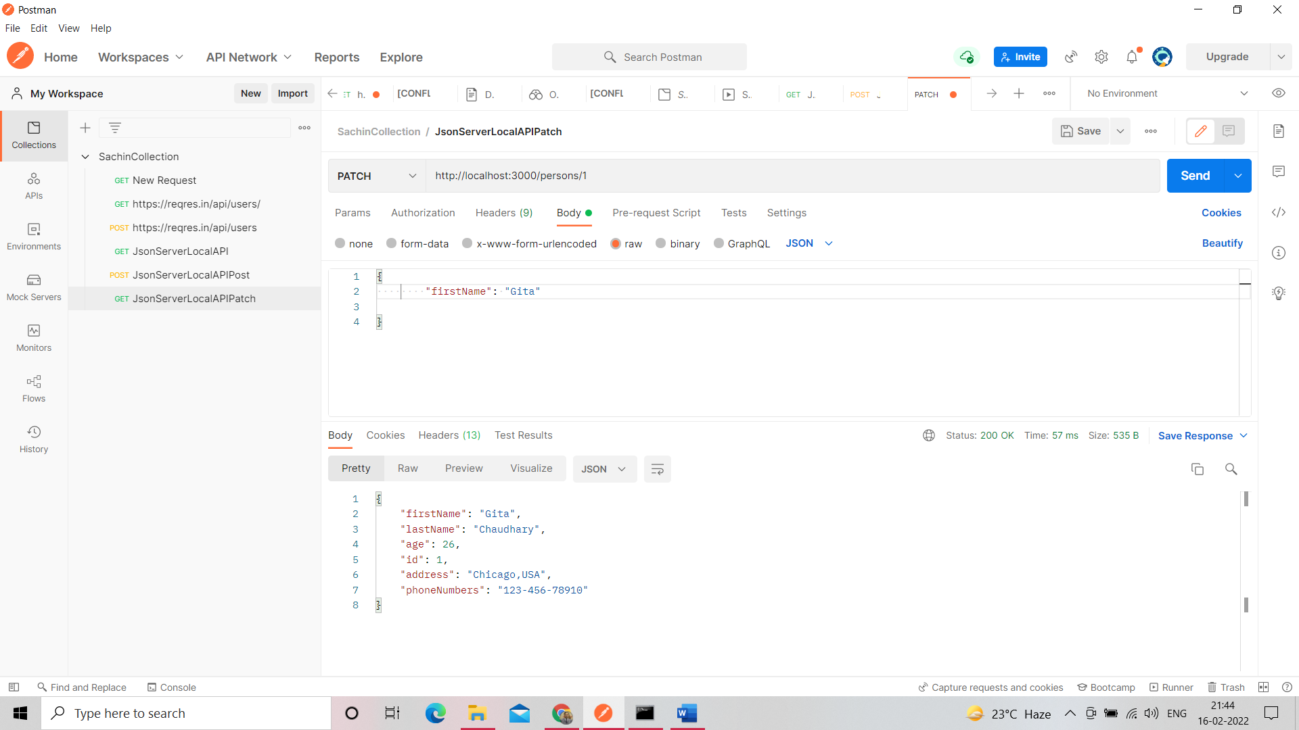

Put Request demand all value to supply but we can change one or more according to your need.

Put also update values whole

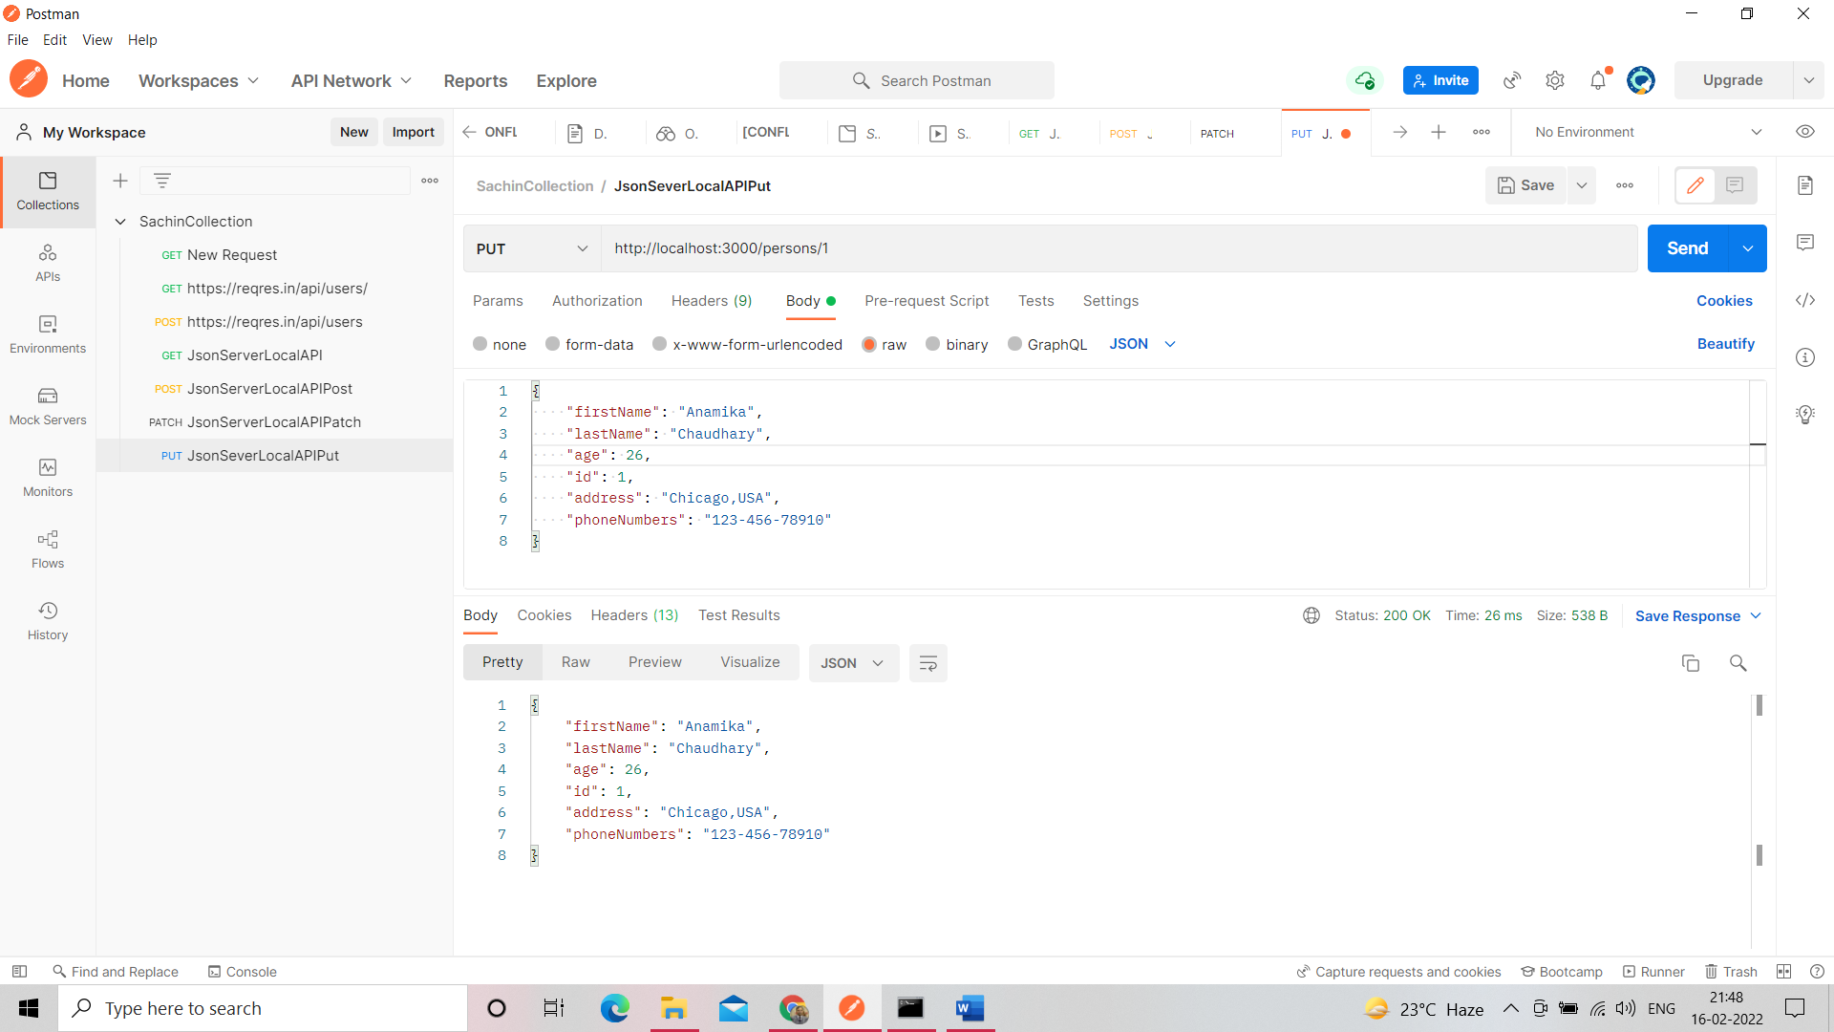

Delete the record behalf of id doesn’t show anything but show only status

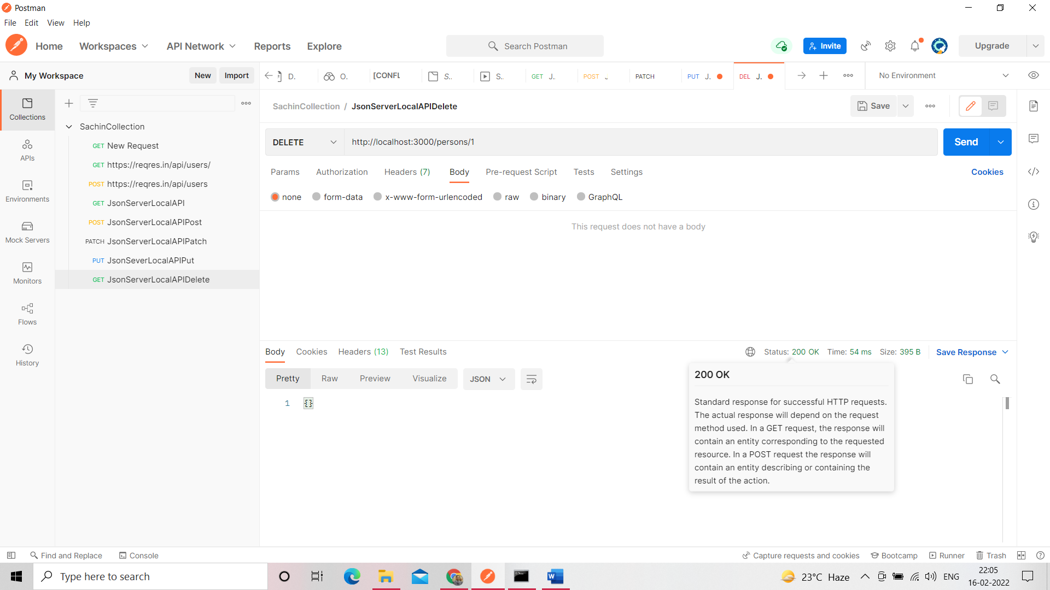

Integration Scenario with the help of test case

Post-Get-Patch-Del-Get-Post-Get work in flow

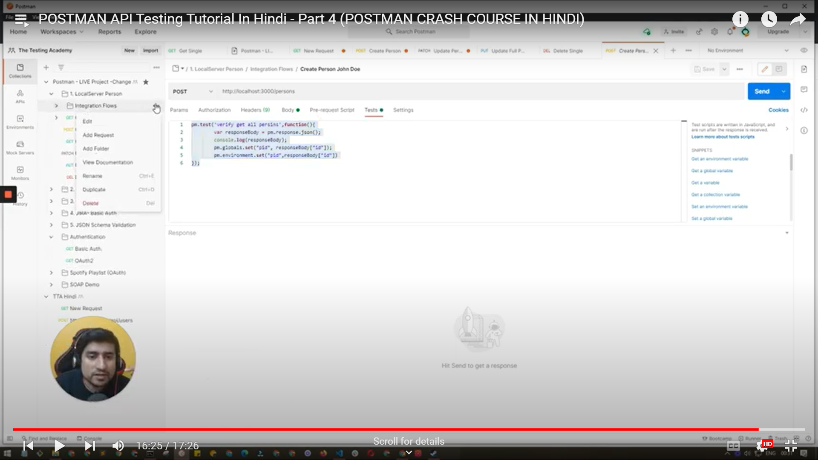

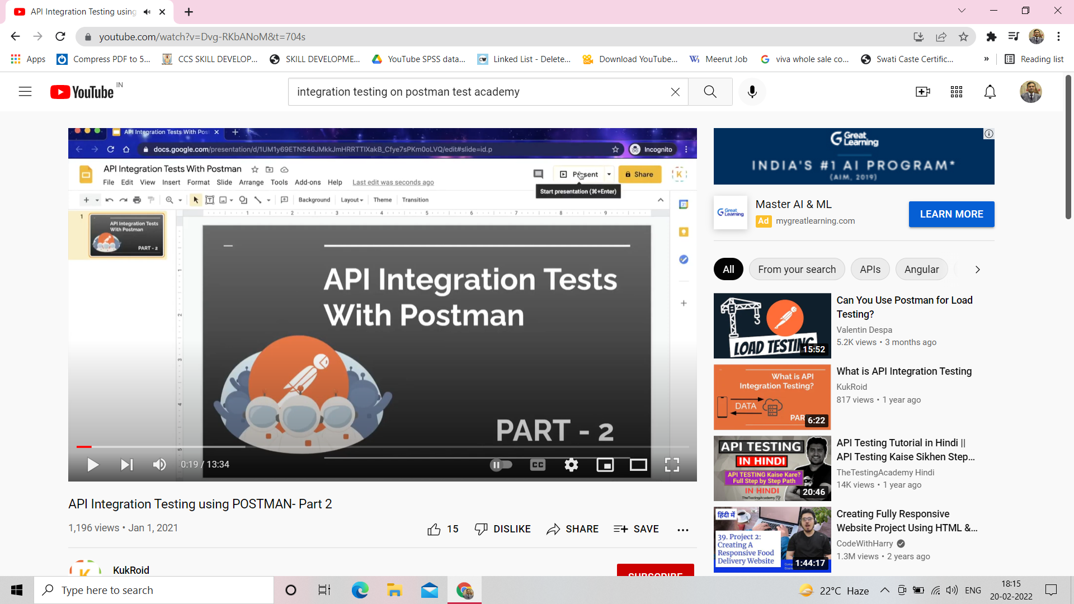

Go to API <https://cat-fact.herokuapp.com/facts>

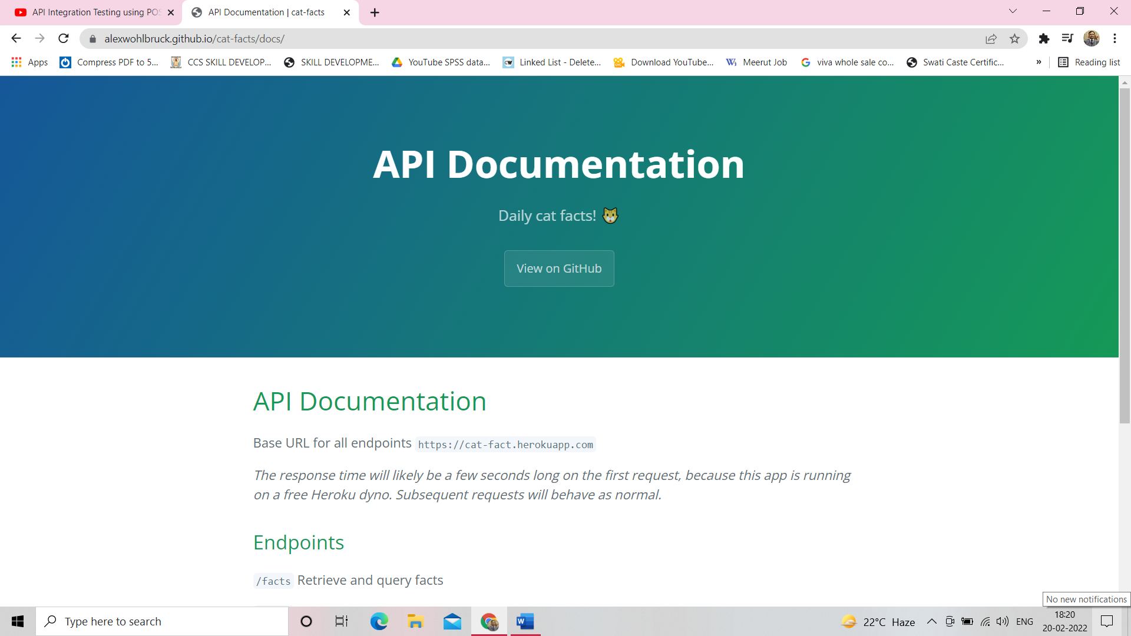

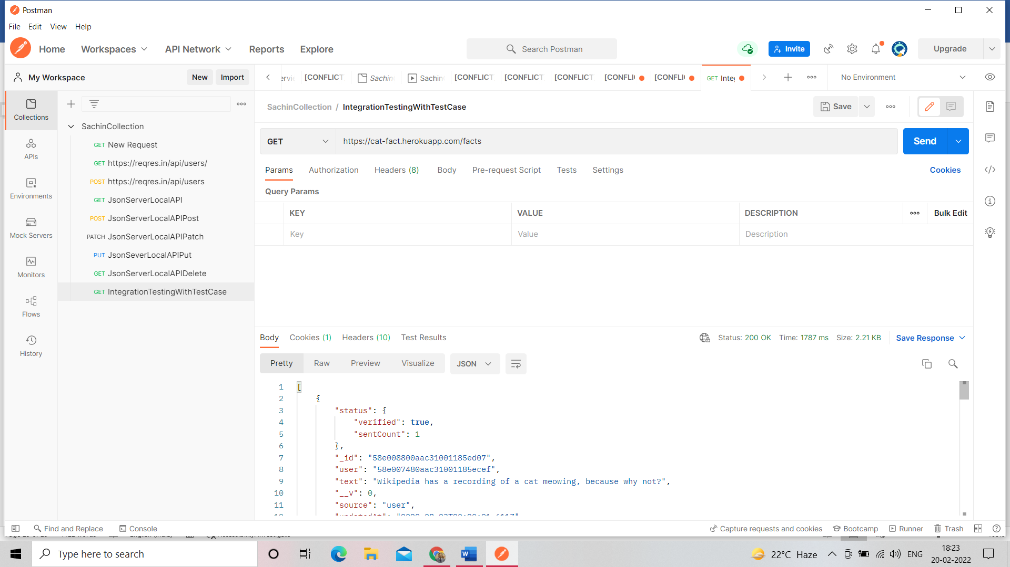

Copy Pate postman API json code into online json formatter [https://jsonformatter.org/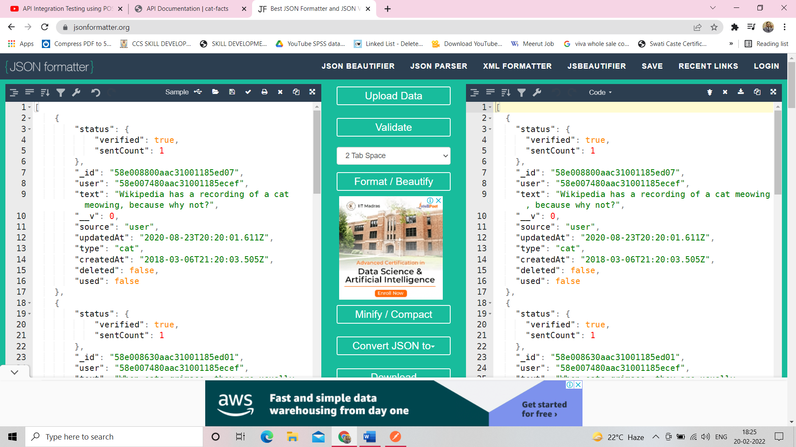](https://jsonformatter.org/)

See object minimize click side in number 2

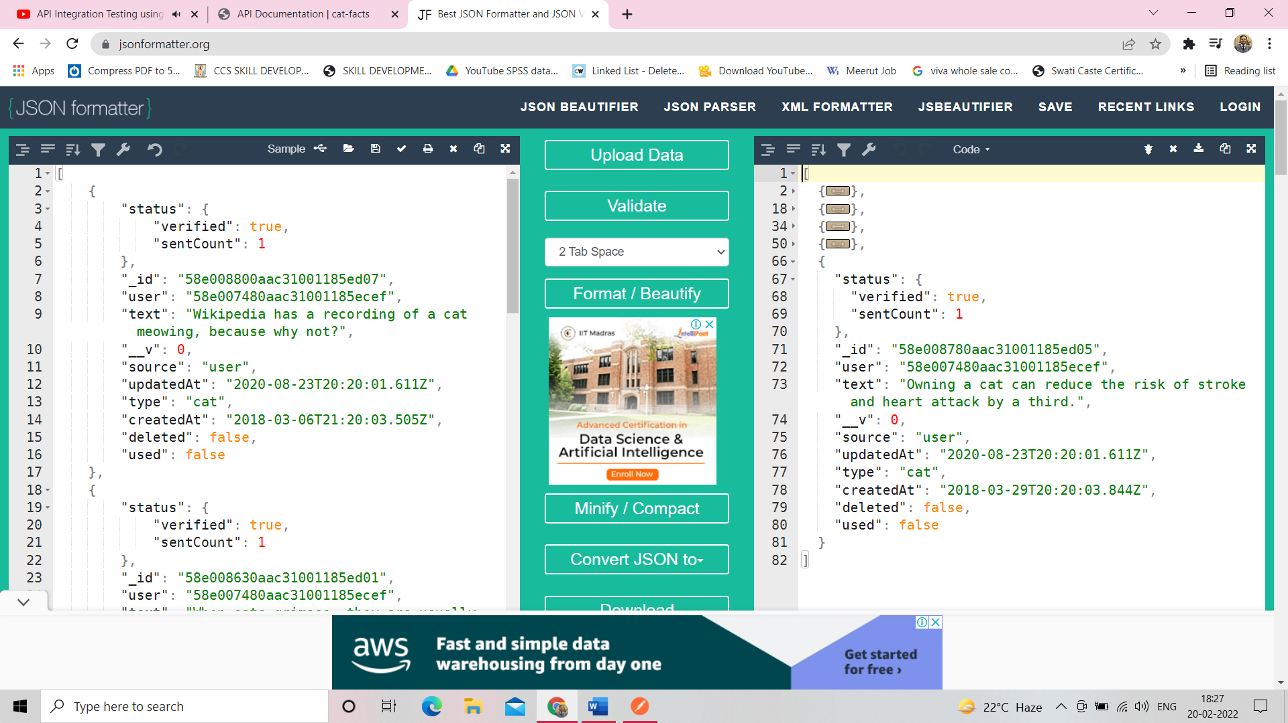

Test Case click on Test->Status Code: Code in 200

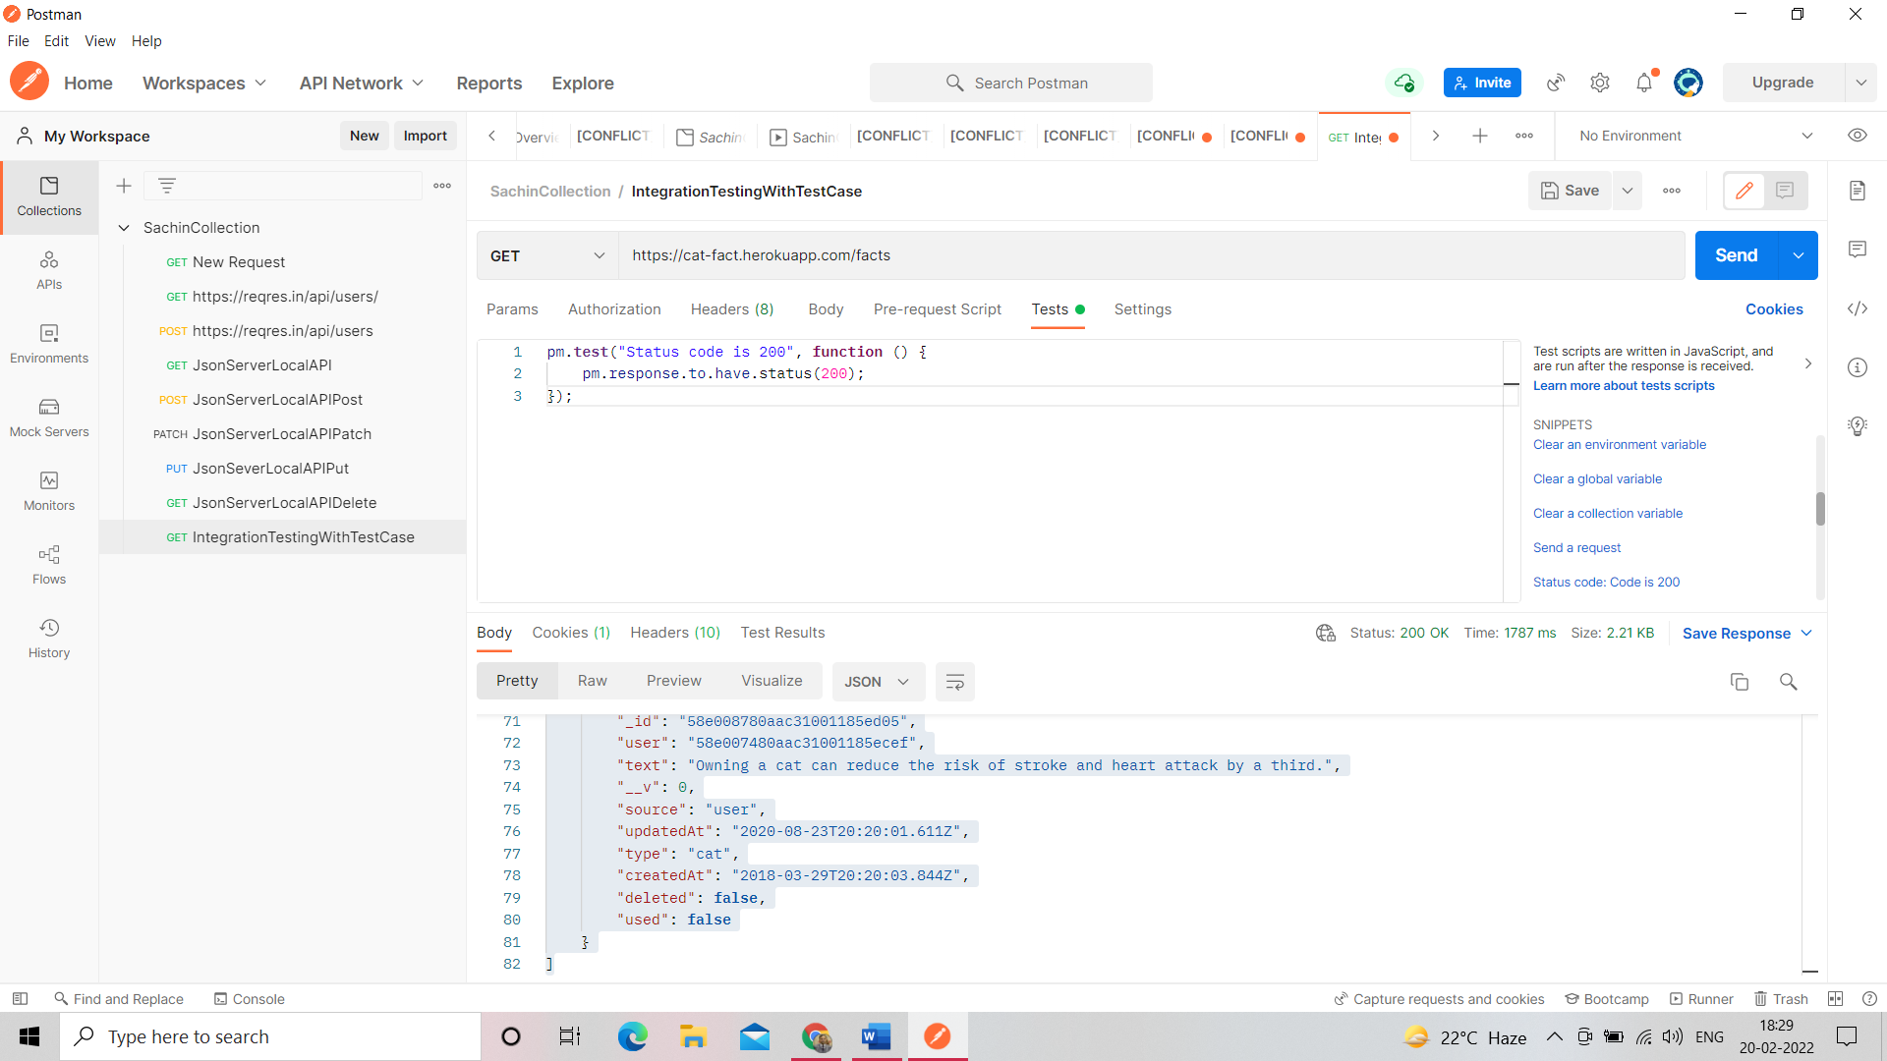

Check test case result -> click on send->see Test Results

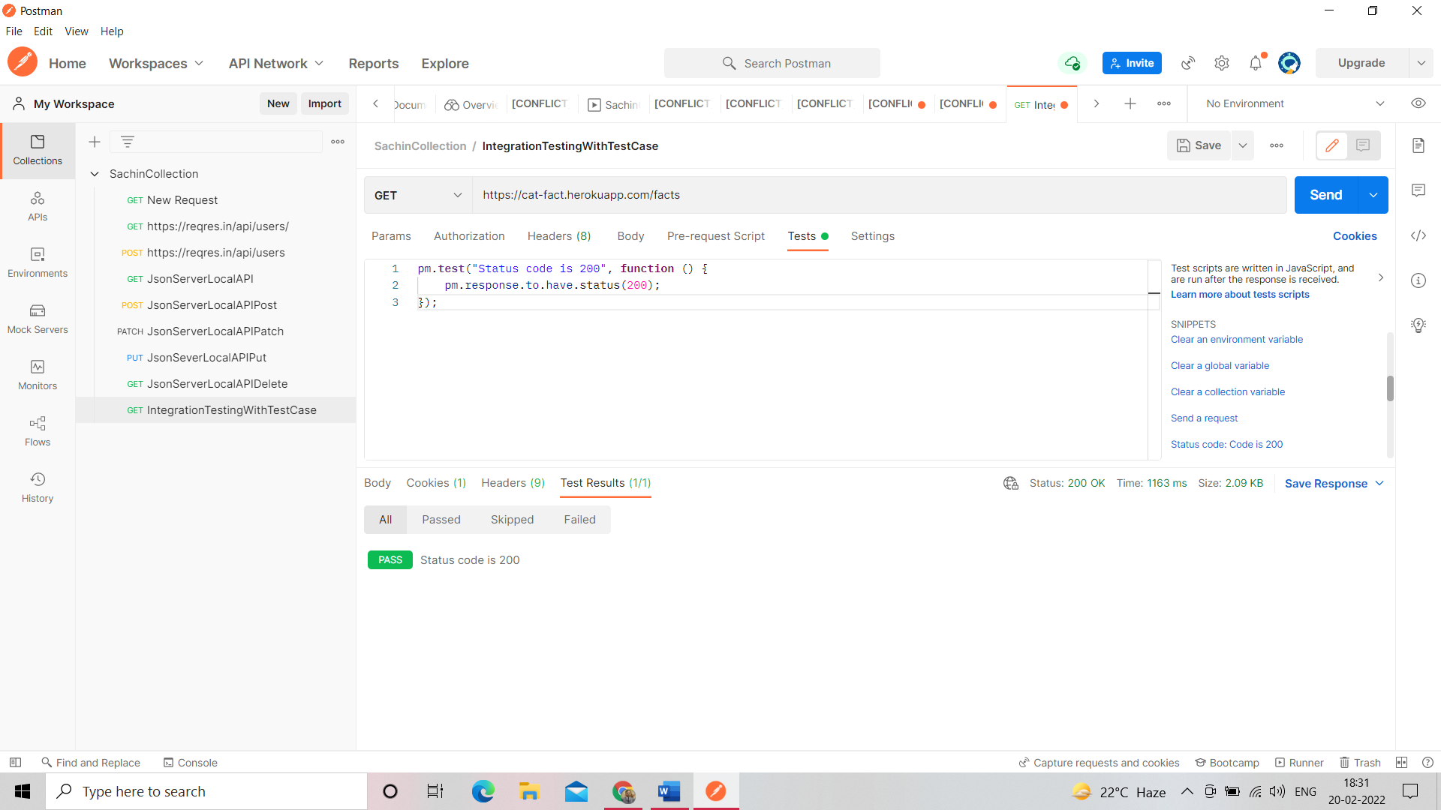

Json Schema Validator format ->click on->use Tiny validator for JSON Data

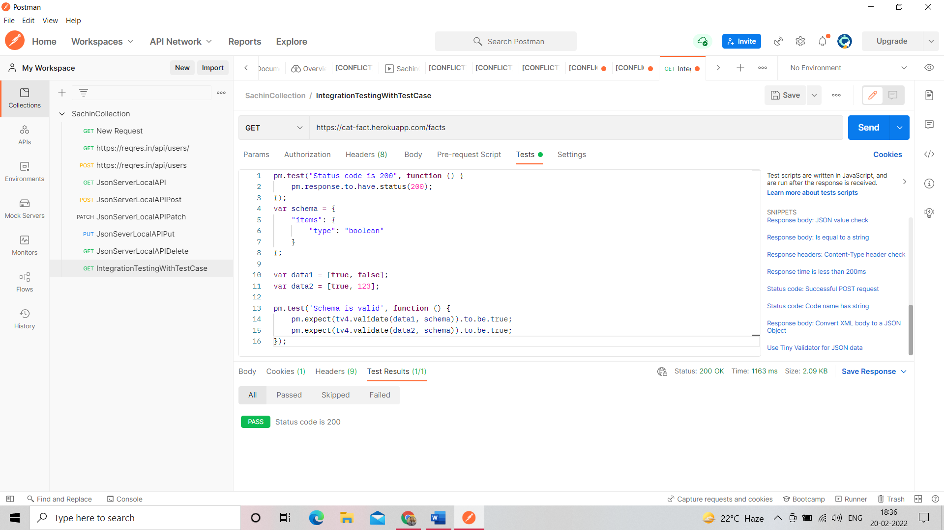

Convert Json to json Schema online ->https://www.liquid-technologies.com/online-json-to-schema-converter

Copy post man json API Code and paste online and generate json schema and copy paste json schema into postman

Var schema={ };

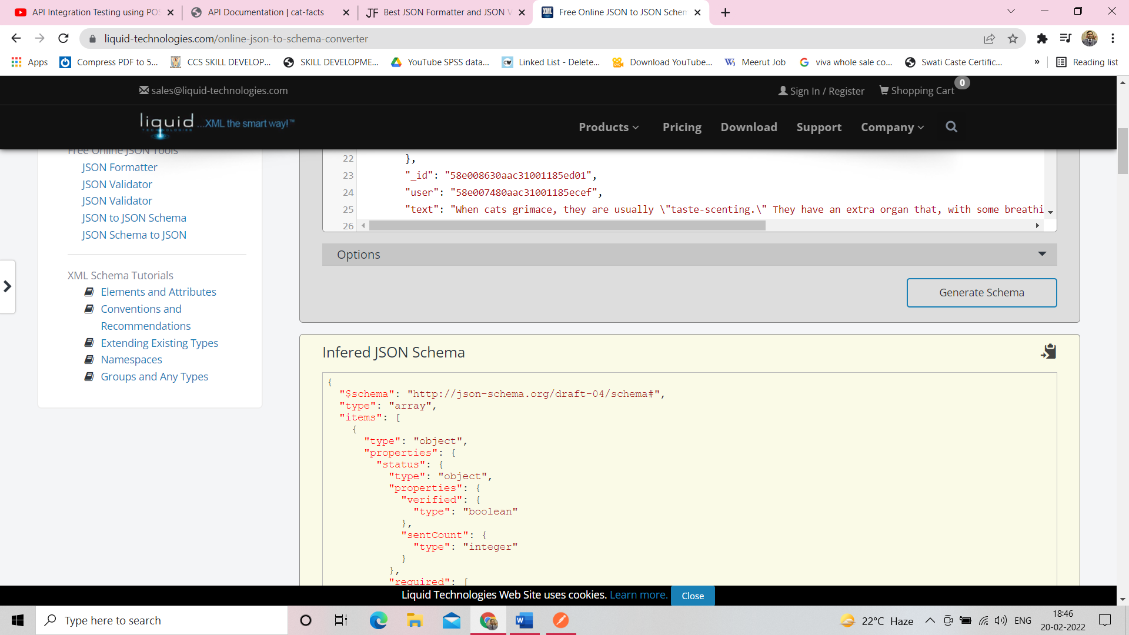

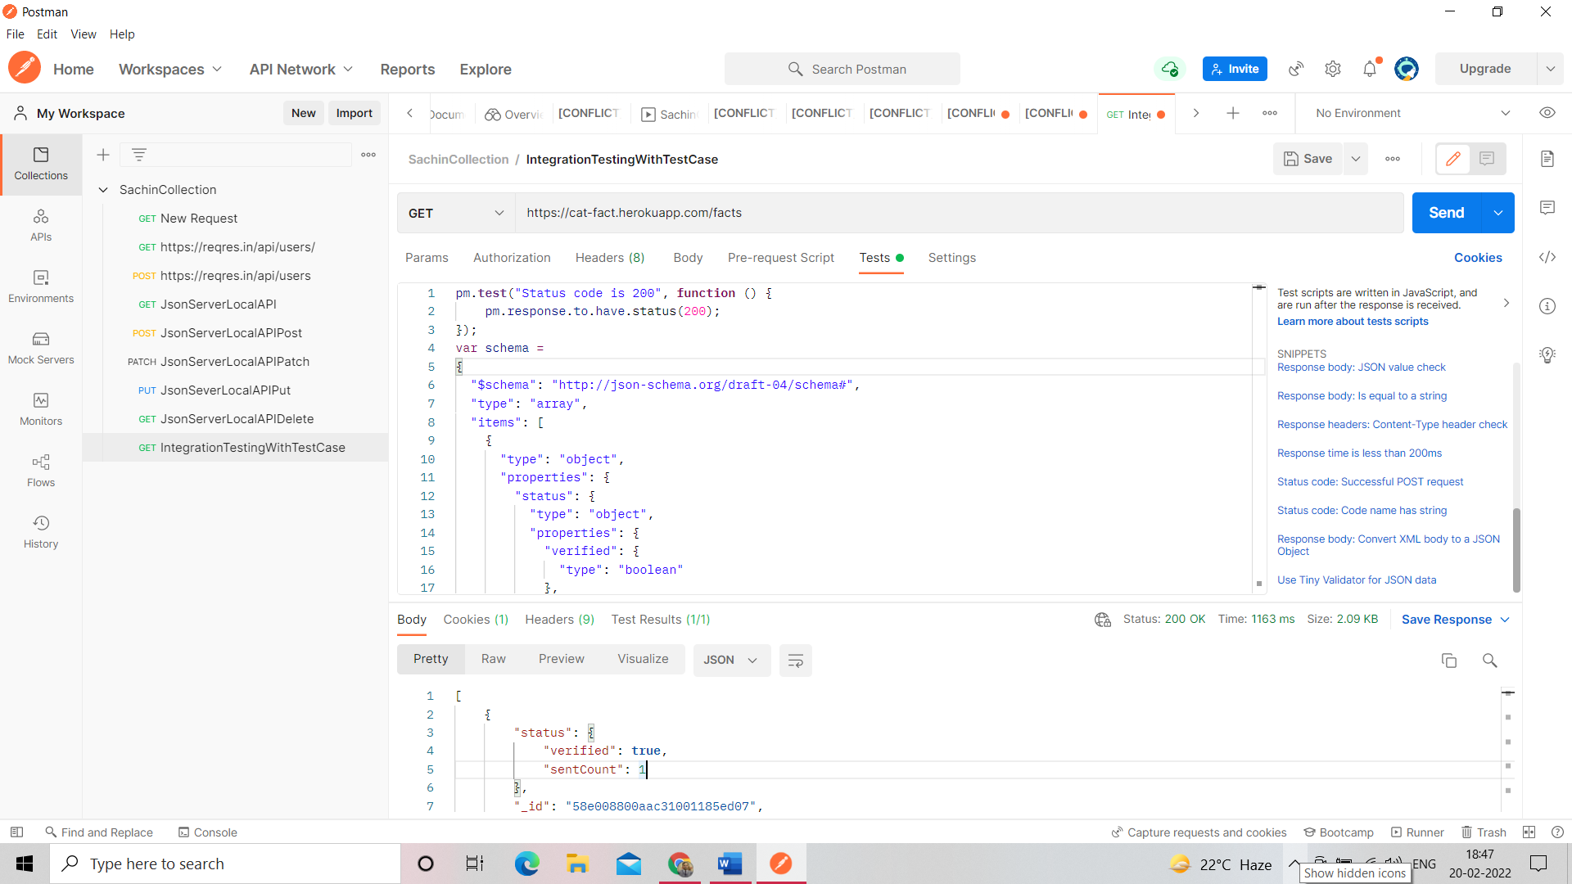

Remove data1 and data2 from postman

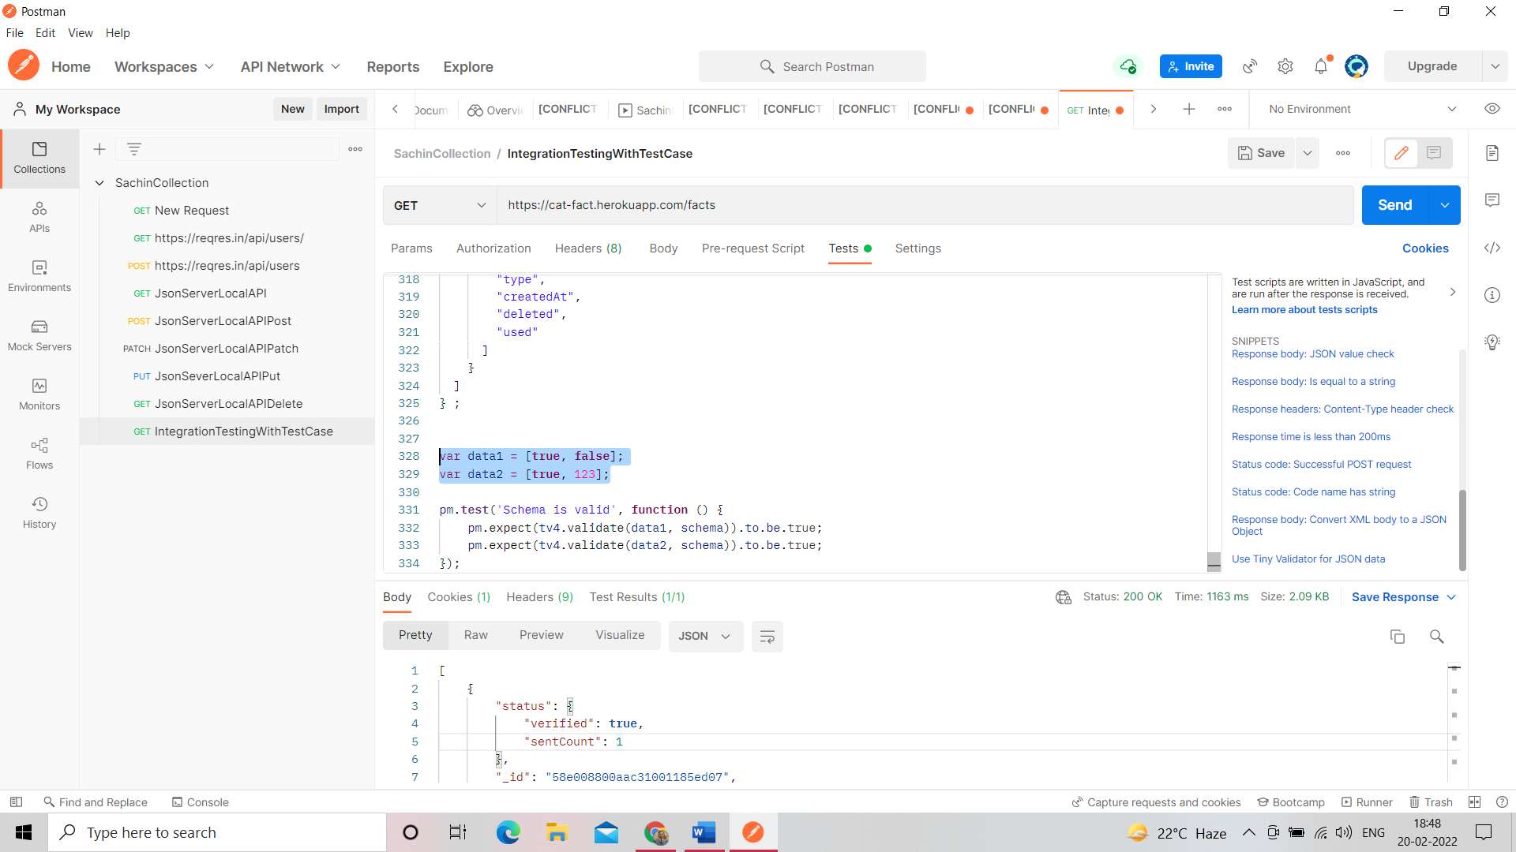

After remove data1 and data2

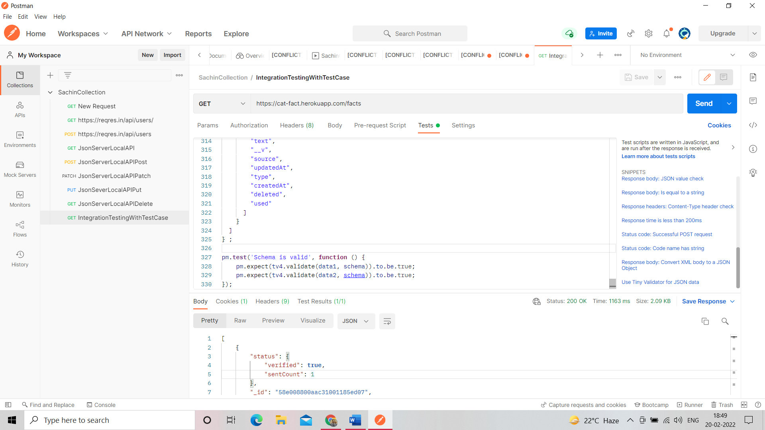

Write test case

pm.**test**('Sachin Sirohi Test Case', **function** ()

 {

     var result**=**tv4.validateResult(pm.response.json(),schema);

**if** (**!**result.valid)

    {

        console.**log**(result)

    }

    pm.expect(result.valid).to.be.true;

});

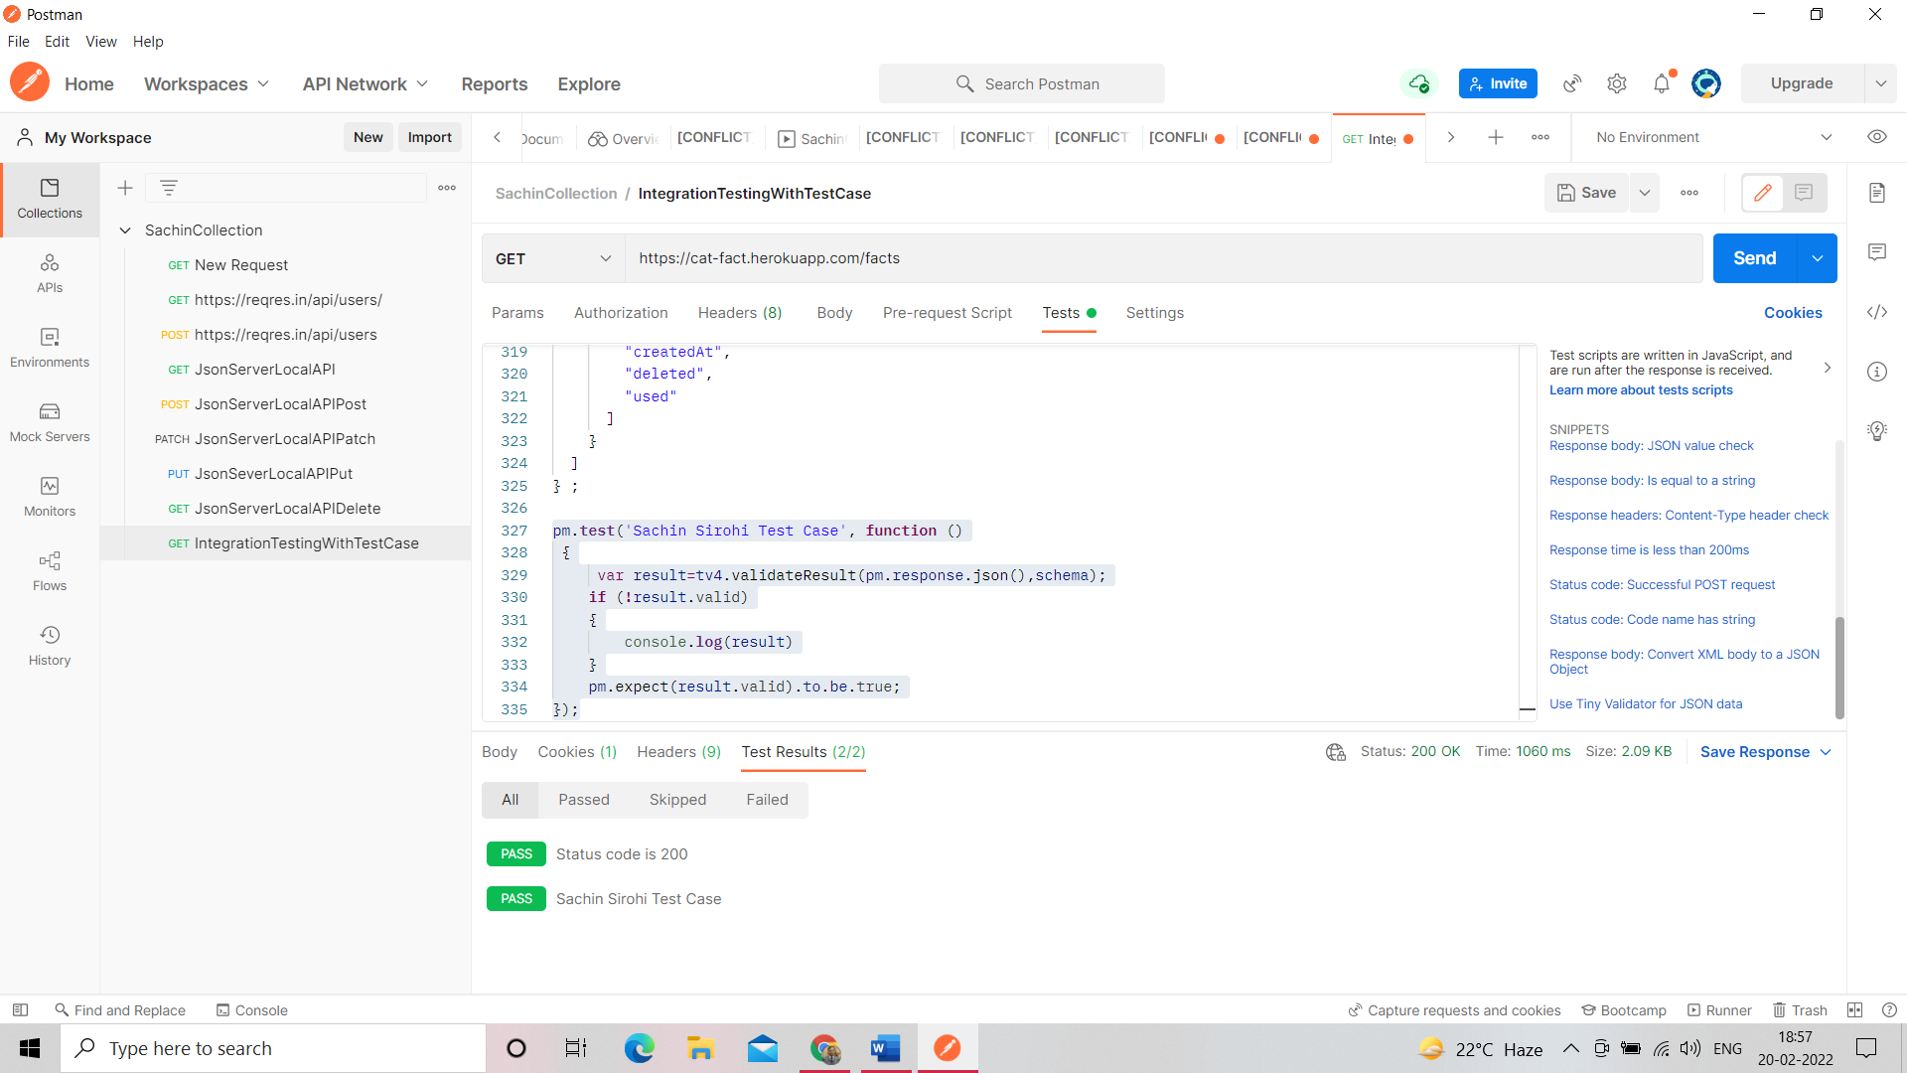

If we change    "sentCount": {

              "type": "integer"

            }

To    "sentCount": {

              "type": "string"

            }

Show test case fail because we can’t supply string value into integer

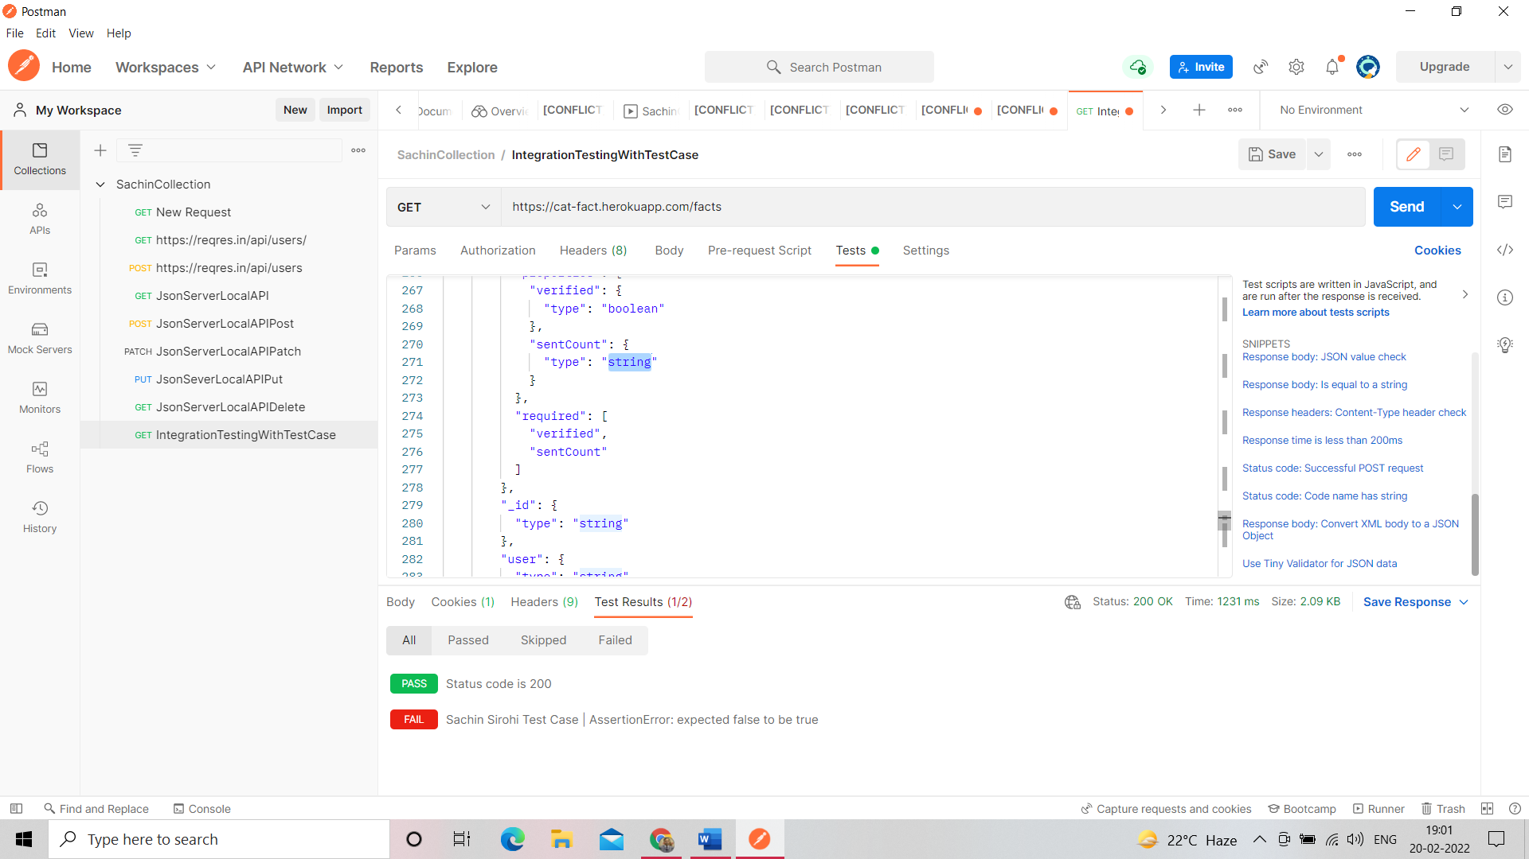

See error in console below postman window invalid type error

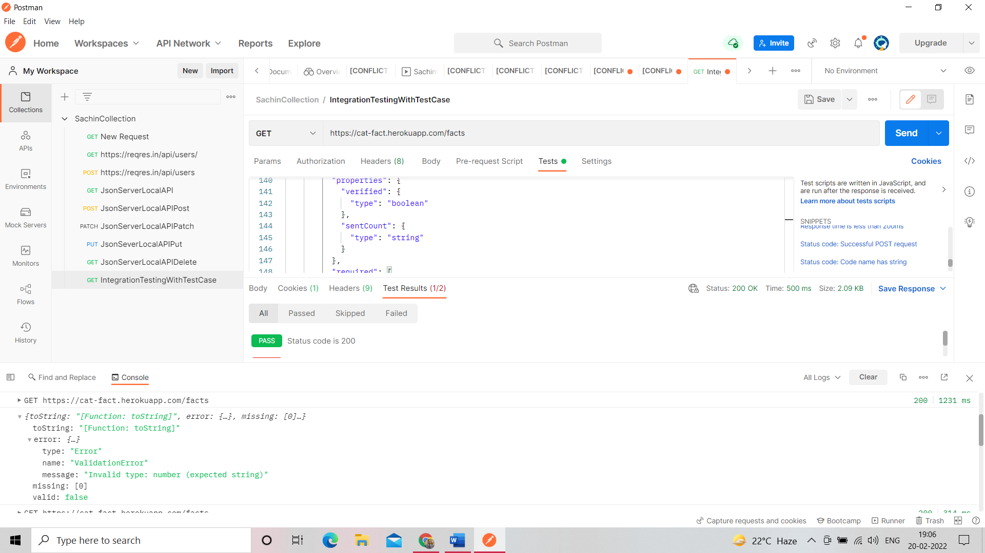

After you can run API Test Case

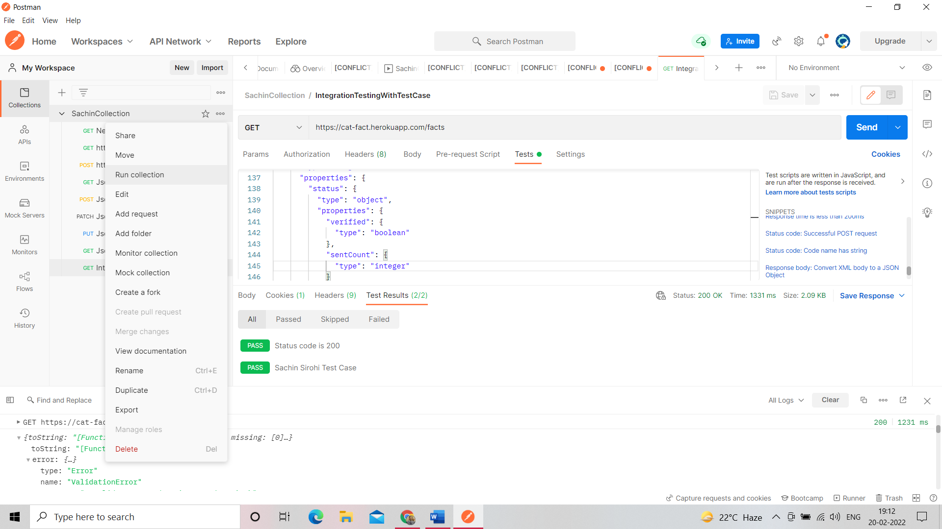

Click only last integration testing test case

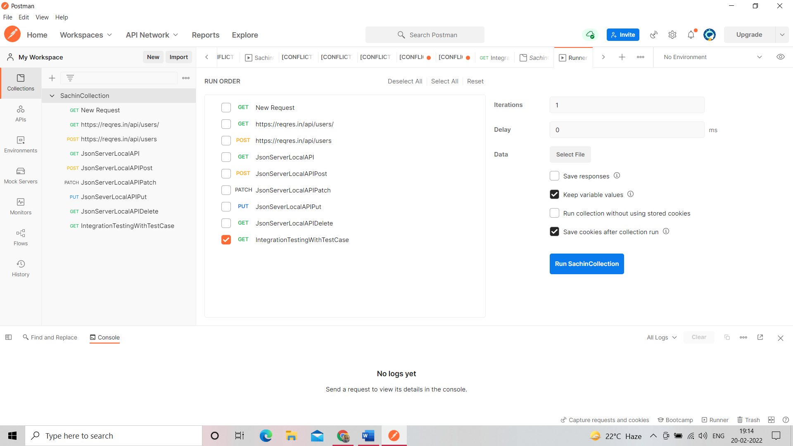

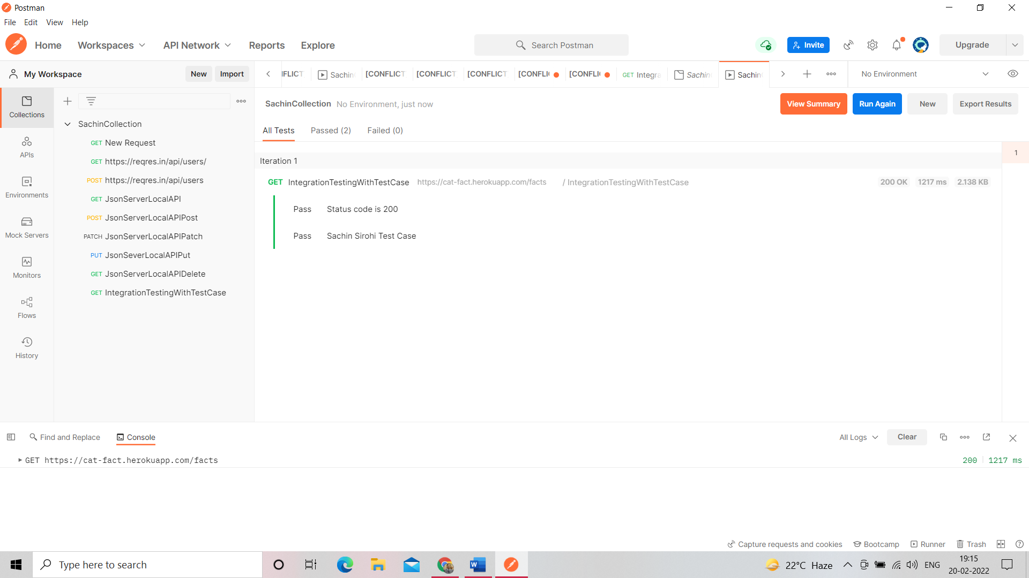

Add environment variable

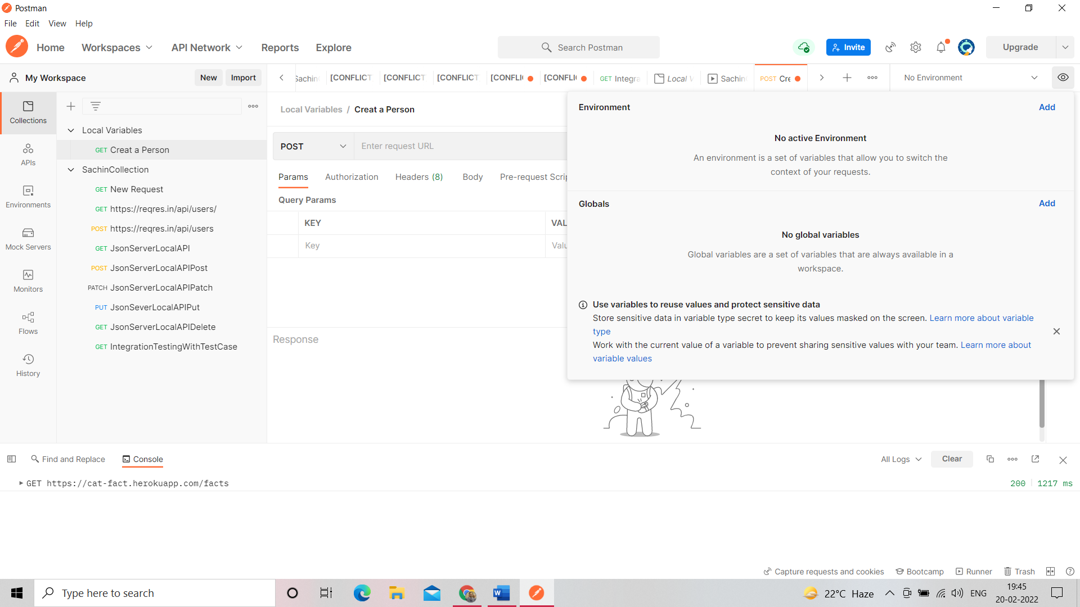

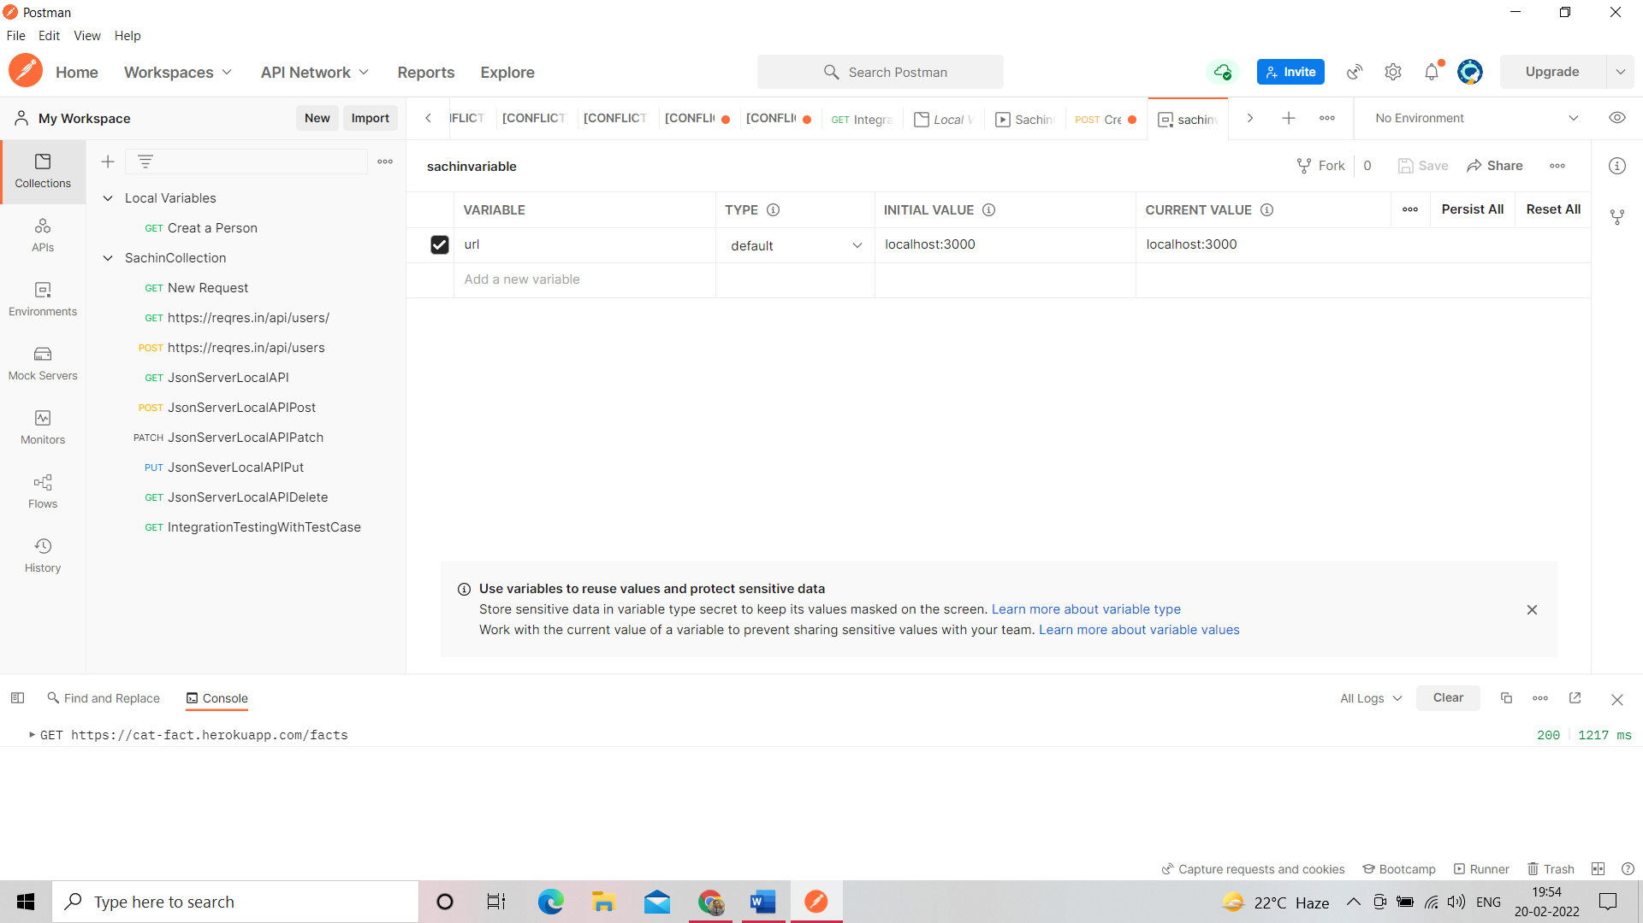

Set environment variable into put request type http://{{ select environment, environment priority is high as compare to normal variable

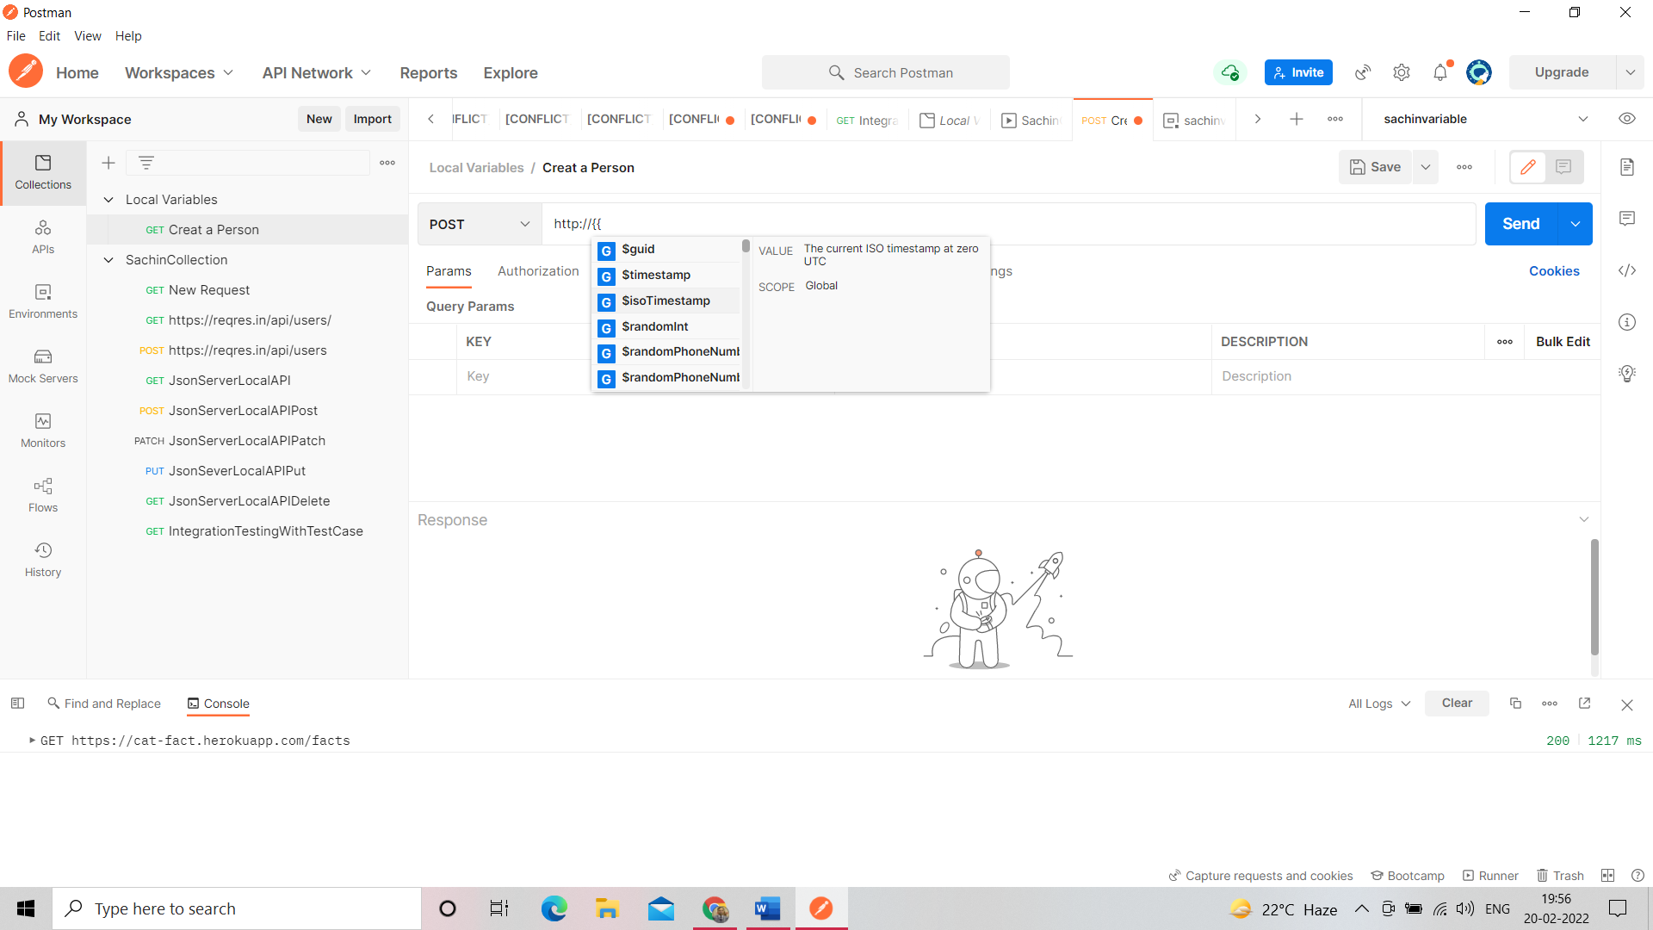

If localhost path is not set set into environment variable -> C:\Program Files\nodejs

Open cmd-> node -v

Open cmd-> json-server --watch db.json

Go to db.json file because persons json data there

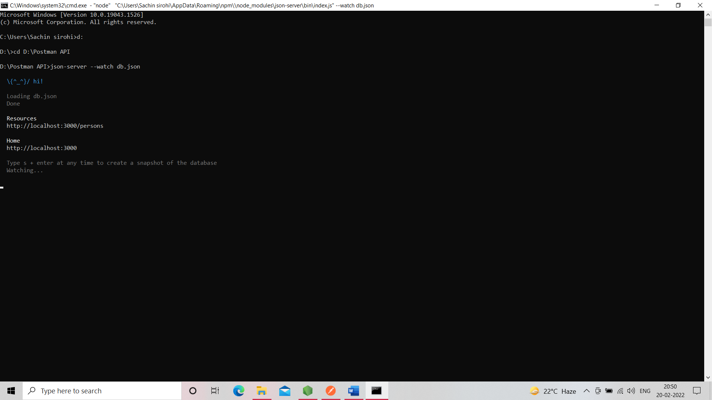

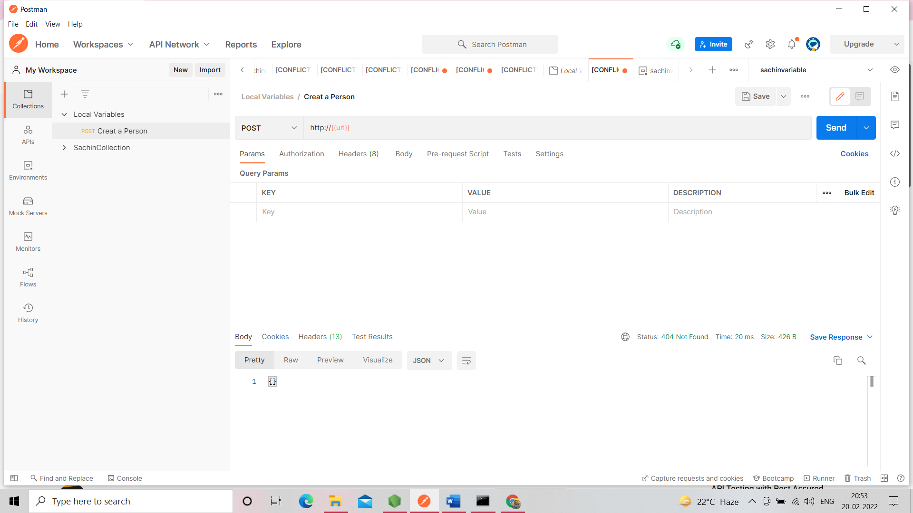

Is should be unique

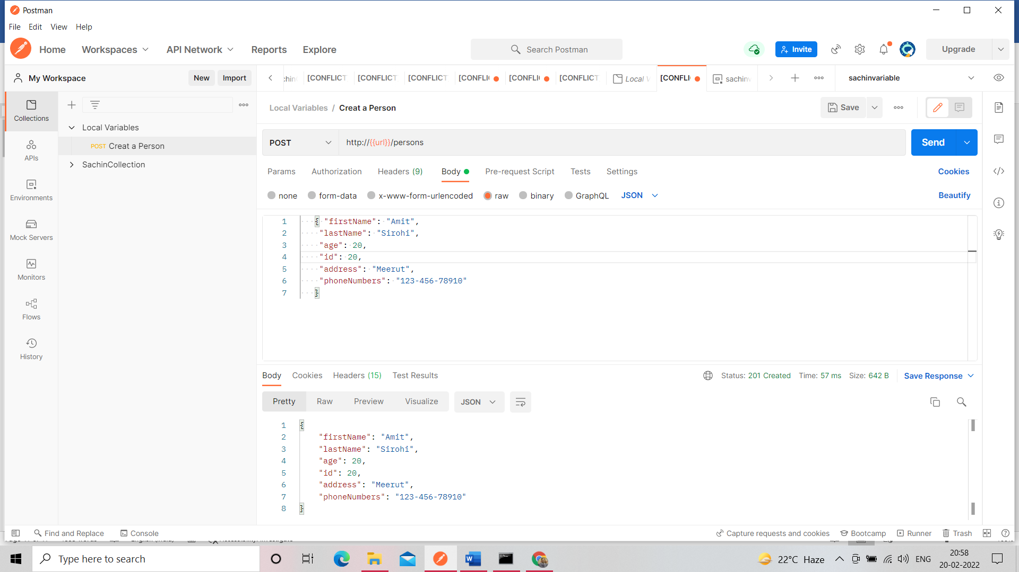

You can check of json file google chrome also

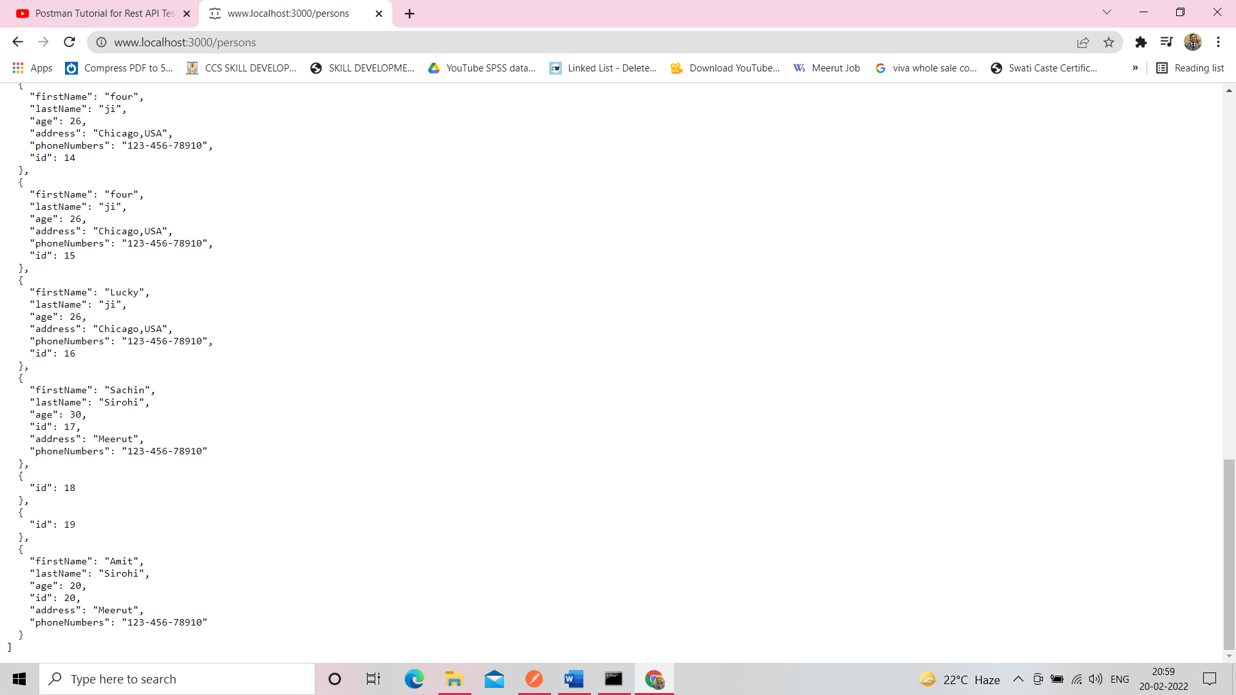

Set test case of local and environment variable because we don’t want to access id value other bcz it can be common.

Click on response body: json value check

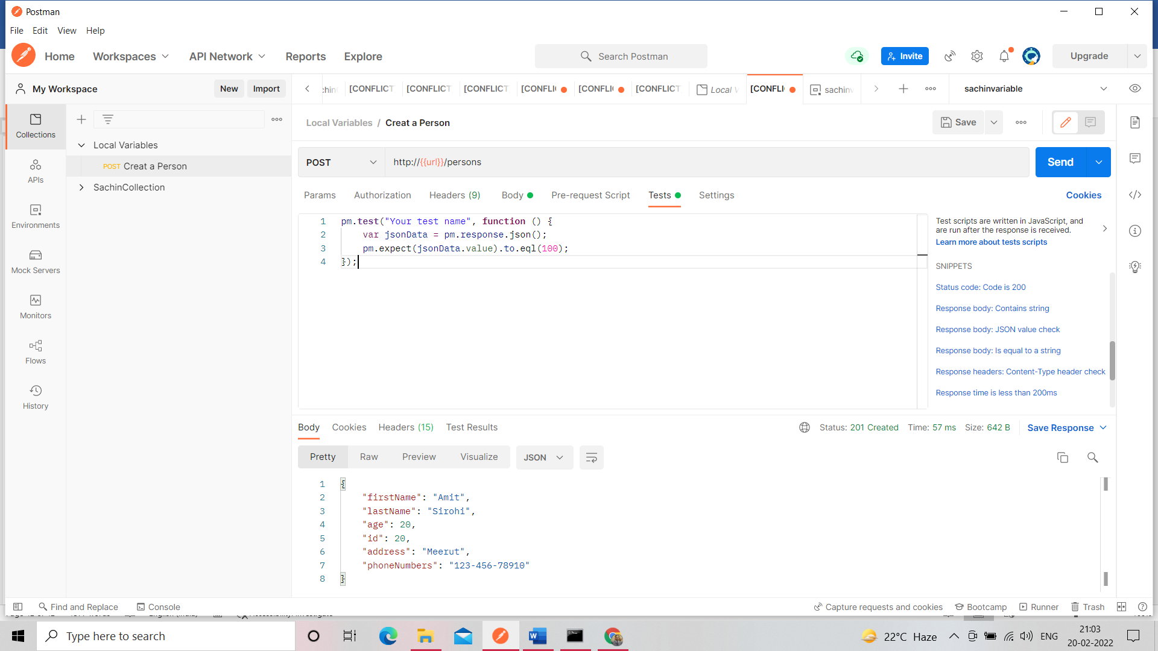

Click on set variable id should be unique

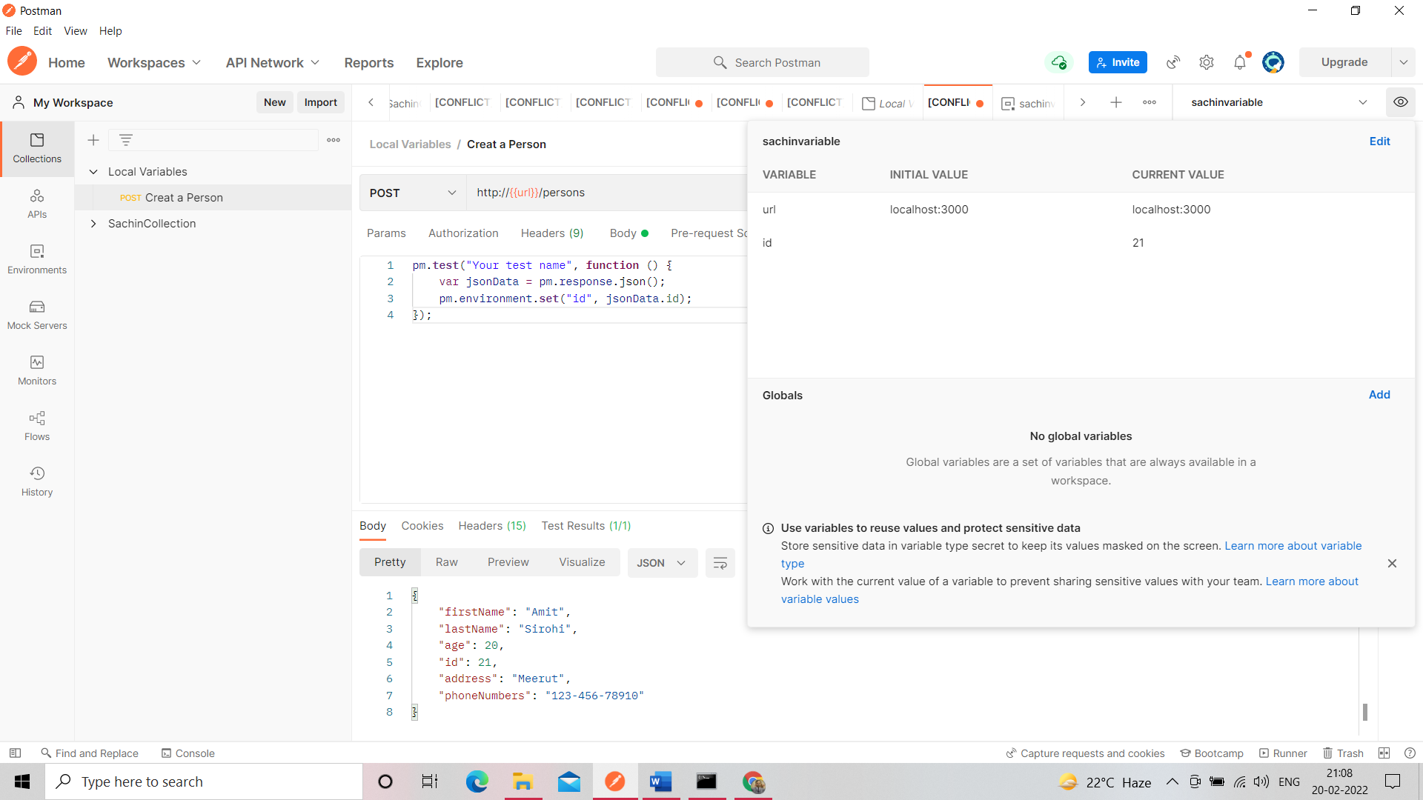

Get value by id

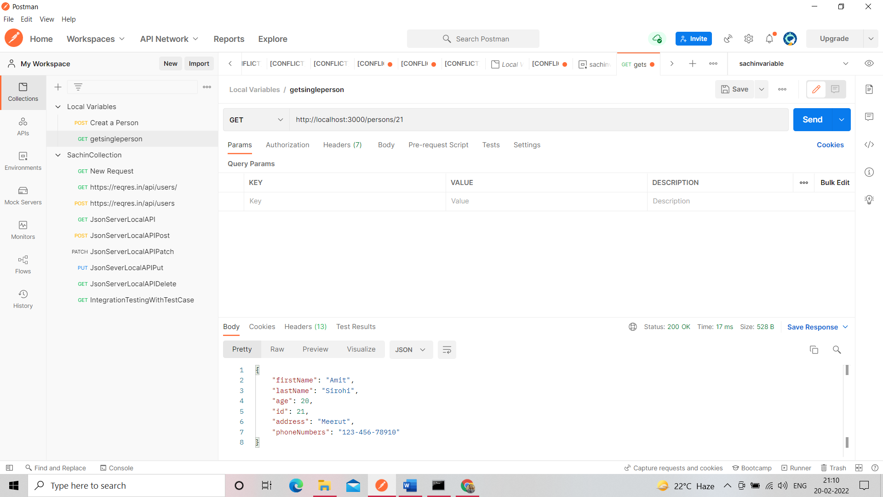

Get value by environment variable id

